Lesson 3 – Worksheet

Activity 1: Summary & Peer Evaluation

Using what you have learnt – explain the concept of LIFELONG LEARNING in the space below. This will be evaluated and assessed by your classmate.


My Conclusion:

Peer Assessment Rubric
Name of Learner: |  | Date:
Name of Assessor: |  | Date:
- The topic was understood and conclusion well written. |  | 
- The conclusion covers all the aspects of the lesson.
- The conclusion was very useful and easy to follow.
- The conclusion helped me understand some of the points.
Activity 2: End of Topic Reflection 
At the end of the topic – think about what you have learnt and use this page to put your thoughts down. You can be honest and truthful.
What I did not enjoy:

What I enjoyed:

Have any of your thoughts/career ideas changed from Lesson 1? How?

What I would have liked to have done:

What I have learnt:

Activity 3: Informal Assessment

INSTRUCTIONS:
- Complete the questions below.
- Pay careful attention to mark allocation and sentence construction. These are the kinds of questions that you will get in your end of year Examination.

Question 1:
Study the following cartoon and answer the questions that follow.

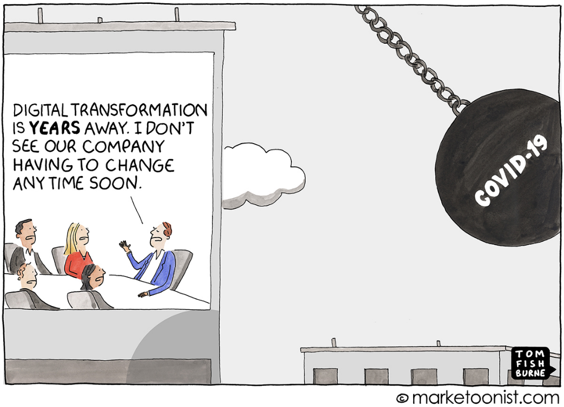

[Accessed from: https://marketoonist.com on 05 October 2020]

1.1 State THREE ways that the nationwide lockdown negatively affected business productivity.
(3x1) (3)

1.2 Discuss FOUR reasons why employees with high technological skills were more likely to succeed during the nationwide lockdown.
(4x2) (8)

1.3 Suggest THREE ways that someone can upskill themselves to increase their technological skills. In your answer, also indicate how EACH suggestion can lead to a more competent employee.
(3x3) (9)
[20]

Question 2:
Study the following infographic and answer the questions that follow.
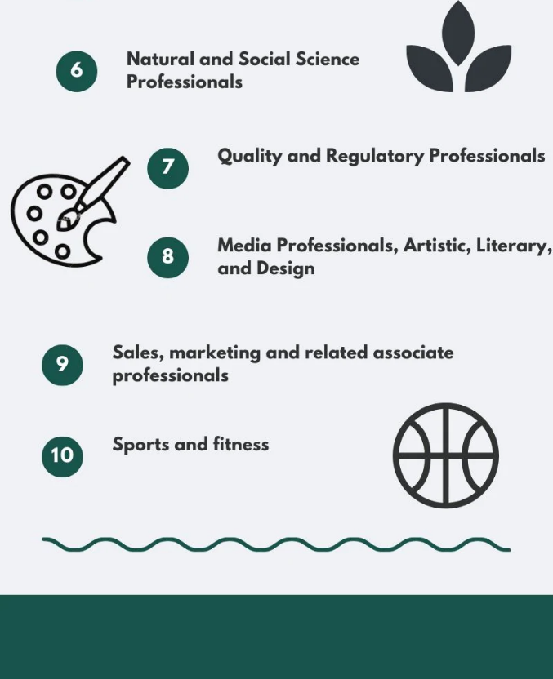
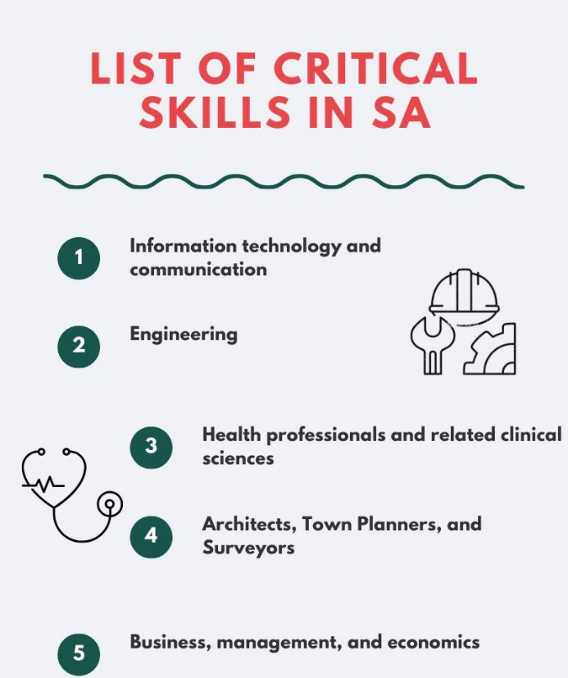

[Accessed from: https://briefly.co.za on 25 September 2020]

2.1 Define the term ‘scarce skills’ and provide TWO reasons why high school learners need to be aware of scarce skills in the country.
(1+2) (3)

2.2 Discuss FOUR ways that Covid-19 could have influenced the scarce skills list.
(4x2) (8)

2.3 Suggest THREE possible ways that life-long learning can make an employee more employable. In your answer, also indicate how EACH strategy will help workers to be more adaptable employees.
(3x3) (9)
[20]

