Lesson 2 – Worksheet


Activity 1: Reflection

Week 2: Use the space below to jot down any thoughts you have or questions you would like to ask regarding the lesson this week.
My thoughts and questions after this week’s lesson:

Things I did not undertsand:
My feelings after this
week’s lesson


Activity 2: Case Study

Read the article from News24 relating to employment trends and answer the questions that follow.

Latest trends revealed for the South African workforce

Since Adzuna.co.za last released stats about the online job market, quite a lot has changed. A lot of predictions were made with regards to the idea that critical skills would become harder and harder to find, and we also speculated that there would be further drops on average salaries, all of which proved to be spot on.
According to reports from Fin24, South Africa’s employment market shrank by 48, 000 jobs during the first quarter of this year. Statistics South Africa confirmed that on average, employment declined by 0.6% over the last year. This decline was driven by a decrease in trade (1.5%), business services (1%), community services (0.3%), manufacturing (0.3%), and transport (0.2%).
Adzuna’s findings indicated that there was an increased trend towards a demand for technical skills, although the number of vacancies in the field declined. This was indicated by an analysis done on over 130,000 unique online job listings in South Africa. This trend is predominantly ushered on by an annual trend of more new talent being hired at the end and start of the year, excluding the month of December of course.
Civil engineers earned top-tier salaries for the month of March, pocketing an average of R628, 000 annually, a statistic that has gone unchanged. Although no conclusive inference could be drawn, other engineering titles (such as geotechnical, facilities, treatment, and section engineers) scored higher when it came to an increase in wages. Engineering managers are currently earning annual remunerations of R862, 701 on average, placing them at the top of their ranks.
Compared to the stats Adzuna released last year, outliers - including “surveyors” - now earn twice as much as they did at the end of 2016. Employees in the sales force, such as sales managers and executives, are now demanding salaries which are around 25% higher than they were in March 2017.

Could this trend indicate proof that companies are now paying more on performance in an effort to tighten their belts in current economic climate? Adzuna believes this might be the case. Since March 2017, recruiters reported a marked decrease in salary at 49% lower, since the first quarter of 2017. The demand for recruiters is now much lower than it was, which might be an indication of a seasonal trend or just a show of how effectively companies have started to manage their own staffing solutions, instead of outsourcing this service.
In general, the job and salary data confirm what we already know – that South Africa is in a tight economic situation. Job seekers would do well to keep their jobs if not entirely unhappy, but are still encouraged to keep job alerts open to stay abreast of opportunities in the market.

Adapted from https://www.news24.com/MyNews24/latest-trends-revealed-for-the-south-african-workforce-20170822. Accessed on 28 July 2019

Homework Questions

2.1 Define the term critical skill. (2)

2.2 Distinguish between skills and competencies . (2+2) (4)

2.3 According to statistics in the article, in which career field is there a demand? (1)

2.4 Identify the career field that has the top remuneration package? (1)

2.5 Define the term remuneration. (1)

2.6 Identify in which sectors was there a decline in employment. (2x1) (2)

2.7 Evaluate the impact of choosing a job that is very popular and will have many applicants
applying in the same sector. (2x2) (4)

2.8 What practical advice would you give to someone that is looking for a job today? (5x1) (5)

[20]

For a helpful, relevant article published in August 2023 – see next page.


These are the 3 most in-demand jobs in South Africa – and what they pay
(Taken from: https://businesstech.co.za/news/business/709206/these-are-the-3-most-in-demand-jobs-in-south-africa-and-what-they-pay/ Accessed on 7th August 2023)
Jobs in sales, financial services, and IT are the most in-demand in South Africa, according to the Q2 2023 Pnet Job Market Trends Report.
The report provides insights into recruitment and employment trends in South Africa, and it is designed to help recruiters develop their strategies.
According to Pnet’s research, the local job market increased by 5% quarter-on-quarter in Q2 2023. Hiring activity also jumped by 3% year-on-year.
“It is encouraging to observe that over the past two years (from Q2:2021 to Q2:2023), there has been a 27% growth in jobs. Hiring activity remains stable and has continued to grow since the beginning of the year,” Pnet said.
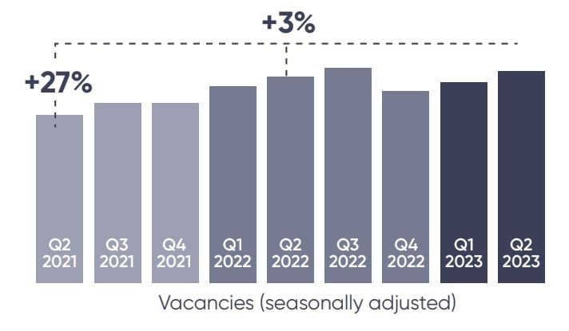
SMEs represent most businesses worldwide and are crucial for job creation. According to a World Bank Report, they represent approximately 90% of businesses and over 50% of employment worldwide.
The World Bank also said that 40% of GDP in emerging markets is generated by SMEs, which also create 7 out of 10 jobs in the formal sector.
According to Pnet, the most in-demand jobs in the SME sector are:
- Sales Representatives
- Accountants
- Software Developers
Moreover, the report listed the most desired skills by SMEs:
- Business and management skills
- Finance skills
- Sales skills
- Admin, office and support skills
- Information Technology Skills
The report said that when it comes to skills that SMEs lack, software development skills ranked the highest at 41%, whilst 35% of SMEs reported inadequate skills in complex data analysis and mathematics.
“This is particularly severe, as these skills are crucial for the initiation of the digitalisation process and the successful adaptation of new technologies,” Pnet said
Below is a comprehensive breakdown of the three most in-demand jobs in South Africa:

Sales Representative
Top skills | Top educational institutes | Salary range
Sales  Communication & Negotiation  Presentation Skills  Customer Services  Administration  Digital skills  Marketing  Leadership  Time Management | UNISA  Damelin  University Of Johannesburg  Tshwane University of Technology  Moonstone  University Of Pretoria  Durban University of Technology | GP – R19 000 to R25 000  KZN – R19 000 to R24 000  WC – R18 000 to R23 000

Financial Accountant
Top skills | Top educational institutes | Salary range
Accounting  Pastel  Microsoft Office  Sage  SAP  Taxation  Communication  Financial reporting  Caseware  Reconciliations  Accpac | UNISA  University Of Johannesburg  CIMA  University Of Natal  University Of Pretoria  SAICA  Damelin  SAIPA | GP – R31 000 to R41 000  WC – R31 000 to R39 000  KZN – R29 000 to R38 000

Software Developer
Top skills | Top educational institutes | Salary range
SQL  Net  C#  HTML  JavaScript  CSS  Java  Asp.Net  PHP  MVC  Angular | UNISA  Tshwane University of Technology  University Of Pretoria  University Of Johannesburg  Durban University of Technology  University Of Durban  University Of Natal  Cape Peninsula University of Technology | GP – R45 000 to R64 000  WC – R34 000 to R66 000  KZN – R37 000 to R49 000

