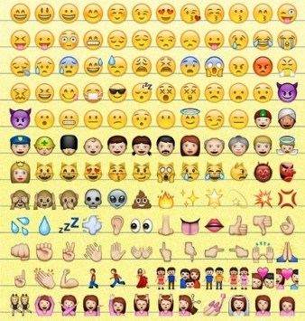
Create a poster in the block below using any emoji (from the list below) or creating new emojis to tell us about your religion.

Use the following as a guideline:
- Belief
- Religious Holidays
- Who to marry?
- What can you eat?
- Specific values to your faith
- Something about your religion you think no one knows…

