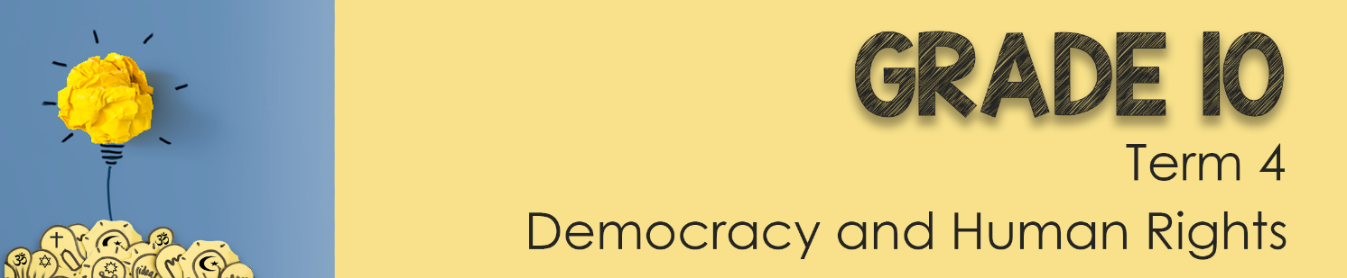
Lesson 1 - Worksheet

Activity 1: Write the following definitions in from the PowerPoint.
RELIGION:

MONOTHEISTIC:

INDIGENOUS:

SECT:

ETHICAL:

TRADITIONS:

Activity 2:
Use the information from the RELIGIONS NOTES and the data table below to complete the table below. Should you not finish this in class, you will need to complete it for homework.

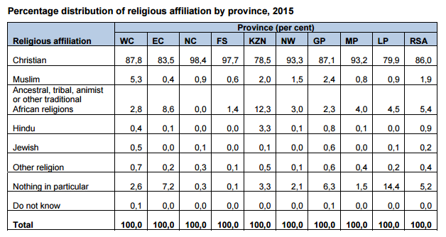

RELIGION | NAME OF DEITY  & RELIGIOUS BOOK | RELIGIOUS RITUAL | RULES or PRACTICES | % in South Africa
Judaism

Christianity

African Christianity

Islam

Hinduism

