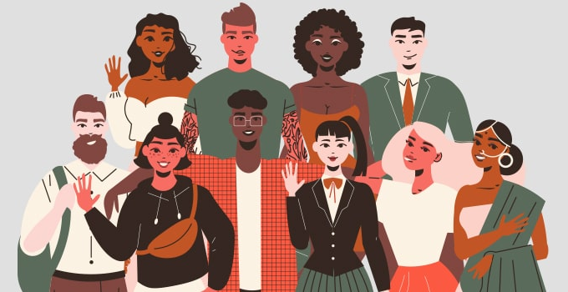
Constitutional Rights and Responsibilities:
Cultural Diversity in South Africa
CONTENT SUMMARY
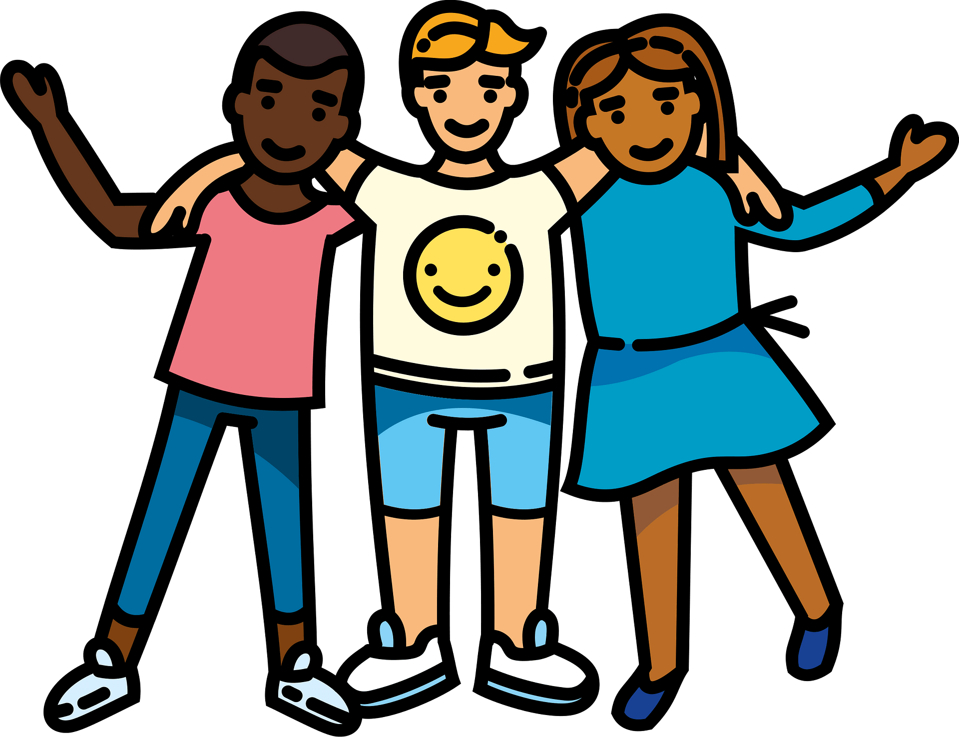

Culture can be defined as all the ways of life including arts, beliefs and institutions of a population that are passed down from generation to generation. Culture has been called "the way of life for an entire society." As such, it includes codes of manners, dress, food, language, religion, rituals and art.
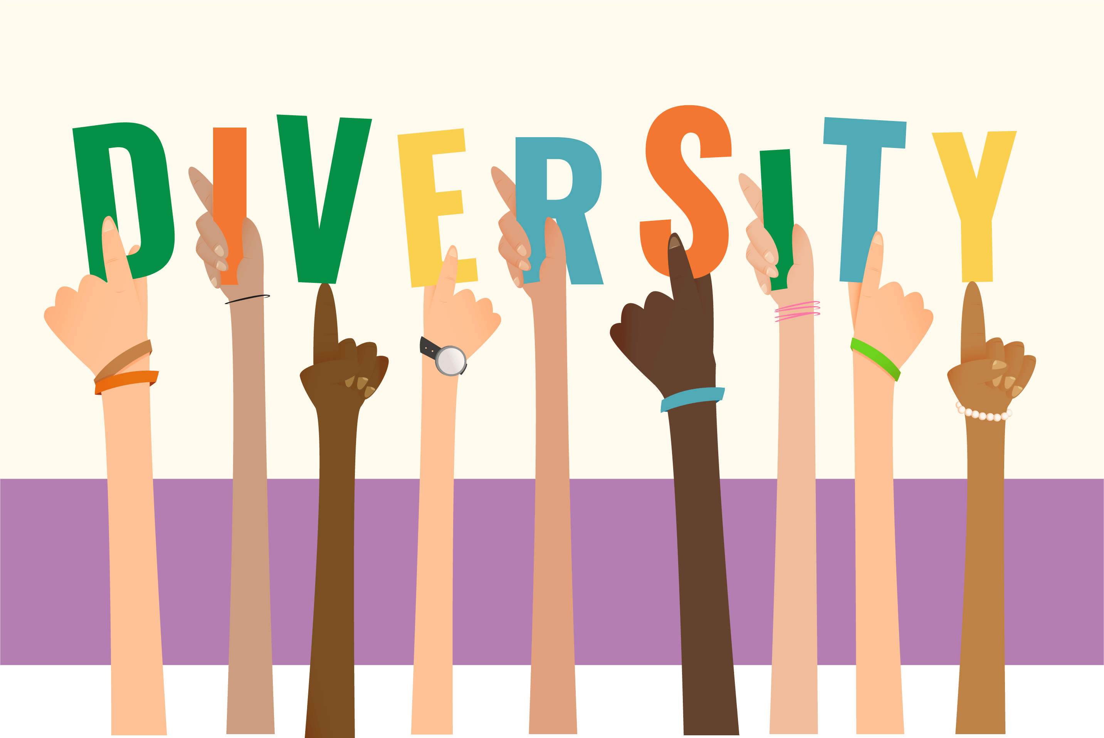
Diversity means being composed of differing elements – to simplify, it means differences. E.g. If there is a diverse group of pets, for example, there might be a dog, a cat, a bird, and a lizard. Just as in your classroom, you may find different genders, cultures, religions, skin colours and appearances. This is what makes your classroom diverse. People can be different in many ways. Some of the most obvious differences we may notice (between people / when comparing people) are age, language, culture, appearance, disabilities, race or ethnicity, and religion.

What is cultural diversity?
Cultural diversity is the quality of diverse or different cultures, as opposed to monoculture (one culture). The term "cultural diversity" can also refer to having different cultures respect each other's differences.
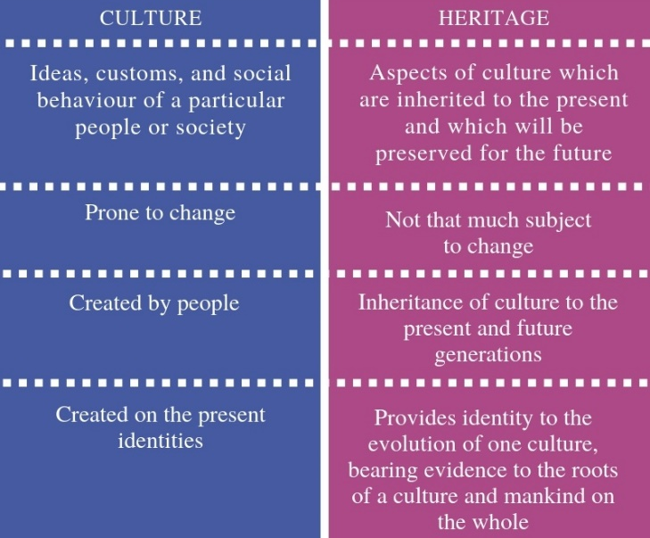
Culture however should not be confused with HERITAGE:
Heritage relates to inheritance, meaning passing of the beliefs, objects, and culture from one generation to the next, like a tradition. Culture is the ‘way of life for an entire society’ i.e. the knowledge, ideas, customs, laws, and habits of a group of people that they accept together as their core values.
It’s important not to get these two concepts confused, they mean different things – and it can be easy to mix them up.

CULTURAL DIVERSITY IN SOUTH AFRICA:
In South Africa, there is no one single heritage or culture and it is very difficult to define the “South African People” based on a set of distinct characteristics or identities. The cultures, languages and ethnic origins of South African people are exceptionally diverse and dynamic. This is what makes South Africa such an interesting and unique place to visit.

South Africa has been famously referred to as the rainbow nation because it is made up of so many diverse cultures and religions. Contained within South Africa’s borders are Zulu, Xhosa, Pedi, Tswana, Ndebele, Khoisan, Christian, Hindu, Muslim, and Afrikaans people to name but a few. All of these people are united by calling South Africa home, and therefore their lives all contribute to the country’s heritage, identity and culture. Understanding that South Africa is composed of all these various influences is essential in understanding the country.

DIVERSE CULTURAL NORMS AND VALUES IN RELATION TO PERSONAL AND COMMUNITY ISSUES:

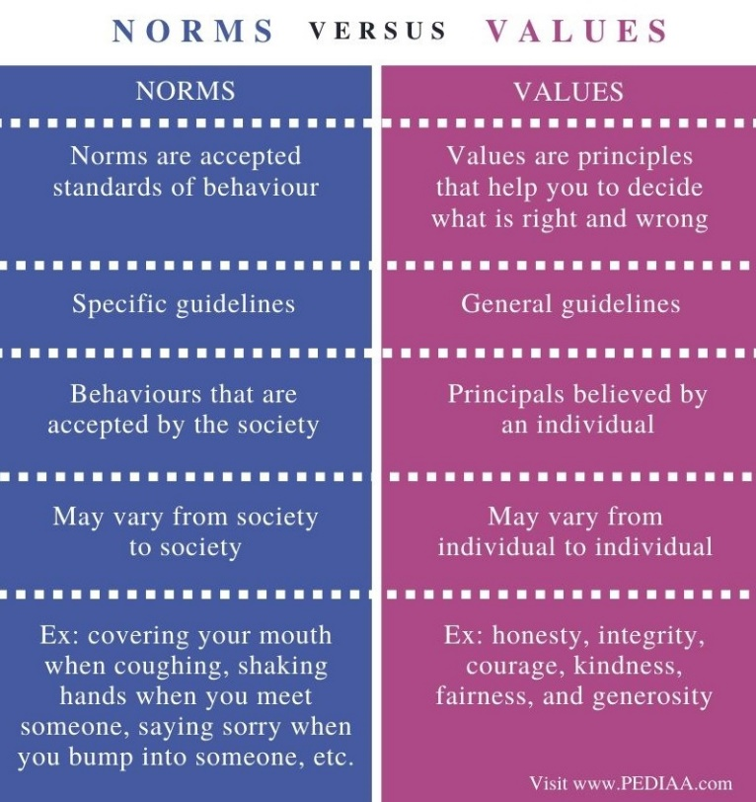
Cultural norms are the shared and accepted standards of behaviour and the ways of doing things that are specific to a cultural group.
They are also the guidelines for developing your values and morals – this means your sense of what is right or wrong. This can include things such as eating habits, greetings, manners, dress, medical treatments, celebrations, relationships and participation in religious activities are all determined by cultural norms.

Another way to look at Cultural Norms is that they are agreed‐upon expectations and rules by which a culture guides the behaviour of its members in any given situation. Of course, norms vary widely across cultural groups. Americans, for instance, maintain fairly direct eye contact when conversing with others. Asians, on the other hand, may avert their eyes as a sign of politeness and respect.

Cultural Values are ideas about what is good, right, fair, and just. Cultural values are a series of principles and values passed on generation after generation by our forefathers / ancestors. Based on values, the entire cultural community decides their way of life. Those ideas decide how a person of that culture will behave and how they will lead their lives.

INFLUENCE OF CULTURAL NORMS AND VALUES ON INDIVIDUAL BEHAVIOUR, ATTITUDE, AND CHOICES: CULTURAL EXPECTATIONS, PRACTICES, AND TRADITIONS

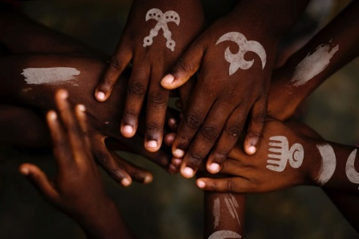
Cultural norms place obligations on people of that culture, certain expectations of practice and behaviour are imposed on those belonging to a particular culture. This can affect people’s participation in activities as well as their decision making. Our personal choices and preferences are sometimes restricted because of traditions and expectations of our culture.

Sometimes our behaviour and attitude may need to change in order to fit in or adapt with the ways of another culture.

There are many ways that people can influence our behaviour, but perhaps one of the most important is that the presence of others seems to set up expectations.
We do not expect people to behave randomly but to behave in certain ways in particular situations. Each social situation entails its own set of expectations about the “proper” way to behave. Such expectations can vary from group to group.

Social norms are the unwritten rules of beliefs, attitudes, and behaviours that are considered acceptable in a particular social group or culture. Norms provide us with an expected idea of how to behave, and function to provide order and predictability in society. For example, we expect students to arrive to a lesson on time and complete their work, in return – teachers do the same and are prepared for their lessons and help learners with their subjects. In communities, norms are usually what they decide to be right or wrong, what the community sees as “normal” and therefore it provides us with an expected idea of how to behave.

An example could be greeting etiquette, in traditional Zulu culture. Greeting is a very important procedure. It is a structured encounter and it is considered bad manners not to greet either a friend or a stranger in passing, one should always greet someone. It is not enough to just say “Sawubona!” You should also take the time to enquire about the other person’s well-being: “Unjani?”
Greeting one person in the plural form is an indication of respect as well as inquiring about the person’s
family members. In Zulu the greeting always stays - no matter the time of day or night.
Who greets first? Normally, the person who arrives somewhere is supposed to greet those present first but according to Zulu custom the junior person should greet the senior person first.
Forms of address: When greeting a person older than yourself (more or less your parents’ age), baba 'father' would be used for a man and mama 'mother' for a woman. For greetings of people of your grandparents’ age mkhulu, 'grandfather', and gogo ‘grandmother’ are used as forms of address. Greeting someone of your own age you would address her as sisi, 'sister', and bhuti, 'brother' for the male counterpart.
Saying goodbye: The person leaving first should be the first to say goodbye. It would be impolite of the other person(s) to end the conversation first. When saying goodbye to one person you would say Hamba kahle (‘Go well’) or Sala kahle (‘Stay/remain well’). When saying goodbye to more than one person, Hambani kahle or Salani kahle would be used.

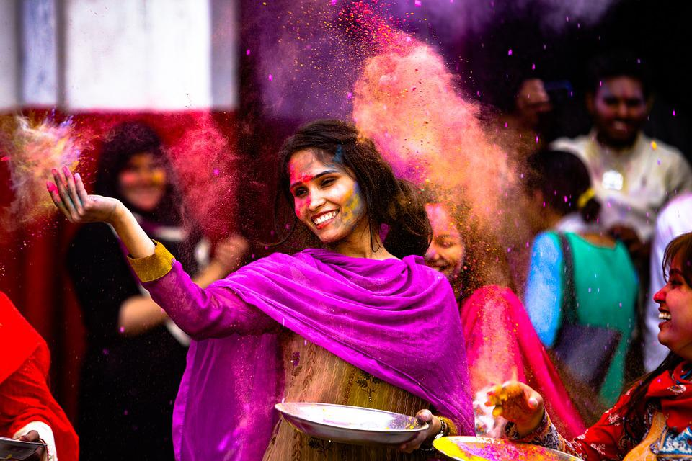
Other examples could be bowing - which is a common greeting across Asia. Each country uses a slightly different bow as a greeting. For example, in Japan your bow reflects the other person’s social status. When bowing a person should keep their hands to their sides and bend at the waist. A longer, deeper bow is expected for more important and respected people. In contrast, in India people greet each other by placing their hands in the centre of their chest and bowing. They also will say namaste as they do this. Namaste means “I bow to you” in Sanskrit. It is a term of respect. A surprising number of cultures greet each other by touching noses, foreheads, or both. For instance, the traditional Māori greeting in New Zealand does this. People press their foreheads and noses together and look into each other’s eyes.
In Tibet, Buddhist monks greet one another by sticking their tongue out. This tradition goes back more than 1,000 years.

UNDERSTANDING DIVERSE CULTURES: RECOGNITION OF DIVERSE CULTURES TO ENRICH SOUTH AFRICAN SOCIETY

The way we treat people and our attitudes towards them is based on what we have learnt and how we have been raised. Being aware of other cultures helps us to respect beliefs and other ways of doing things that may not be our own. Recognizing other cultures is part of respecting their practices and beliefs.
Enriching society means to make it better by understanding and accepting diverse cultures we learn to live harmoniously through understanding and tolerance.

Within the Bill of Rights, the South African Constitution, sets out certain cultural rights. For example, Section 15 of the Bill of Rights provides for the freedom of religion, belief, and opinion. Section 16 prohibits hate speech. Section 30 entitles everyone to use their own language and to participate in the cultural life of their choice and Section 31 protects the rights of people belonging to cultural, religious, or linguistic communities.

RESPECT DIFFERENCE: CULTURE, RELIGION, AND GENDER

By respecting differences, we can overcome racism and discrimination, instead we can encourage and support multiculturalism. Meaningful interactions across cultures are the most effective way to reduce prejudice and to encourage respect for and understanding of our differences. Different cultures can be explored through art, music, literature festivals and community celebrations. We live in a diverse nation made-up of many different cultures, languages, races and backgrounds. This variety can make our lives a lot more fun and interesting, but only if we get along with one another. To do that we need to have respect for one another, treating people with respect will make our world a better place to live in at home, at school or art in our community.

Our culture is what shapes us; it shapes our behaviour and our identity. Culture is our way of living, it refers to the shared language, beliefs, values, norms, behaviours, and material objects that are passed down from one generation to the next.

CELEBRATE UNITY IN DIVERSITY: RESPECT DIFFERENCE AND CELEBRATE SIMILARITY

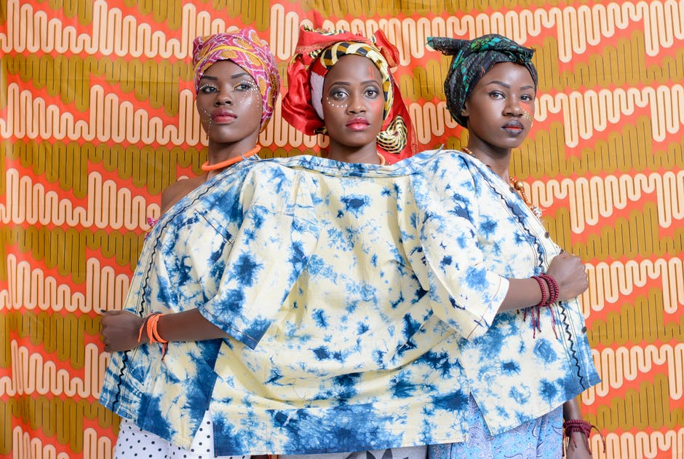
What does “CULTURALLY DIVERSE” mean?
The term “culturally diverse” is often used interchangeably with the concept of “multiculturalism.”

- recognition of the abundant diversity of cultures;
- respect for the differences;
- acknowledging the validity of different cultural expressions and contributions;
- valuing what other cultures offer;
- encouraging the contribution of diverse groups;
- empowering people to strengthen themselves and others to achieve their maximum potential by being critical of their own biases; and
- celebrating rather than just tolerating the differences to bring about unity through diversity.

Why is CULTURAL DIVERSITY a “good thing” / so important?
Cultural diversity is important because our country, workplaces, and schools increasingly consist of various cultural, racial, and ethnic groups. We can learn from one another, but first, we must have a level of understanding about each other. Learning about other cultures helps us understand different perspectives within the world in which we live. It helps dispel negative stereotypes and personal biases about different groups.
In addition, cultural diversity helps us recognize and respect “ways of being” that are not necessarily our own. So that as we interact with others we can build bridges to trust, respect, and understanding across cultures. Furthermore, this diversity makes our country a more interesting place to live in. As people from diverse cultures contribute language skills, new ways of thinking, new knowledge, and different experiences.

How can YOU support CULTURAL DIVERSITY?
- Increase your level of understanding about other cultures by interacting with people outside of your own culture.
- Avoid imposing values on others that may conflict or be inconsistent with other cultures.
- When interacting with others who may not be proficient in English, recognize that their limitations in English proficiency in no way reflects their level of intellectual functioning.
- Recognize and understand that concepts within the helping profession, such as family, gender roles, spirituality, and emotional well-being, vary significantly among cultures and influence behaviour.
- Within the workplace, educational setting, and/or clinical setting, advocate for the use of materials that are representative of the various cultural groups within the local community and the society in general.
- Intervene in an appropriate manner when you observe others engaging in behaviours that show cultural insensitivity, bias, or prejudice.
- Be proactive in listening, accepting, and welcoming people and ideas that are different from your own.

According to the late Archbishop Emeritus Desmond Tutu, South Africa is the rainbow nation because of its cultural diversity. Because South Africa is one of the most multicultural societies in the world, it is actually very difficult to define South African culture. The more we know about one another, the more we break down the barriers that prevent people of different cultures from getting along. By learning about the history and the culture of various groups in society, you can develop respect for them and the values that lie behind people’s behaviour as well as the similarities between cultures.
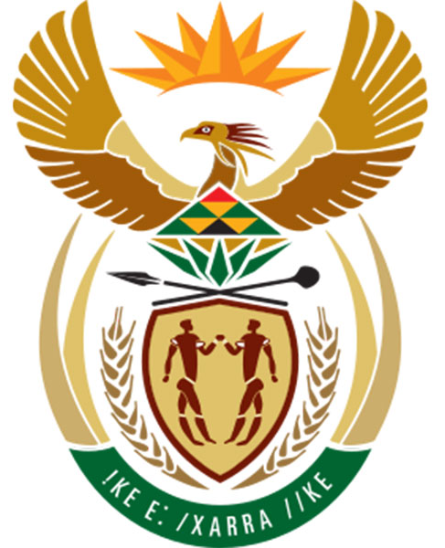
The motto on the South African coat of arms is IKE E: /XARRA //KE and it means diverse people unite. With these words we are called to celebrate our differences in people and to use our diversity to create a unique culture of peace, cooperation and unity.

South Africa has a population of over 45 million people our constitution recognises 11 different languages although there are many sub dialects and other languages spoken by immigrants from Europe elsewhere in Africa and the Indian subcontinent as well as China.

CONTRIBUTIONS TO SOCIAL DEVELOPMENT BY ORGANISATIONS FROM VARIOUS RELIGIONS

Social development is about improving the well-being of every individual within a society so they can reach their full potential. The success of society is linked to the well-being of all its citizens. Social development means investing in people.

The National Religious Association for Social Development was established in 1997 to allow for closer cooperation between the church, the religious sector, the state and public institutions.
The association was established by representatives of the religious organisations (Baha’i, Buddhist, Christian, Hindu, Islamic and Jewish) involved in a national conference.

The basic approach of the NRASD is to strengthen the capacity and programmes of existing networks to enable them to play an even bigger role in this field. Together the religious groups represent by far the largest networks for social, welfare and development work in South Africa.

Today the NRASD represents the concerns and interests of different faith welfare networks, which include Baha’i, Buddhist, Christian, Hindu, Islamic and Jewish traditions. It has established itself in a relatively short period as an important national role-player that strives to fulfil the following functions:
- consultations with government departments and ministries;
- joint lobby processes for changes on programme level; and
- implementation of a new development partnership with the government.

A few examples of where The NRASD focuses:
- Health – combatting HIV and AIDS, Malaria and Tuberculosis.
- Early Childhood Education – providing resources (physical, material and human) and being involved in the interaction between communities, NGO agencies, and government.
- Home and Community Based Care – health and social services to assist care givers in the home and community, as well as assisting families in things they may need.
- Skills training and access to information – training in technical and life sills, adult education, business skills and entrepreneurship.

Examples of different Religious Organisations and their contribution to Social Development:

- The Salvation Army aims to help the homeless, uplift the abused and assist the elderly and the displaced.
- YMCA/YWCA (Young Men/Women Christian Association) aims to help prepare young people for life with leadership programmes focusing on national issues at a local level (like gender violence.
- Gift of the Givers is a disaster relief organisation, the run multiple projects like feeding schemes, life skills and education.
- Al Aqsa Foundation is a charitable organisation providing religious, cultural, and social needs for the Palestinians living in Gaza, Lebanon and Jordan.
- Buddhist Global Relief aims to help the poor wo live healthy lives with dignity and purpose. The partner with Save the Children and the Red Cross.
- American Jewish World Services provides grants to communities in Africa, Asia and the Americas to create a fair, just and equitable world.
- Divine Life Society builds schools and houses for the disadvantaged and provide school meals at centres in KwaZulu Natal.
- International Society for Krishna Consciousness works with orphanages, old age homes and crisis relief centres in KwaZulu Natal.
- Bahá’i Training Institutes help individuals to study in a meaningful way and is made up of volunteers who tutor, provide administrative assistance and general assistance. It is funded through donations.


IMPORTANT TERMINOLOGY:

- Cultural Diversity: the quality of diverse or different cultures, as opposed to monoculture (one).
- Cultural Norms: agreed‐upon expectations and rules by which a culture guides the behaviour of its members in any given situation.
- Cultural Values: Cultural values are a series of principles and values passed on generation after generation by our ancestors.
- Culture: can be defined as all the ways of life including arts, beliefs and institutions of a population that are passed down from generation to generation.
- Customs: cultural idea that describes a regular, patterned behaviour that is considered characteristic of life in a social system.
- Diversity: the practice or quality of including or involving people from a range of different social and ethnic backgrounds and of different genders, sexual orientations, etc.
- Ethnicity: an ethnic group; a social group that shares a common and distinctive culture, religion, language, or the like.
- Gender: characteristics of women, men, girls, and boys that are socially constructed. This includes norms, behaviours and roles associated with being a woman, man, girl or boy, as well as relationships with each other.
- Heritage: features belonging to the culture of a particular society, such as traditions, languages, or buildings, that were created in the past and still have historical importance.
- Laws: a rule, usually made by a government, that is used to order the way in which a society behaves
- Moral: a sense of what is right or wrong.
- Multicultural: a society made-up of more than one culture.
- Multicultural: relating to or containing several cultural or ethnic groups within a society.
- Race: protected characteristic that refers to an individual's race, colour, nationality and ethnic or national origins.
- Religion: system of designated behaviours and practices, morals, beliefs, worldviews, texts, sanctified places, prophecies, ethics, or organizations.
- Tolerance: the ability or willingness to tolerate the existence of opinions or behaviour that one dislikes or disagrees with.
- Traditions: an inherited, established, or customary pattern of thought, action, or behaviour (such as a religious practice or a social custom) or a belief or story or a body of beliefs or stories relating to the past that are commonly accepted as historical though not verifiable.
- Value: principles or ethics of behaviour of a personal group.

