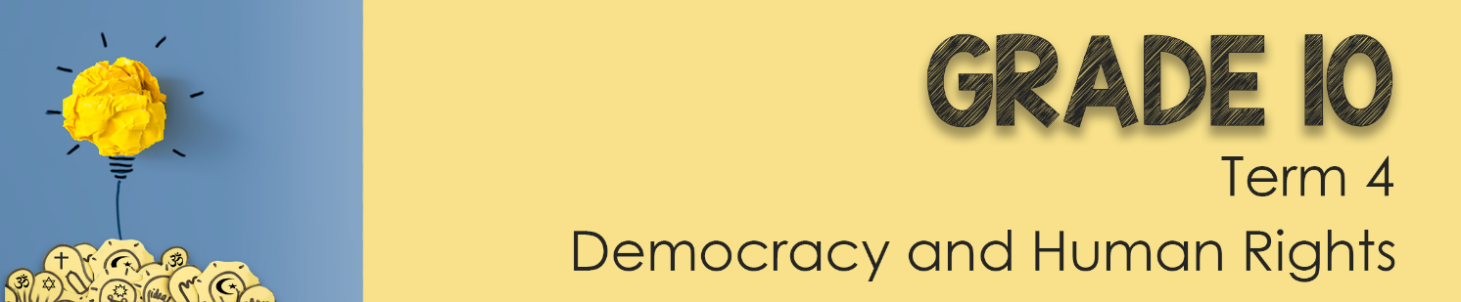
Lesson 3 – Worksheet MEMO

Activity 1: Write out the impact that addiction and use of anabolic steroids
in sport would have on the following:
Men may develop:
- Prominent breasts
- Shrunken testicles
- Infertility
- Prostate gland enlargement

Women may develop:
- A deeper voice, which may be irreversible
- An enlarged clitoris, which may be irreversible
- Increased body hair
- Baldness, which may be irreversible
- Infrequent or absent periods

Both men and women may develop:
- Severe acne
- Increased risk of tendinitis and tendon rupture
- Liver abnormalities and tumours
- High blood pressure (hypertension)
- Heart and blood circulation problems
- Aggressive behaviors, rage or violence
- Psychiatric disorders, such as depression
- Drug dependence
- Infections or diseases such as HIV or hepatitis if you're injecting the drugs
- Inhibited growth and development, and risk of future health problems in teenagers

Activity 2:

- Knowing all these possible side effects, do you think its worth “winning at all costs?”
Hopefully learenrs will see the danger in this attitude and comment on the cost being too high as it impacts their health in the long run.
- If its so dangerous, why do teenagers still take the drugs?
Peer pressure play a large role in teens feeling that they need to conform to what other learners are doing.
At the same time the pressure to be the best also impacts taking PEDs

- Recommend three ways to communicate the danger of drugs in school.

You could create an awareness campaign and put posters around the school communicating the danger of taking drugs.
Become a spokesperson for anti-drugs and promote healthier options in school articles and newsletters.
Encourage RCL and societies at school to take a stand against PED’s using the school social media page.

Activity 3: List the SIX steps you would take to become a critical analyst of
sports coverage in the media:
Any SIX statements from this list:
- You need to research and make sure you have evidence to support your argument.
- You will find this evidence by cross referencing different sports news outlets or articles.
- Ask yourself: What did I find in the media about sports coverage?
- As well as how does this support my viewpoint?
- And have I found evidence of bias or prejudice in sport?
- Once you’ve done all this research, present a critical argument with your evidence.
- If someone else opposes your viewpoint, take time to listen to them and carefully evaluate what they have said.
- Stay calm, do not argue! Try to counter their response with evidence.

Activity 4: Study the cartoon below and answer the questions that follow:
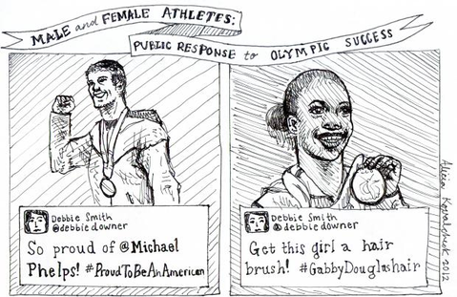
1. Define the term “gender bias” and state THREE examples of gender bias seen
in the coverage of sport. (1+3) (4)
Marks should be awarded as follows:
ONE () mark for the correct definition
Gender Bias: inclination towards or prejudice against one or more genders.
The above definition for ONE mark. (1x1) (1)
AND
Marks should be awarded as follows:
ONE () mark for a well-explained response.
Possible answers could include:
- As in this cartoon both male and female have won medals, but the male receives compliments while the woman is criticised rather than being praised for her achievement
- Male dominated sport has greater coverage than female sport
- Due to greater coverage, male sport receives more sponsorship than female sport
- The focus on coverage of women in sport is often more about their appearance rather than their athletic performance.
Any THREE of the above for ONE mark each (3x1) (3)

2. Suggest TWO practical solutions to address bias in sport in your school
environment to ensure equal opportunities for all. (2x3) (6)
Marks should be awarded as follows:
THREE () marks for a well explained response
Possible answers could include:
- Schools should advertise both male and female sports equally so that the public and learners are made aware of all these athletes and sports as that could allow for equal recognition and rewards
- Learners could be encouraged to speak up about unfair bias in sport so that their local RCL and School Governing Body could be made aware of the problem and by doing so, policies or traditions that promote unfair bias in sport (at the school) could be removed / reviewed
- Males and females should be allowed to choose to play in comfortable functional sport wear so that the focus is off appearances and place the attention on the sport itself.
- Encourage learners (who are passionate about addressing bias in sport) to get involved in RCL or joining a participating body / leadership so that decision makers and leaders at the school are made aware of the problem as they can change the way sport is conducted or events are run at the school.

Any TWO of the above for THREE marks each (2x3) (6)
(i.e. ONE mark for statement and ONE mark for the qualifier and ONE mark for the outcome.)

3. Critically discuss TWO strategies that South African media could adopt
to redress bias in sports. (2x4) (8)
Marks should be awarded as follows:
FOUR () marks for a well-explained response
Possible answers could include:
- Broadcasting agencies in South Africa need to all adhere to a common code or law against gender bias. That way sporting organisations or broadcasters are held liable for bias. With this level of accountability, media agencies would become more responsible and make sure that all sporting events are advertised and carried out fairly and equally.
- All sportsmen and women need to actively promote and endorse gender equality in their sport by using their social media platforms and encouraging positive affirmation of both genders. Others would see them acting as ambassadors and role models for aspiring athletes and society. The result would be a greater acceptance amongst the public of gender equality in sport.
- Government must make sure to give indigenous games more opportunities and attention so that all cultures can be represented and celebrated.Most South Africans are not aware of the different indigenous sports. With more coverage, South Africans could support and become proud of our varied culture.
- Government or sporting organisations should identify bias in sportsso that they can re-educate the public and address these negative behaviours. People would then be encouraged to report bias in sport so that changes can be made, and the authorities can address the problem.

Any TWO of the above for FOUR marks each. (2x4) (8)
(i.e. To be awarded the full FOUR marks for a CRITICALLY DISCUSS
question: candidates must give a statement, () elaborate on the
statement, () qualify the statement () and give an outcome ())
[18]
Activity 5: Reflection
Take a moment to reflect on what you have learnt about yourself today.
Each learner will have their own response

