Lesson 3 - Reflective Activity
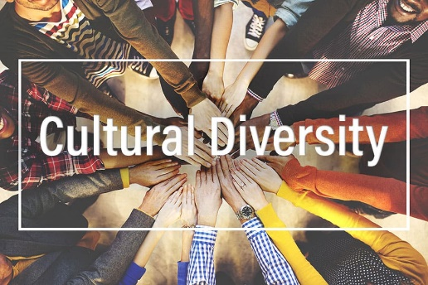
Answer these reflections as best you can.
Do I know what Cultural Diversity means?

What have I learnt about my classmates?

Why is an understanding of culture important?

What can I do to embrace other cultures and those around me?

What was the most important thing I learnt?

What can I do better?

How I feel I have performed in these lessons:

