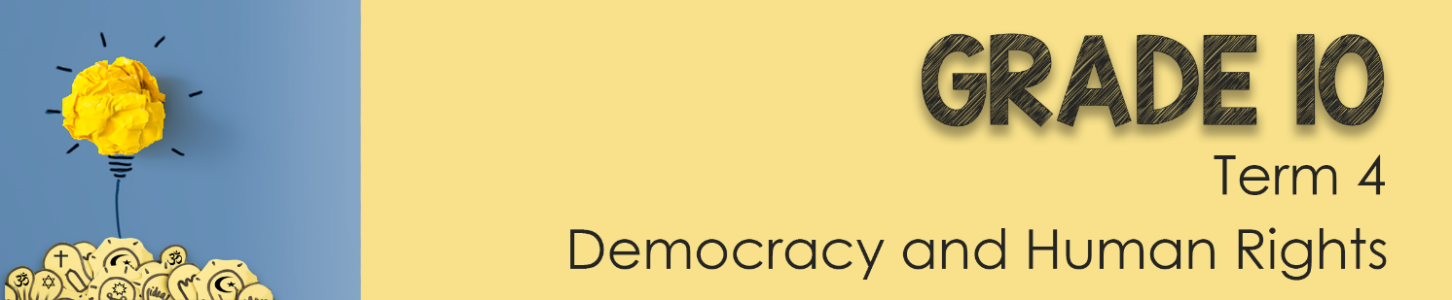
Lesson 3 – Worksheet

Activity 1: Write out the impact that addiction and use of anabolic steroids
in sport would have on the following:
Men may develop:
- ________________
- ________________
- ________________
- ________________
________________

Women may develop:
- ________________
________________
- ________________
________________
- ________________
________________
- ________________
________________
- ________________
________________

Both men and women may develop:
- Severe acne
- _____________________________
- Liver abnormalities and tumours
- High blood pressure (hypertension)
- ______________________________
- _____________________________________violence
- Psychiatric disorders, such as depression
- Drug dependence
- __________________________________________________
- Inhibited growth and development, and risk of future health problems in teenagers

Activity 2:

- Knowing all these possible side effects, do you think its worth “winning at all costs?”
_________________________________________________________________
_________________________________________________________________
- If its so dangerous, why do teenagers still take the drugs?
_________________________________________________________________
_________________________________________________________________

- Recommend THREE ways to communicate the danger of drugs in school.
_________________________________________________________________
_________________________________________________________________
_________________________________________________________________
_________________________________________________________________
_________________________________________________________________
_________________________________________________________________

Activity 3: List the SIX steps you would take to become a critical analyst of
sports coverage in the media:
1) __________________________________
2) __________________________________
3) __________________________________
4) __________________________________
5) __________________________________
6) __________________________________
Activity 4: Study the cartoon below and answer the questions that follow:
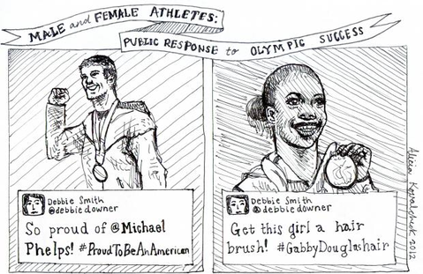
1. Define the term “gender bias” and state THREE examples of gender bias seen
in the coverage of sport. (1+3) (4)
_________________________________________________________________
_________________________________________________________________
_________________________________________________________________
_________________________________________________________________
_________________________________________________________________
_________________________________________________________________
_________________________________________________________________

2. Suggest TWO practical solutions to address bias in sport in your school
environment to ensure equal opportunities for all. (2x3) (6)
_________________________________________________________________
_________________________________________________________________
_________________________________________________________________
_________________________________________________________________
_________________________________________________________________
_________________________________________________________________
_________________________________________________________________
_________________________________________________________________
_________________________________________________________________

3. Critically discuss TWO strategies that South African media could adopt
to redress bias in sports. (2x4) (8)
_________________________________________________________________
_________________________________________________________________
_________________________________________________________________
_________________________________________________________________
_________________________________________________________________
_________________________________________________________________
_________________________________________________________________
_________________________________________________________________
_________________________________________________________________
[18]
Activity 5: Reflection
Take a moment to reflect on what you have learnt about yourself today.
• Write a short paragraph on what you have learnt today about unfair practices in sports.

- How has the media impacted your perceptions on gender bias in sport?

