Classroom Activities That Teach Job Readiness Skills
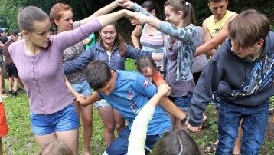
Students need these skills to succeed in the workplace.
https://www.weareteachers.com/9-awesome-classroom-activities-that-teach-job-readiness-skills/

Elizabeth Mulvahill on March 19, 2021

When it’s time to go start working and/or head to college, in addition to academic knowledge and vocational skills, students also need “soft skills,” otherwise known as job readiness skills.

Soft skills are those characteristics that help you function as an individual (motivation, self-confidence, and flexibility) as well as within a group (teamwork, negotiation, and respect). To succeed in the workplace, these skills are key! After all, if you can’t show up on time, speak up for yourself, or get along with your peers, chances are you’re not going to have a very smooth go of it.

Explicitly teaching students these skills is the best way to give them valuable insight into their strengths and weaknesses. We’ve found ten engaging lessons that are not only just right for teaching the job readiness skills students need—they are also a lot of fun!
For each activity below, give students time to talk (or write) about what they learned—what went right, how they felt while they were participating, and what they would do differently next time.

Listen and Recap

There are so many things competing for kids’ attention in today’s overstimulating world, so learning the simple art of listening can be a difficult task. This one-on-one communication activity will help students practice taking the time to clear their minds, focus, and really listen to what their partner is saying in a way that they can clearly and accurately repeat.

Divide students into pairs. Partner one draws a topic card from a prepared deck and talks about that topic while partner two listens without speaking. The listener must really focus on simply receiving their partner’s words—not letting their mind wander or think about how they are going to respond. Then, without a rebuttal, partner two recaps what partner one said. Then, they switch roles.

Social distance adaptation:
Take this one outside where kids can couple up with enough space between and around them.
Skills they’ll practice:
Listening, respect, interpersonal skills, communication.

Human Marble Run
Working together to meet a goal takes patience and focus. This IRL version of marble run will help your students learn to work together, and they’ll have fun doing it!

Give each member of the team a length of gutter or drainpipe. The team has to transfer a tennis or golf ball from one place to another by rolling the ball from one piece of gutter to the next. Make it interesting by making the team get the ball to traverse an obstacle course or to go up and down stairs.

Social distance adaptation:
This activity will work well for socially distancing as students must stand a drainpipe’s distance away from one another. Just add a “no-hands” rule and ask that students cannot gather around to cheer.
Skills they’ll practice:
Patience, negotiation, teamwork.
No-Hands Cup Stacking Challenge

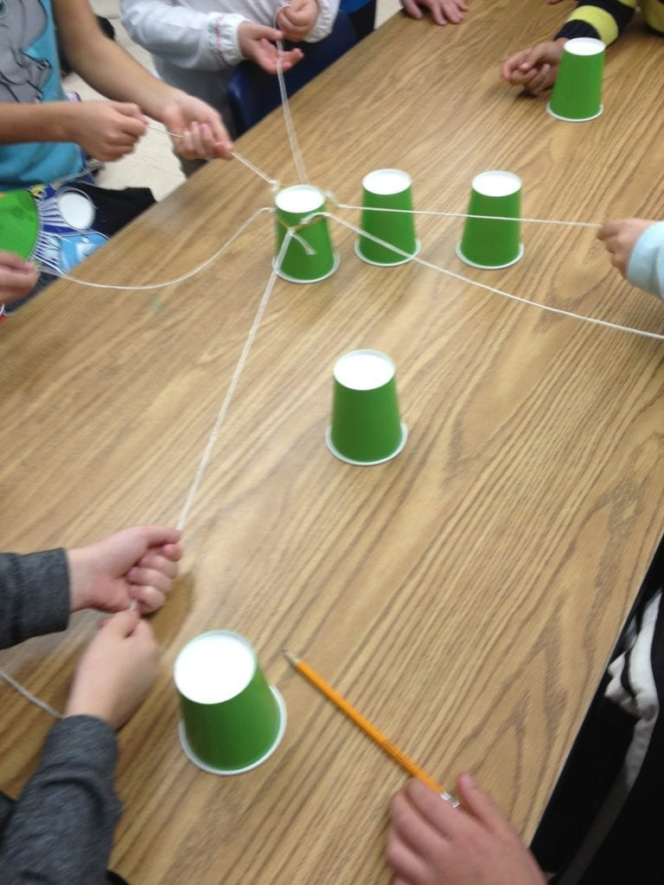
This hands-on group challenge is an exercise in patience and perseverance, not to mention a total blast!

Decide how many students you want in each group and tie that number strings to a single rubber band. Each person in the group holds on to one of the strings attached to the rubber band, and as a group, they use this device to pick up the cups (by pulling the rubber band apart and then bringing it back together over the cups) and place them on top of each other in order to build a pyramid.

Social distance adaptation:
Allow only one student per side of the table and use new string for each group.
Skills they’ll practice:
Critical-thinking and problem-solving skills, teamwork, patience.

Paper Bag Skits
You never know what life is going to hand to you. This is true at work, school, and in life in general. Sometimes you’re handed a set of circumstances and have very little time to figure out what to do. This fun activity will help teens practice thinking on their feet.
Fill a few paper bags with four or five assorted classroom or household items. Break the teens into groups, and assign each group a bag without showing them what’s inside. Give them two minutes to examine the items in their bag and come up with a skit, using all of the items, for the rest of the class.

Social distance adaptation:
Instead of putting all items in one bag, give each student their own bag with one item inside, and then assign groups.
Skills they’ll practice:
Decision-making, creativity, teamwork.

Team Survival Challenge
What would happen if your class went out on a pleasure cruise only to end up being lost at sea? Who would take charge? What materials would be essential for survival? If you ever saw an episode of the TV series Lost, you know that making these decisions as a group can get ugly fast. This activity is a great lesson in group decision-making, as students will undoubtedly have different ideas about what materials to add to a limited list in a limited amount of time.

Social distance adaptation:
This activity could actually work online in breakout groups. It will be trickier to facilitate than the in-person version, so allow extra time.
Skills they’ll practice:
Critical thinking skills, negotiation, communication, teamwork.

Time-Management Challenge
We all have days when our list of tasks is huge, and the amount of time we have to complete them just isn’t. When time is tight, and your agenda is packed, you’ve got to prioritize tasks and work efficiently! This activity gives students the opportunity to practice just that by presenting them with a long list of tasks to complete in a limited time frame.

Make a list of tasks on chart paper, assigning a point value for each job. For example: Do 25 jumping jacks (5 points); make up a nickname for each member of the group (5 points); get every person in the class to sign a piece of paper (15 points); form a conga line and conga from one end of the room to the other (5 points, 10 bonus points if anyone joins you); etc. Make sure you list enough tasks to take up more than 10 minutes.

Divide your students into groups of five or six and give them 10 minutes to collect as many points as they can by deciding which tasks to perform. A debriefing session is essential with this game. Guide your students to think about how they made decisions, which group dynamics came into play, and how they determined the value of each task.

Social distance adaptation:
Make sure activities are appropriate for social distancing.
Skills they’ll practice:
Negotiation, critical thinking, communication, time management.

Play The Career Game Show
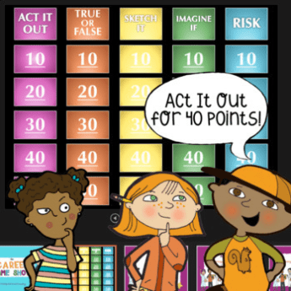
Teach your students about the different career clusters with this hands-on, experiential game. Different categories include Act it Out, True or False, Sketch it, and more. Great for small groups focused on social skills and executive functioning.

Social distance adaptation:
This game comes with in-person and virtual versions. Simply share the Google Slides file with your students and/or share your screen!
Skills they’ll practice:
Teamwork, cooperation, reflective thinking.

The Blindfold Game
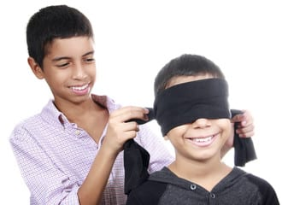
You will need a large space for this activity (maybe the cafeteria after lunch or the gym during an off-period), enough blindfolds for half of the participants, and furniture and other items that you can use as obstacles (cardboard boxes, pillows, chairs, tables). Scatter furniture and objects around the room before the activity begins. Your course should be challenging but safe to navigate.
Pair students and have them line up at one end of the room. One person from each pair should put on the blindfold. The sighted person must guide their partner across the room and give them clear oral instructions (without touching them) to help them avoid the obstacles. When each team reaches the far side of the room, partners can switch roles and repeat the exercise. Have just a few pairs tackle the course at a time so that the others can observe. Take some time between rounds to process what went well, what didn’t, and what could make the challenge easier.

Social distance adaptation:
Take this one outdoors. Have the sighted person stand a distance away. The blindfolded person will have to listen for their voice. Also, have individual blindfolds, so there’s no reuse.
Skills they’ll practice:
Communication, listening skills, respect (taking the task and their partner’s safety seriously), flexibility.

Four Card Negotiation
Sometimes to get ahead in life, you have to know how to wheel and deal. This is entirely what this lesson is all about. The objective is for teams to trade and barter for pieces of cards to match up with the pieces they already have and ultimately end up with four complete playing cards.
Start with a pile of playing cards (four cards per team of four or five students). Cut each card diagonally into four pieces and mix all of the pieces together. Now divide the mixed-up pieces evenly among the teams. Give teams a couple of minutes to sort out their card pieces and figure out which pieces they have and which pieces are missing. Set a timer for 10 minutes. The goal of the game is for the students to use their negotiation skills with the other teams in order to gain as many complete cards as possible for their team. At the end of 10 minutes, the team with the most cards wins.

Skills they’ll practice:
Negotiation, communication, interpersonal skills.

Rope Circle Shimmy

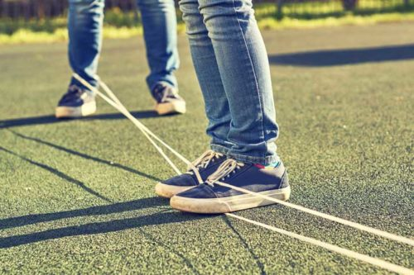
Divide the teens into two groups. Each group should have a minimum of five members. To begin play, make a big circle out of rope for each team and put it on the floor. Each member of the team stands at the edges of the circle, so the rope is taut around their ankles while holding their hands in the air.
Team members must take turns moving to work the rope up from ankles to wrists, keeping hands in the air at all times. The team member will have to wiggle and move to slide the rope up. Other team members can help by keeping the rope as taut as possible. The team that finishes the challenge first, wins!

Skills they’ll practice:
Communication, flexibility, cooperation.

