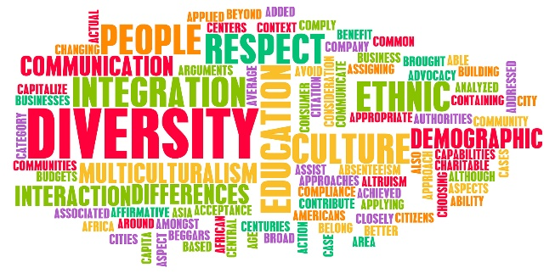

Lesson 2 - Worksheet MEMO
CULTURAL DIVERSITY

Read the following extract and answer the questions that follow:

South Africa ranks as the ninth most diverse country in the world
South Africa is one of the most diverse nations in the world with a well-documented and rich heritage.
The country is well known for its rich culture and traditions, and it is precisely this kaleidoscope (changing and enjoyable mixture or pattern) of religions and music and languages that helped coin the term the rainbow nation.
But what makes us truly South African?
[Adapted from https://www.thesouthafrican.com/lifestyle/south-africa-ranks-ninth-most-diverse-country/
Accessed on 20 September 2022]

Write paragraphs about South Africa’s diversity.

Use the following as a guideline:

- Define the concept cultural diversity in the South African context and give ONE way
how you could learn about other cultures in your neighbourhood. (1 + 1) (2)
(Lower Order)

- Explain TWO ways how your cultural norms and values may affect communication
in your relationships with classmates. (2 x 2) (4)
(Middle Order)

- Recommend TWO ways how different religions may contribute to social development
of all people and not just their own followers. (2 x 2) (4)
(Higher Order)
[10]

Marking Guideline

- Define the concept cultural diversity in the South African context and give ONE way
how you could learn about other cultures in your neighbourhood. (1 + 1) (2)
(Lower Order)
Cultural diversity: We are ONE nation, but we have many different cultures- people with different languages, social customs, religions, and values .
and
Ways how could learn about other cultures in your neighbourhood:
Talk to people from a different cultural background in your neighbourhood
Do research about the different cultures in your neighbourhood
Attend celebrations of other cultures
Spend time with other culture
Read up about the other cultures in your neighbourhood
Increase your level of understanding about other cultures by interacting with people outside of your own culture.ü
Avoid imposing values on others that may conflict or be inconsistent with other cultures. ü
When interacting with others who may not be proficient in English, recognize that their limitations in English proficiency in no way reflects their level of intellectual functioning.ü
Recognize and understand that concepts within the helping profession, such as family, gender roles, spirituality, and emotional well-being, vary significantly among cultures and influence behaviour.ü
Within the workplace, educational setting, and/or clinical setting, advocate for the use of materials that are representative of the various cultural groups within the local community and the society in general.ü
Intervene in an appropriate manner when you observe others engaging in behaviours that show cultural insensitivity, bias, or prejudice.ü
Be proactive in listening, accepting, and welcoming people and ideas that are different from your own.ü

Any ONE of the above for ONE mark

- Explain TWO ways how your cultural norms and values may affect communication
in your relationships with classmates. (2 x 2) (4)
(Middle Order)
Relationships are not based on co-operative- everybody on the same level in all cultures so conflict may occur because of misunderstandings
Values differ in different cultures which often leads to misinterpretation in decisions and actions
In the traditional communities people are forced to fit in with the values of the community, if not- they are forced to leave the relationship because of traditions
Culture can influence how we communicate verbally via the words, phrases, metaphors, and culture-specific slang between people, so people may misunderstand each other
Cultural norms and values may also help us to communicate better with our classmates and increase understanding of those around us, strengthening relationships.
Different cultural groups will have different ways of doing things, such as greetings or gestures
– this may be different from those around us and can lead to confusion.
Words may have different meanings within different cultures, and one person may use a word in a way that others do not understand or could find it offensive.

Any TWO of the above for TWO marks each (2x2) (4)
(i.e. ONE mark for statement and ONE mark for qualifier / explanation)

- Recommend TWO ways how different religions contribute to social development
of all people and not just their own followers. (2 x 2) (4)
(Higher Order)
Organisations in different religions contribute through the practice of caring for people in need to improve their lives
Churches of different religions look after the elderly so that they do not feel alone
Organizations of different religions organise fundraising activities to support the needs of people
People of different religions volunteer their time to people in providing services to people
Many religious organizations contribute to people’s educational and health needs, by running various health and education programs.
Religion helps us know ourselves and teaches us many important life lessons as well as how we treat others, thereby forming the basis for many social relationships.
Organisations in different religions have programs and initiatives that aim to help those are less fortunate or in the position to need help. By helping those around us, we are able to help our society and in turn develop communities.
Some religious organizations offer training and learnership programs which benefit the community and society. Assistance in relief efforts in the case of disasters.
Any TWO of the above for TWO marks each (2x2) (4)
(i.e. ONE mark for statement and ONE mark for qualifier / explanation)

[10]

