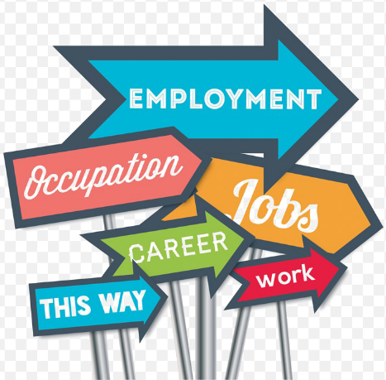
Careers and Career Choices: Grade 10 Term 4
Content Summary

The CAREER LANDSCAPE is all about what jobs are out there, which jobs are on the critical list that we need more of, and which jobs or fields of work are in the decline. The World of Work has changed in recent times, it’s not what it was 5 years ago, and very different to what was happening 10 years ago. It is what we could call dynamic – it is always changing and always evolving. It will never be something that we can consider to be fixed and completely static.

Reasons For Change:
- Shifting demographics, dynamic workforces
Trends like aging and declining birth rates mean the days of abundant labour are ending in much of the world.
- The rise of individual choice
the goal today is to be employable: to develop the skills, experience, and expertise necessary to move on or up.
- The technological revolution
As a result of rapid technological change, companies today face shorter business cycles and truly global competition.
- Client sophistication and the dawn of data
Behavioural and intelligence tests, digital performance scorecards and better human resource information systems, companies know their people better than ever.
- Global Changes
The world has faced changes that no one would have ever thought possible. The pandemic has changed the way people work around the world.

Terminology:
Scarce Skills: refer to those occupations in which there is a scarcity of qualified and experienced people, currently or anticipated in the future, either (a) because such skilled people are not available or (b) they are available but do not meet employment criteria.

Niche Markets: a small, specialized market for a particular product or service. A niche market is a small part of a larger market that has its own specific needs, which are different from the larger market in some way. For example, the market for computers is huge but there are niche markets for student computers and gaming computers, which include different types of system requirements depending on the needs of the customer.

Employable Skills: defined as the transferable skills needed by an individual to make them 'employable’.
These skills are what they believe will equip the employee to carry out their role to the best of their ability.

Soft Skills: a combination of people skills, social skills, communication skills, character or personality traits, attitudes, career attributes, social intelligence, and emotional intelligence quotients that enable employees to navigate their environment, work well with others, perform well, and achieve their goals.

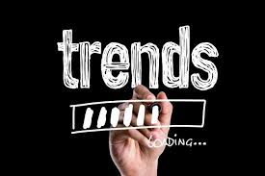
Trends in the Job Market:
In the past 18 months we have seen increasing changes and trends in the job market - Covid-19 has likely changed careers and the job search permanently. With many companies ditching offices and moving to new virtual hiring and remote work practices, the human resources department has evolved how and where they are hiring, what skills they are searching for and the way the post-pandemic workplace will operate.

Declining markets, what it means and reasons for decline:
Manual vs Machine Labour
Jobs that used to be done by people can now be done by machines thanks to the advancements of technology and engineering. Automation has led to a huge change in the workforce needed to work in some industries.
Office Environment Changes
The way we communicate has also changed – if people have some type of internet /network connection they can practically work from anywhere. A coffee shop, your home, satellite offices. Today, many people work from home entirely and don’t even need to go into the office. Board meetings are held from home, meetings take place in multiple locations using software like Zoom or Microsoft Teams.
Digitalisation
Many jobs that were once done by hand can now be done using digital equipment – designers can design entire collections using software – from clothes to advertising, book illustrations, cartoon graphics. Shopping can be done from the comfort of your home using an app.

Top 15 skills according to the World Economic Forum
The World Economic Forum has identified skills that they believe will become increasingly important by 2025.

- Analytical thinking and innovation
- Active learning and learning strategies
- Complex problem-solving
- Critical thinking and analysis
- Creativity, originality, and initiative
- Leadership and social influence
- Technological use, monitoring and control
- Technology design and programming
- Resilience, stress tolerance and flexibility
- Reasoning, problem-solving and ideation
- Emotional intelligence
- Troubleshooting and user experience
- Service orientation
- Systems analysis and evaluation
- Persuasion and negotiation

South African Qualification Authority
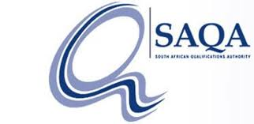
SAQA Explained:
- The South African Qualifications Authority (SAQA) is the oversight body of the NQF and the custodian of its values and quality character.
- The role of SAQA, as stipulated in the NQF Act, is to advance the objectives of the NQF, oversee the further development and implementation of the NQF, and co-ordinate the Sub-Frameworks.
- Functions of SAQA:
  - Oversee NQF implementation and collaborate with the Quality Councils
  - Develop and implement NQF policies and criteria
  - Register qualifications and part-qualifications on the NQF
  - Recognise professional bodies and register professional designations
  - Undertake research and collaborate with international counterparts
  - Maintain the National Learners’ Records Database
  - Provide an evaluation and advisory service with respect to foreign qualifications
  - Inform the public about the NQF
  - Provide advice to the Minister of Higher Education and Training

National Qualifications Framework:
- NQF Explained
  - The National Qualifications Framework records the credits given to specific study areas and gives them an NQF level. This is done to make sure that all learning done across the country, at the same level, can be recognised.
  - For instance. A grade 9 certificate has an NQF level of 1. That goes for all grade 9 certificates across the country from accredited schools.
  - NQF levels range from level 1 (grade 9) to level 10 (doctorate degree).
  - With a grade 9 certificate or NQF 1 you can start studying an N1 NATED Qualification.
  - You can build your way to an NQF 6 without ever finishing matric.
  - A degree is an NQF 7 and can go up to an NQF 10 which is a doctorate.

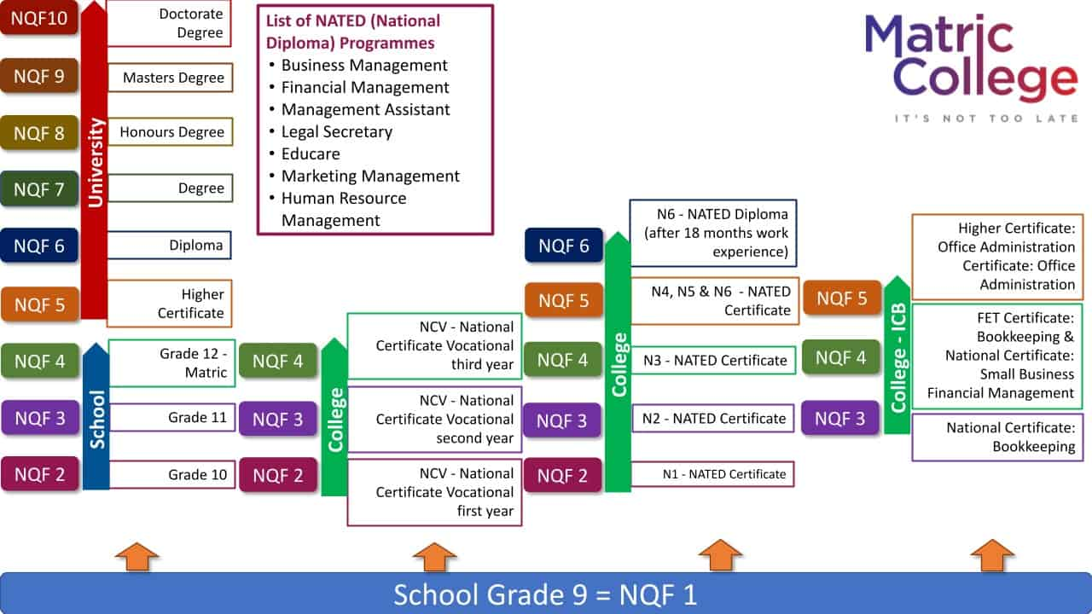

Traditional study method:
School
- NQF 1: Grade 9
- NQF 2: Grade 10
- NQF 3: Grade 11
- NQF 4: Grade 12

University/College
- NQF 5: Higher Certificate
- NQF 6: Diploma
- NQF 7: Degree
- NQF 8: Honours Degree
- NQF 9: Master’s Degree
- NQF 10: Doctorate Degree
Alternative study methods:
Not going through the traditional schooling methods, the NQF levels are as follows:
NCV Programmes:
- NQF 2: National Certificate Vocational first year
- NQF 3: National Certificate Vocational second year
- NQF 4: National Certificate Vocational third year
National Qualification (NATED) Courses
RPL: Recognition of Prior Learning
Recognition of Prior Learning (RPL) is a process whereby non-formal learning and informal learning are measured, mediated for recognition across different contexts, and certified against the requirements for credit, access, inclusion or advancement in the formal education and training system, or workplace.
What Does Recognition of Prior Learning Mean?
In your lifetime you have obtained certain skills, qualifications, knowledge, and experiences. These learning experiences could have been officially obtained via a college, university, or any other accredited education body. You could have also gained this knowledge while at the workplace, doing short courses or compulsory training. Irrespective of where this learning took place, you can use the skills and qualifications you already have to gain credits within formal qualifications offered by various colleges and universities.
Recognition of Prior Learning provides an opportunity for you to identify your learning, have it assessed and formally acknowledged in the form of a qualification.

How Does it Work?
- The process is simple and straightforward – your skills will be assessed on the skills or knowledge you have, regardless of where and how it was learned. Unlike other forms of assessment, it doesn’t judge someone’s evidence of competence solely by the credentials or qualifications they have achieved, although this can form part of their claim. What RPL does is allow people to demonstrate that they can undertake specific tasks or working in certain industries based on evidence of skills and knowledge gained throughout their life. Anyone can apply for recognition of prior learning and this is usually used for:
  - personal development and/or certification of current skills without progression into a learning programme, if the candidate so chooses.
  - progression into a learning programme, using RPL to fast-track progression through the learning programme.
  - promotion
  - career or job change
- Recognition of prior learning can be greatly beneficial and really fast-track your progress in a learning programme. However, it is IMPORTANT TO NOTE: RPL is not automatically guaranteed.

LIFELONG LEARNING
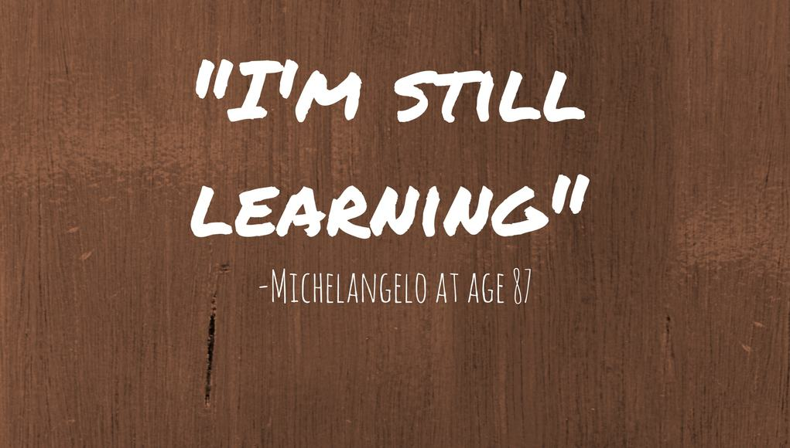
- A traditional definition of lifelong learning is “all learning activity undertaken throughout life, with the aim of improving knowledge, skills and competences within a personal, civic, social and/or employment-related perspective” (European Commission [EC], 2001, p. 9).
- Lifelong learners are motivated to learn and develop because they want to - it is a deliberate and voluntary act. Lifelong learning can enhance our understanding of the world around us, provide us with more and better opportunities and improve our quality of life.
- There are various ways in which professionals can enhance their learning - which includes learning from other people, listening to learn and actively realising their potential. These can be used as a starting point for any professional who wants to achieve personal and/or professional development.

Is it that important?
There are two main reasons why professionals are encouraged to learn throughout life:
- The first benefit of practising lifelong learning as a professional - is for personal development whereby you seek to realise your full potential as an individual. This is done through increasing your knowledge or skills around an area that you enjoy or perhaps you want to develop a skill that will in some way enhance your life. All this is done so you can attain meaning in your life.
- Secondly, lifelong learning is applied in one's life for professional development - whereby one develops a vision of where one wants to see oneself and determines the qualities needed to get there. Therefore, employers of today look for people with transferable skills as they give an indication of one's zeal to learn and develop.
Technical skills become outdated as fast as we obtain them especially with the rapid change in technology these days. This makes lifelong learning more important than ever! It has become vital to stay committed to lifelong learning habits. The overall habits of lifelong learning encompass the following three principles:
- PROFESSIONALS MUST STAY UP TO DATE
Creating a habit of reading and understanding what's going on in the world around you will keep any professional abreast with what is happening and possible gaps within different markets. Various mediums such as newspapers, online sources or social networks for example can help you start this process. This will assist you to open your worldview and gain global understanding of how world events impact our lives and therefore anticipate trends.
- PROFESSIONALS MUST DEVELOP CAREER GOALS AND STRATEGY
It is imperative for professionals to understand their lifelong learning career goals which are guided by their personal development needs.
Even if it means going back to high school and doing your matric at the age of 60, that is also part of lifelong learning.
- PROFESSIONALS MUST BE IN TOUCH WITH WHAT IS HAPPENING IN THEIR ENVIRONMENTS
Information is available all around us; we must keep our eyes and ears open. The contexts people exist in contain various opportunities for learning. These contexts have various information sources, problems that need to be solved, opportunities to connect with the environment itself and practice what has been learned.

Examples of Lifelong Learning
- Developing a new skill (e.g. sewing, cooking, programming, public speaking, etc.)
- Self-taught study (e.g. learning a new language, researching a topic of interest, subscribing to a podcast, etc.)
- Learning a new sport or activity (e.g. joining martial arts, learning to cycle, learning to exercise, etc.)
- Learning to use a new technology (smart devices, new software applications, etc.)
- Acquiring new knowledge (taking a self-interest course via online education or a classroom-based course)

Benefits of Lifelong Learning
- Renewed self-motivation: figuring out what inspires you puts you back in the driver’s seat and is a reminder that you can really do things in life that you want to do.
- Recognition of personal interests and goals: can even open future opportunities. You never know where your interests will lead you if you focus on them.
- Improvement in other personal and professional skills: While we’re busy learning a new skill or acquiring new knowledge, we’re also building other valuable skills that can help us in our personal and professional lives.

Ongoing Development of Ourselves:
- Knowledge can be acquired and skill sets developed anywhere – learning happens all the time and all around us.
- Lifelong learning is about creating and maintaining a positive attitude to learning both for personal and professional development.
- Lifelong learners are motivated to learn and develop because they want to: it is a deliberate and voluntary act.
- Lifelong learning can enhance our understanding of the world around us, provide us with more and better opportunities and improve our quality of life.
- There are two main reasons for learning throughout life: for personal development and for professional development. These reasons may not necessarily be distinct as personal development can improve your employment opportunities and professional development can enable personal growth.

Flexibility and Retraining:
- Flexibility: means that young people can adapt their learning pathway as they go along, to suit their interests and abilities.
- Retraining: is when people refresh, revisit, and develop their skills through continuous learning, training programmes, and courses.

Different Types of Learning:
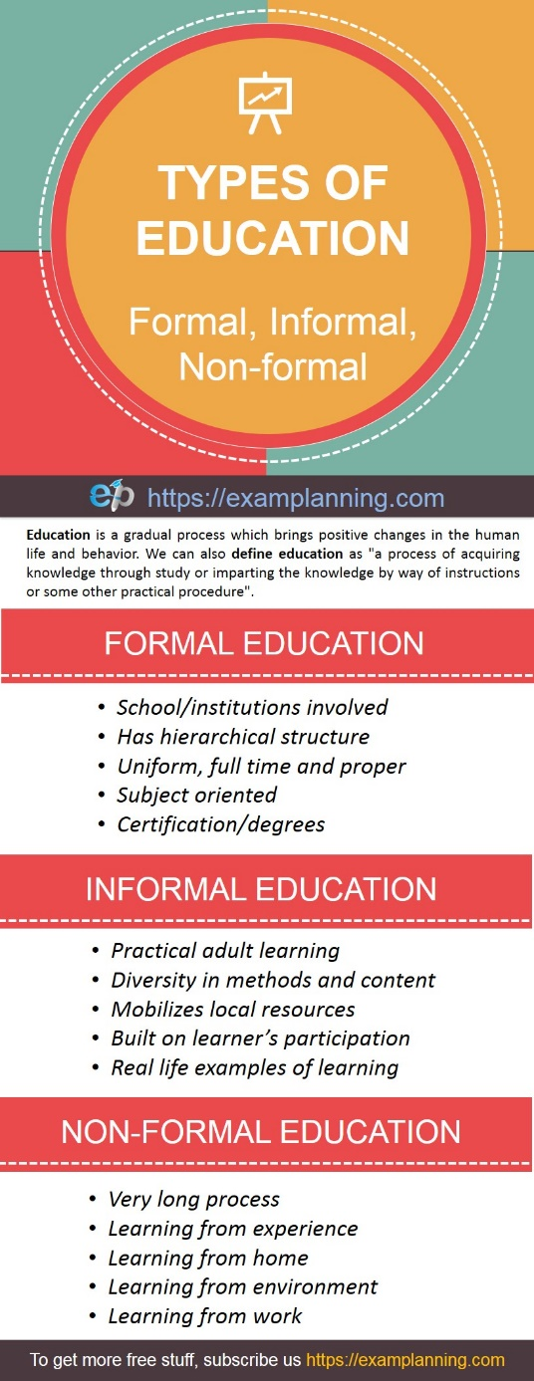
By engaging in Lifelong Learning, you can keep up with career changes and allow for ongoing Self Development.
Education goes beyond what takes places within the four walls of the classroom. We learn from experiences outside the school as well as from those within. There are three main types of education, namely, Formal, Informal and Non-formal.

- Formal learning usually takes place in the premises of the school, where a person may learn basic, academic, or trade skills. Small children often attend a nursery or pre-primary school, but often formal education begins in elementary school and continues with secondary school
- Informal learning is when you are not studying in a school and do not use one single learning method. In this type of education, conscious efforts are not involved. It is neither pre-planned nor deliberate. It may be learned in some marketplace area or at home.
- Non-formal education includes adult basic education, adult literacy education or school equivalency preparation. In
non-formal education, someone (who is not in school) can learn literacy, other basic skills, or job skills.

