Lesson 3 – Worksheet MEMO



Activity 1: Summary & Peer Evaluation
There are no memo answers to these questions
Learners will each have a personal response to this activity.

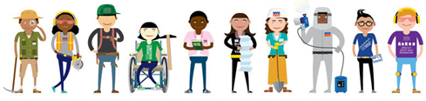

Activity 2: End of Topic Reflection
There are no memo answers to these questions
Learners will each have a personal response to this activity.

Activity 3: Informal Assessment

Question 1:
Study the following cartoon and answer the questions that follow.

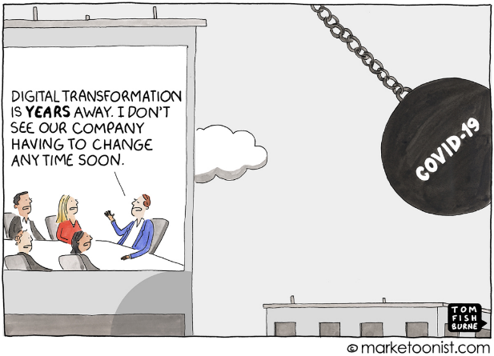

[Accessed from: https://marketoonist.com on 05 October 2020]

  - State THREE ways that the nationwide lockdown negatively affected business productivity. (3x1) (3)

Any THREE of the below or any relevant answers for ONE mark each
- Businesses had to close
- Businesses that were open could not get supplies
- Clients were not open to make orders
- Many people lost their jobs and so were unable to buy certain goods or services.

  - Discuss FOUR reasons why employees with high technological skills were more likely to succeed during the nationwide lockdown. (4x2) (8)

Any FOUR of the below or any relevant answers for TWO marks each
(i.e. ONE mark for statement and ONE mark for qualifier / explanation)

- Companies needed to function from home using technology. This meant that those with technological competency were able to start working productively straight away instead of having to learn technological functions first.
- These people were able to perform well in online meetings which could allow them to demonstrate their skills and impress their bosses in ways that they would not have been able to do before the lockdown
- They would be less frustrated as they did not have to struggle to figure out the technology. This could create a more efficient employee who has the confidence to ensure that they do well.
- They were able to use social media tools effectively to gain more clients for themselves and their company.
- They would increase their value within the company, where their skills may not have been used/ stood out previously, by suggesting easier ways to use platforms.

  - Suggest THREE ways that someone can upskill themselves to increase their technological skills. In your answer, also indicate how EACH suggestion can lead to a more competent employee.
(3x3) (9)

Any THREE of the below or any relevant answers for THREE marks each
(i.e. ONE mark for statement, ONE mark for qualifier / explanation, ONE mark for outcome)

- They could take part in online courses to broaden their knowledge of the different uses of the technology. They could use this new technological knowledge to make their admin work easier and more efficient.
- They could ask a friend to help them understand certain problems. This would mean that they are less likely to respond negatively to a technological problem as they already know how to fix it. /or/ they are less likely to encounter problems as they will proactively avoid them.
- They could Google or YouTube certain concerns to help them stay informed about the latest fixes to common problems. This would ensure such problems do not impact their work productivity and makes them popular/helpful with other colleagues.
- They could practice their skills afterhours to boost their confidence and comfortability. This would make them seem more professional to clients or their boss.

[20]

Question 2:
Study the following infographic and answer the questions that follow.

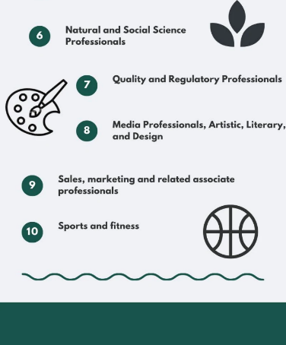
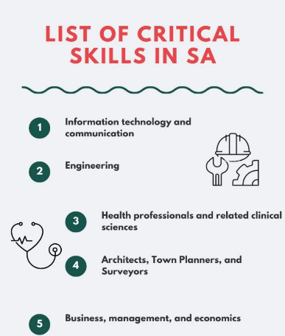

[Accessed from: https://briefly.co.za on 25 September 2020]

2.1 Define the term ‘scarce skills’ and provide TWO reasons why high school learners need to be aware of scarce skills in the country. (1+2) (3)

Scarce Skills: A demand for skilled people to fill particular roles / professions or occupations
in the labour market.
Any TWO of the below or any relevant answers for ONE mark each
- They can take this into account when choosing their careers.
- This could affect their subject choices
- They could decide to take extra courses or volunteer work that include these skills to
increase future employability.
- They could see if the career that they have already chosen is going to be oversaturated
or obsolete when they start work.

2.2 Discuss FOUR ways that Covid-19 could have influenced the scarce skills list. (4x2) (8)
Any FOUR of the below or any relevant answers for TWO marks each
(i.e. ONE mark for statement and ONE mark for qualifier / explanation)

- Covid-19 has changed the way we conduct business which has now called for businesses to relook at skills that they previously prioritised.
- Lockdown allowed many people to take online courses which could mean that many people are now proficient in what was once a scarce skill.
- Technology/ technological skills are now even more sought after than before as technology allows for less contact in the workspace.
- Jobs that were important during lockdown may no longer be able to acquire funding /or/ companies may have shut down which means that there are fewer occupations that require some of these skills.
- Healthcare skills are in higher demand to battle against the pandemic and the increased number of cases.
- Many people moved to less expensive areas/ safer areas which could lead to a skills shortage in a certain area.

2.3 Suggest THREE possible ways that life-long learning can make an employee more employable. In your answer, also indicate how EACH strategy will help workers to be more adaptable employees.
(3x3) (9)

Any THREE of the below or any relevant answers for THREE marks each
(i.e. ONE mark for statement, ONE mark for qualifier / explanation, ONE mark for outcome)

- They could attend online courses when they get home from work which specifically target the skills that are now in demand. This means that they will be better able to meet the changing demands of the Covid-19 world.
- They could ask their employers for the opportunity to study through the company to fill certain vacancies within the company. This will show the company that they are willing to work to adapt to the needs of the company.
- They could apply for a promotion/ position within their company which exposes them to a different skill set that they could learn on the job. This will allow them to develop the necessary experience that they could apply to other areas in the workplace.
- They could ask colleagues with the skill that they want to become their mentors and teach them what they know. This will allow them to get useful tips and tricks that they could apply when they use these skills in their work.

[20]

