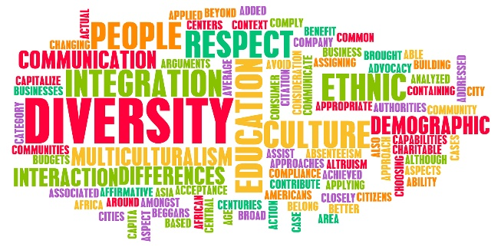

Lesson 2 - Worksheet
CULTURAL DIVERSITY

Read the following extract and answer the questions that follow:

South Africa ranks as the ninth most diverse country in the world
South Africa is one of the most diverse nations in the world with a well-documented and rich heritage.
The country is well known for its rich culture and traditions, and it is precisely this kaleidoscope (changing and enjoyable mixture or pattern) of religions and music and languages that helped coin the term the rainbow nation.
But what makes us truly South African?
[Adapted from https://www.thesouthafrican.com/lifestyle/south-africa-ranks-ninth-most-diverse-country/
Accessed on 20 September 2022]

Write paragraphs about South Africa’s diversity.

Use the following as a guideline:

- Define the concept cultural diversity in the South African context and give ONE way
how you could learn about other cultures in your neighbourhood. (1 + 1) (2)
(Lower Order)

- Explain TWO ways how your cultural norms and values may affect communication
in your relationships with classmates (2 x 2) (4)
(Middle Order)

- Recommend TWO ways how different religions may contribute to social development
of all people and not just their own followers. (2 x 2) (4)
(Higher Order)
[10]

