Lesson 3 – Worksheet


Activity 1: Group Activity

Living with HIV

Read the article below and using it and what you have learnt to complete the activity with your group.

What is it like to live with HIV?
The last few decades have seen dramatic improvements in HIV treatments and the public’s understanding of the condition. Many people with HIV have lives that are not so different from those of people without the virus.
As long as they follow their treatment plans, most people with HIV can enjoy full social and professional lives. In fact, those who receive an early diagnosis and effective treatment can expect to live almost as long as individuals who have not contracted the virus.
In addition to taking medication, people living with HIV need to commit to regular check-ups with a health professional. Maintaining a balanced lifestyle and seeking treatment for other medical issues can help those with the condition stay healthy.
When a person discovers they have HIV, they tend to experience a range of feelings, from fear and anger to denial. It is important to understand that this reaction is typical. Research has shown that individuals living with HIV and those at risk of contracting HIV are more likely to have mental health conditions.
It is essential for people to understand there is life after an HIV diagnosis. As worrying as it may seem at first, there are steps individuals can take to manage the condition and improve their health.
Step 1: Seek medical care: accessing affordable healthcare is essential to the health and well-being of a person living with HIV.

Step 2: Start HIV medications: everyone living with HIV should start as soon as possible. This medication lowers the amount of HIV in a person’s body, helps them to stay healthy, and reduces the risk of transmitting HIV to another person.

Step 3: Find support: receiving support is one of the most important things a person can do after an HIV diagnosis. Whether that support comes from friends, family, or an organization, connecting with people who care can help a person feel less alone.

Step 4: Learn about HIV and AIDS: people should educate themselves about HIV and AIDS. The more they know, the better equipped they will be to manage their condition and remain healthy.

Step 5: Understand how to avoid transmission: people who faithfully follow an ART regimen are able to lower their viral load or the levels of HIV in their bodies. Over time, these levels can drop so low as to become undetectable.

Following a treatment plan and attending medical appointments are essential for someone living with HIV. Those who manage their condition properly can expect a high quality of life.

[Adapted from: https://www.medicalnewstoday.com/articles/323981#healthy-lifestyle
Accessed on 18 May 2023]

Complete the below table:

How to help someone who is sick: | Guidelines for carers:

Activity 2: Terminology Crossword

Use the clues below complete the crossword.
ACROSS:
1. virus is the virus that causes ______ infection.
4. negative feelings or thoughts about something (or an illness) that may not be true.
6. develop into something different and become something different.
8. using a condom / protective barriers during sexual intercourse.
9. the use of HIV medicines to treat HIV infection.
10. cells in the body that fight infection.
12. a preparation used to stimulate the immune system to fight infection.

DOWN:
2. the most advanced stage of HIV infection.
3. avoiding sexual contact or not doing something altogether.
5. the body’s natural defence against infection.
7. spread something from one person to another.
11. can be passed from one person to another.
13. disease caused by the new coronavirus that was first identified in December 2019.

 |  |  |  |  | 8
12 | 2 |  |  |  |  |  |  |  |  |  | 11
1 |  |  |  |  |  |  |  |  | 7
 | 4 |  | 5 |  |  | 3 |  |  | 9
13
 |  |  |  |  | 10
 |  |  | 6

Activity 3: Informal Assessment

Question 1
Study the image below and answer the questions that follow.

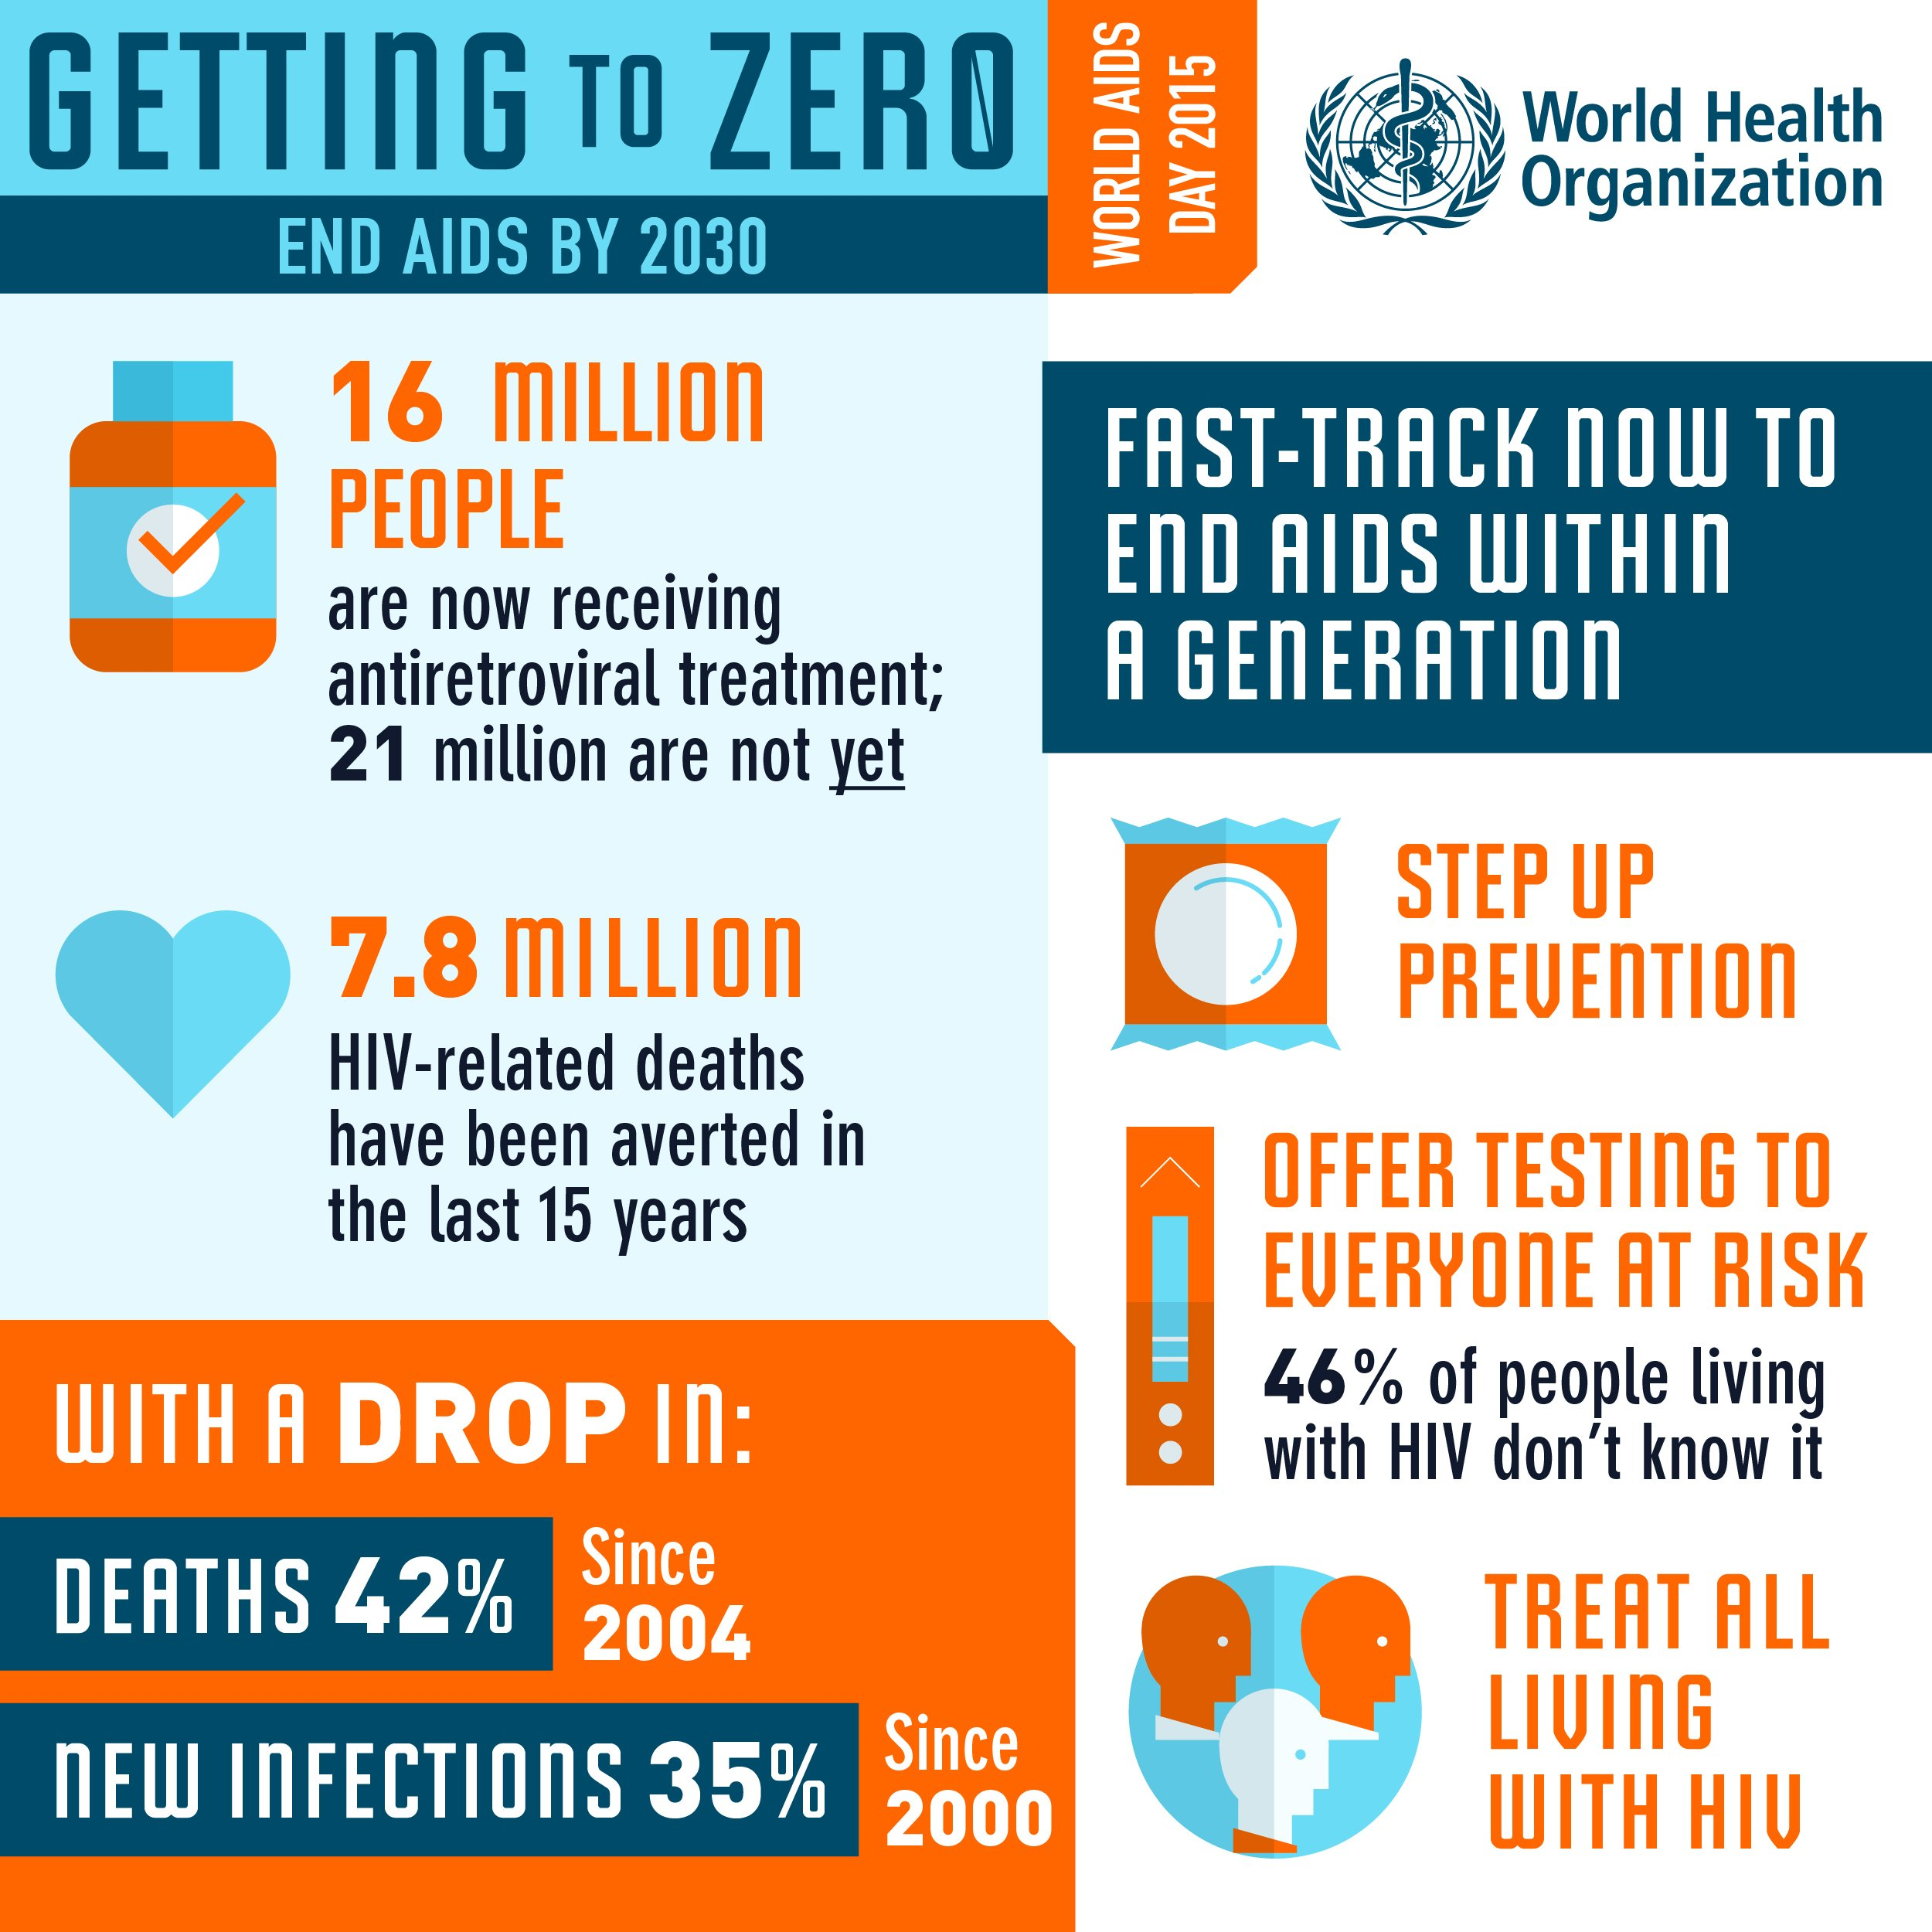
[Taken from https://www.who.int/images/default-source/wpro/campaigns/world-aids-day/infographic1-large.jpg?sfvrsn=f60317c4_5
Accessed on 01 September 2022]

1.1 Define the term “ARV” and provide TWO purposes of ARVs. (1+2) (3)

1.2 Explain why people living with HIV might struggle with mental illnesses. (1x2) (2)

1.3 Discuss TWO reasons why World Aids Day is observed. (2x2) (4)

1.4 Describe TWO ways that friends and family members can care for and support people
living with HIV. (2x2) (4)

1.5 Recommend ONE possible strategy to decrease the chances of contracting HIV. (1x2) (2)

(15)

Question 2

Read the extract below and answer the questions that follow.

COVID-19 in SA: Western Cape prepares for third wave
CAPE TOWN - As the Western Cape begins to exit its COVID-19 second wave, preparations are already in place for a third wave.
Health authorities are concerned about people’s behaviour now that restrictions have been eased and also with gatherings looming during the Easter weekend. These are some of the factors that could influence the third wave hitting sooner and harder.
The Western Cape is not taking any chances and is gearing up for a third wave. Health authorities are using this time to stock up on supplies like PPE and improve on experiences from the previous wave.
Authorities are not able to say exactly when the third wave will hit.
[Adapted from https://www.enca.com/news/covid-19-sa-western-cape-prepares-third-wave
Accessed March, 4, 2021]

Write paragraphs using the following as a guideline:

- Explain the difference between “asymptomatic” and “symptomatic”. (2x1) (2)

- Examine TWO ways how a COVID-19 positive patient can ensure that they do not
spread the virus. (2x2) (4)

- Determine TWO ways how communities can show care and support to people
living with sicknesses like COVID-19 (or HIV/AIDS) to manage their sickness. (2x2) (4)

(10)

