Lesson 2 – Worksheet MEMO


Activity 1:

Using the information provided in the below article and Table 1, answer the questions that follow regarding different work settings.

Jobs for people who love being outdoors
Some people can’t imagine working inside all day. For them, there’s good news: they may be able to join the thousands of workers who call the outdoors their office.
Outdoor careers often don’t fit a mold. Some workers spend their time in a single location, unloading cargo or constructing homes. Others may be on the move all day, delivering the mail or walking through nature preserves to catalogue plants.
Although working in the open air may offer upsides, it’s not all sunshine and blue skies. Keep reading to learn why—and to learn more about some of the possibilities for careers outside.

DID YOU KNOW: according to the U.S. Bureau of Labour Statistics (BLS), nearly half of all jobs required outdoor work in 2016. For the purposes of this article, an outdoor career is one in which at least some workers spend a large part of their workday doing tasks outside.
Industry sectors with opportunities for employment outdoors include:
- Agriculture, forestry, fishing, and hunting
- Construction
- Leisure and hospitality
- Mining, quarrying, and oil and gas extraction
- Transportation and warehousing
- Utilities
Not all workers in these industry sectors are outdoors, of course, but at least some of them are. Even people who work primarily outdoors, however, may spend at least part of their time indoors.
‌There is a good growth projection in many of the industry sectors with opportunities for employment outdoors. The leisure and hospitality sector—which includes golf courses, nature parks, and recreational camps—is projected to add the most new jobs over the 2014–24 decade.
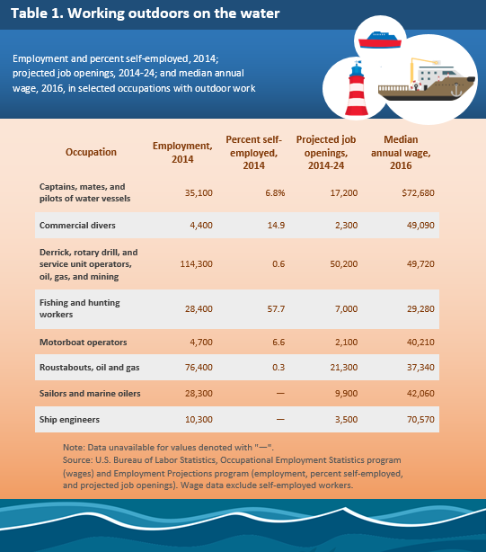
Workers may not need formal education to enter some of these occupations. Oil and gas roustabouts, for example, usually learn the skills they need on the job. In other occupations, such as commercial divers, workers typically need a certificate or other postsecondary non-degree award. Work experience in a related occupation also may be important. Ship officers, for example, might need to have first worked as a sailor before qualifying for the higher level position. Even in sectors that are projected to have employment declines—such as agriculture, forestry, fishing, and hunting—job openings are expected to arise from the need to replace workers who retire or leave their occupations for other reasons.
[Adapted from: https://www.bls.gov/careeroutlook/2017/article/outdoor-careers.htm Accessed on 1 June 2023]
- List some of the possible benefits of working in a job outdoors on the water?

- Make a list of cons or negatives of working in this setting.

- Match each of the jobs in Table 1 with one of the Industry Sectors described in the article.

- Analyze the job growth prospects in this outdoor job setting between 2014 -2024.

- Discuss other working conditions that may affect someone working in this environment.

- What kinds of qualifications or certification, skills and training are required for jobs outdoors on the water?

Learners will give personalized responses to this activity.

Activity 2:

Your teacher will give your group one of the job advertisements from www.indeed.com, an employment website that offers career help and where local jobs are advertised.
You are going to read your groups’ job advertisement and answer the following questions:
- Which of the following activities best describes the job that you are looking
at: Assembling, Designing or Growing? (1x1) (1)

Advert 1 – Sappi (assembling) ✔
Advert 2 - Farming Irrigation Assistant (growing/designing) ✔
Advert 3 – Senior Beef and Crop Farm Manager (growing) ✔
Advert 4 – Superbalist Digital Pattern Maker (designing) ✔

- Which Economic sector and Industry sector does the job represent? (2x1) (2)

Advert 1 – Sappi Secondary✔ and Forestry✔
Advert 2 - Farming Irrigation Assistant Primary✔ and Agriculture✔
Advert 3 – Senior Beef and Crop Farm Manager Primary✔ and Agriculture✔
Advert 4 – Superbalist Digital Pattern Maker Secondary ✔and Textile production✔

- Explain which TWO school subjects would be useful to a learner wishing to
fill this position one day? (2x2) (4)

Any TWO of the below or any relevant answer for TWO marks each
(i.e. ONE mark for statement and ONE mark for qualifier / explanation)

Advert 1 – Sappi
- EGD - Must be very mechanically-minded
- Must be able to take exact measurements and work accurately
- Mathematics - Must be mathematically-minded
- Be able to read three-dimensional drawings
Advert 2 - Farming Irrigation Assistant
- Agricultural subjects
- Agricultural management science and agricultural technology – to help with the basics of growing plant maintenance and irrigations systems
- Life Science/Geography – interested in plant life, ecology, sustainability
Advert 3 – Senior Beef and Crop Farm Manager
- Agricultural management science and agricultural technology – to help with the basics of growing plant maintenance and irrigations systems
- Physical Science/ Life Science – for the animal and crop growing
- Technical subjects – mechanically minded.
- Accounting
- Entrepreneurship
- Introduction to Business – these will help you to be a farm manager.
Advert 4 – Superbalist Digital Pattern Maker
- Maths Literacy – position needs you to have basic mathematical skills like geometry
- CAT – use of many computer programmes for pattern making.
- Consumer Studies - you are taught to be responsible and informed consumers of food, clothing, housing, furnishings and household equipment. This provides a solid base in both the fashion industry as well as the construction of fashion itself.
- Visual Art - the option of manual sketches, knowledge of colours, lines, contrast, perspective and insight into the history of art can only improve your fashion design chances.
- Pick ONE of the key competencies in the job advert. Analyse how this key
competency requirement will help the successful applicant with their daily
activities. (1x4) (4)

Any ONE or any relevant answer for FOUR marks
(i.e. ONE mark for the key competency chosen and the statement of how it will help with daily activities, ONE mark for elaboration, ONE mark for qualifier, ONE mark for outcome)
E.g.:
At Superbalist (Advert 4) the successful candidate must have the ability to interpret a design concept and put it on cardboard. ✔ Being a pattern maker requires the ability to visualise and interpret a concept that is discussed in a design setting and translate that onto cardboard in the form of a pattern✔. This skill is essential as you will work with a designer’s detailed brief✔ and ultimately create and construct a pattern.✔

- Recommend TWO hobbies or activities to a Grade 10 learner wishing to
develop the skills and competencies required for this job in their future. (2x2) (4)

Any TWO relevant answers for TWO marks each
(i.e. ONE mark for hobby or activity and ONE mark for qualifier / explanation)

E.g.
- Interest in sewing and designing garments✔ – this will allow you to understand and know about an array of fabrics and how they shrink and stretch. ✔ - part of the job at Superbalist Digital Pattern Maker (Advert 4)
- Interest in working on machines and with mechanical systems – perhaps you fix broken equipment, or learn how engines work, refurbish old parts✔ this interest in mechanical equipment will help you to understand maintenance and modification of mechanical equipment ✔– part of the job at SAPPI (Advert 1)

[15]
Activity 3: Self-reflection
Take a few moments to think and reflect on your own skills and interests.
- What activities do you like doing?

- Do you have any natural aptitude or competencies that you think you could pursue in your job one day?

- Did any of the jobs or work environments covered in our lesson today stick out for you?
- Write down ONE area of the world of work or a job/career that you would like to research further after our lesson today.

Learners will give personalized responses to this activity.

