Lesson 1 - Worksheet

Activity 1: SELF EXPLORATION & DISCOVERY:
Who Am I?
The purpose of this activity is to help you reflect on what’s important to you, which is the first step to understanding what to look for in a job or career. Reflect on the following and fill in the boxes.

Experiences What’s Important to Me

List activities, clubs, hobbies, interests, Mark / circle which of the below values are

job shadows, leadership positions, part-time jobs, important to you in relation to what you

volunteer work, etc: would like to achieve one day:
- Achievement
- Building Relationships
- Challenge
- Collaboration/
- Teamwork
- Compensation/Salary
- Creativity
- Cultural Diversity
- Helping Others/Society
- Independence
- Job Security
- Leadership
- Leisure
- Prestige
- Recognition
- Self-Expression
- Support
- Utilizing Skills
- Variety
- Working Inside
- Working Outdoors

Example  Soccer | Team Captain | 2023

My top FIVE strengths, skills, interests, favourite classes, or subjects:

What I could do with my interests and abilities and the things that interest me:

What I’d like to improve on and learn more about:

Activity 2: MY SKILLS AND ABILITIES
Who Am I?

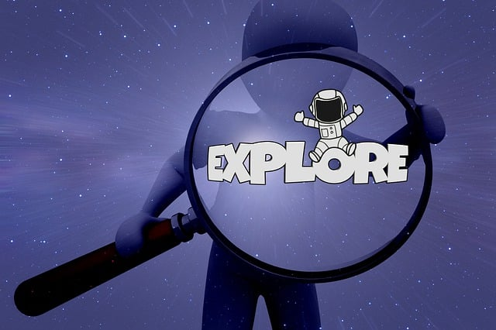
SKILLS & ABILITIES ASSESSMENT: all jobs require different skills and abilities. You might not have all the skills or abilities necessary for some occupations, but you do have an aptitude to learn new skills. Aptitudes measure the ease with which you can learn something new.
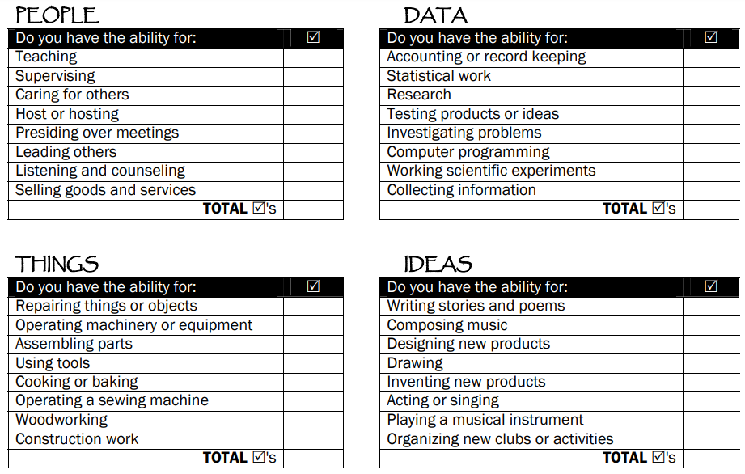
Instructions: In each section below, place a check mark next to the skill(s) you have now. Then go back and place a check mark next to the skills you might not have yet but feel you could learn with a little work. Total the checks in each section then, at the bottom of the page, circle the area where you had the most skills and aptitude.

My highest SKILLS & ABILITIES section currently is: ________________________________
What comes to mind when you think of your skills?
What can you do with your skills that is unique to you?

PERSONALITY & TEMPERAMENT
Your personality is a combination of emotional and behavioural characteristics that make you different from others. How you think, feel and act with different people and in different situations is influenced by your personality or temperament. Different careers appeal to people, partially based on their personality traits.
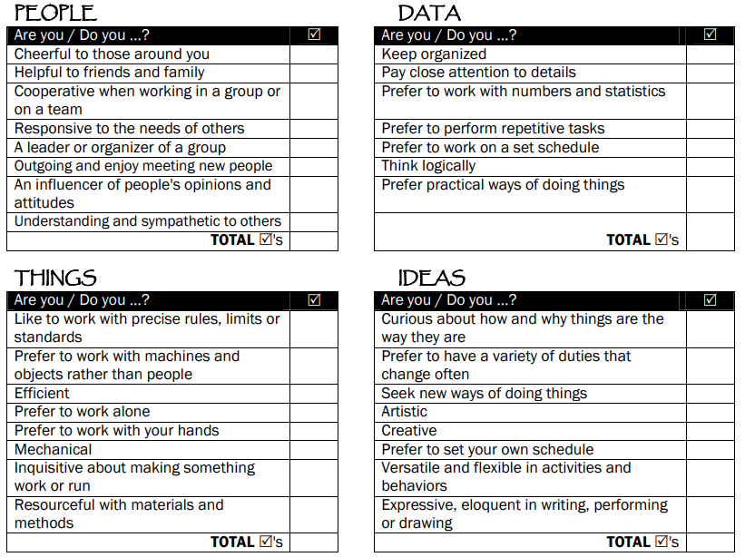
Instructions: Think about your temperament when you answer the following questions. In which situations would you prefer the major part of your working day to involved?

My highest PERSONALITY & TEMPERAMENT section currently is: ____________________________
Do your surveys match? Are they similar or very different?
What do you think of your choices from the first part of the assessment? Do they still apply?

