


Lesson 6 – Worksheet MEMO

Activity 1:
Look at the positive coping strategies below and answer the questions that follow.
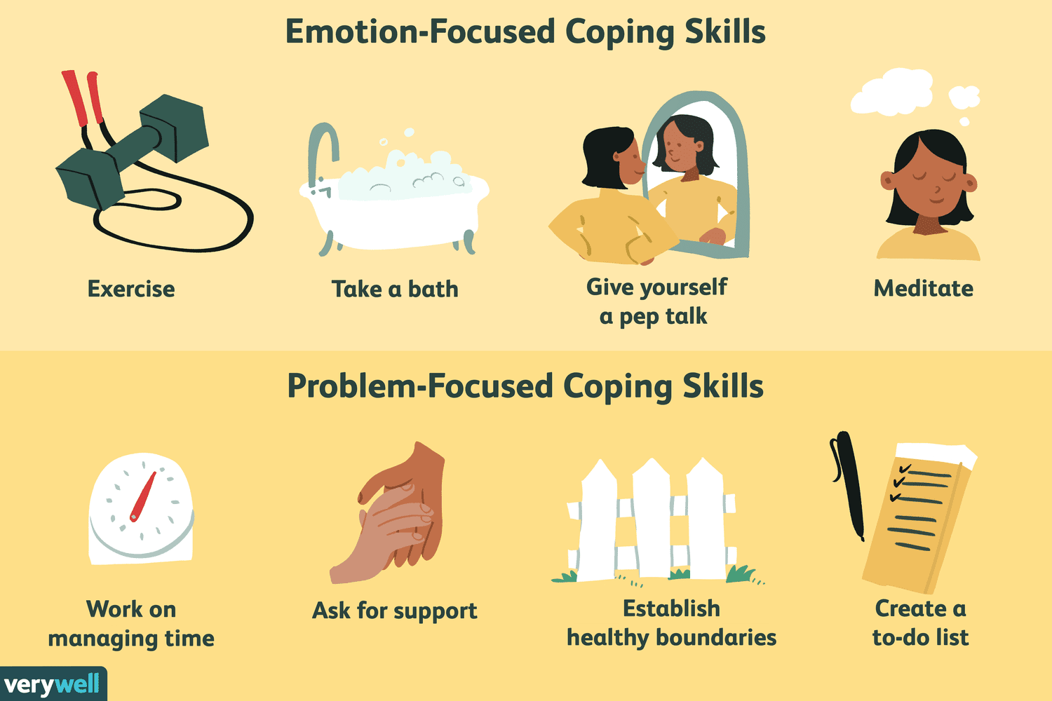

- Identify TWO negative coping strategies you have when you feel overwhelmed or stressed.
- Escapism by playing games
- Eating food
- Sleeping
- Avoidance by doing something else I like.

- Give TWO effects of the benefits of positive coping strategies on your mental health.
E.g.
- Exercise will help focus my mind and help my body handle the stress of making a tough decision on preparing for a test.
- Creating a to-do list would turn an impossible task into smaller bite size, manageable tasks.

- Provide TWO strategies you could apply to improve your time management and describe the long-term benefits it would have on your well-being.
- I could keep a diary and use it to write in when my assignments are due so that I can plan in advance. That way I will become a person that knows how to handle stressful situations by not procrastinating and prioritising what task to deal with next.
- I could use a shared calendar with my family so that they could help me by keeping me accountable to what I need to do. This will also improve my communication in the long run with my family.

Activity 2: Reflection

In the last six weeks we have covered a lot of new content that forms the foundation that
Grade 11 and 12 theory will build on. It is important that you understand and can apply solutions. Using the prompts in the table below, reflect on how well you understood the content covered over the last SIX lessons.
Rate your understanding by choosing:
1 - I still don’t understand
2 - I still have some questions
3 - I feel confident and I understand

1. | Reflection Questions | Answer 1 or 2 or 3
1.1 | I understand the impact being sexually active could have on my different roles.
1.2 | I could explain to my younger sister why she would start her period and what is happening in her body.
1.3 | I have a healthy respect for others and would never manipulate my girlfriend/ boyfriend to kiss me.
1.4 | I understand the dangers of alcohol abuse on my mental reasoning.
1.5 | I am able to communicate my responses to decisions about traveling with a friend who has been drinking.
1.6 | I can identify the negative coping strategies I have when trying to avoid studying.
1.7 | I know how to change my negative coping strategies to positive coping strategies.

As we draw to a close this series of lessons, in the last lesson (Lesson 7) you will need to have an understanding of the content we have covered so far.
If there are any sections you responded to with a “1” (in the table), go and revise the content before the next lesson.
Learners will give personalized responses to this activity.

