

Lesson 4 – Worksheet MEMO

Activity 1:

Read the following stories from rape survivors before answering:

Mvuleni Fana was walking down a quiet alleyway in Springs – 30 miles east of Johannesburg – on her way home from football practice one evening when four men surrounded her and dragged her back to the football stadium. She recognised her attackers. One by one, the men raped her, beating her unconscious and leaving her for dead.
----------------------------------------------------
Joana Smit said, "I very clearly remember attending a friend’s birthday party in Bloemfontein. Towards the end of the party, I went to change out of my swimsuit when this group of four teenage boys came in and forced themselves on me.

"I remember the door opening as soon as I took my bikini top off, I remember feeling embarrassed, thinking those boys entered the room by mistake. I felt sick to my stomach,” an emotional Smit said. The realisation of what was about to happen became apparent when one of the boys put his hand over her mouth and told her to ‘keep quiet’. "I can still smell the scent of his Brut deodorant even today,” Smit said. Her perpetrators were known to her, as they attended the
same school and church as she did.
[Adapted from: https://www.independent.co.uk/news/world/africa/crisis-in-south-africa-the-shocking-practice-of-corrective-rape-aimed-at-curing-lesbians-9033224.html , Accessed on 2 June 2023]
[Adapted from: https://www.news24.com/news24/southafrica/news/i-survived-suicide-to-share-my-story-gang-rape-victim-on-a-mission-to-empower-others-20220817 , Accessed on 2 June 2023]

You have been tasked by your school RCL to design a poster (see Lesson 4 – Poster) that will educate the new grade 8’s on the following:

- FIVE dangerous situations to avoid that could result in rape, sexual intercourse or sexual abuse.
- Advice on what to do if this had happened to you.
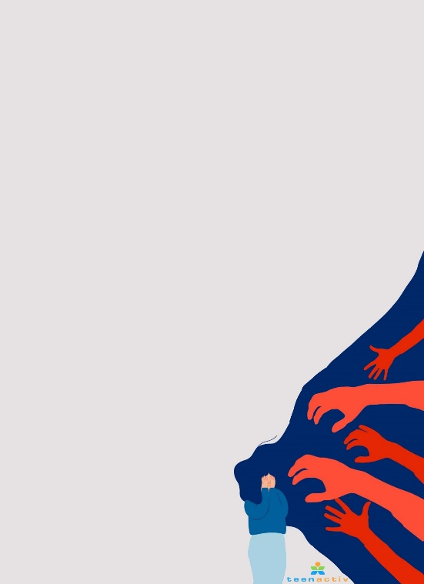
FIVE dangerous situations to avoid:
- Walking alone from school to the bus stop – especially when it's dark.
- Being alone with someone you don’t know in a locked room.
- Being at a party at a friend’s house where you know there is no adult supervision.
- Getting a lift home with a complete stranger.
- Accepting a drink from someone at a club that you did not buy. It could be drugged.
- Spending time with people you know use drugs and alcohol freely.
Advice on what to do if this had happened to you.

  - Go to the doctor or hospital so they check that you are ok.
  - Report the rape to the police.
  - Speak to a trustworthy person and get help.
  - See a counsellor if you need assistance working through the trauma.

Activity 2:

Take a moment to reflect on what you have learnt about yourself today.

- List THREE values you feel that you need to work on in your own life that would protect you from taking part in unhealthy sexual behaviour.

- Write down THREE values around sexual behaviour you would like to see in your future spouse. Why did you include these values? Are these values different to your own set of values around sexual behaviour?
Values:

Why did you include these values:

- Think of the people in your life you respect, who would you talk to if you needed advice or help?

Learners will give personalized responses to this activity.

