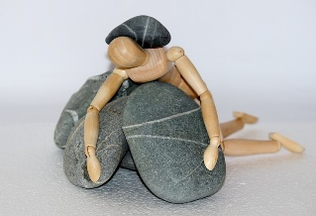
Lesson 4 – Worksheet
Activity 1:
Complete the content map below as the lesson progresses.


Activity 2: Group Activity

Dealing with trauma:

Read the following passage and then using the discussion points at the end, have a group discussion. You can write down points made by your group in the space below.

People can experience trauma both directly and indirectly. Many South Africans have experienced trauma, grief, or a crisis at some point in their lives. Many South Africans know somebody who has been a victim of crime, suffered a tragedy or illness even if they themselves have not experienced it. Simply hearing about it can be very frightening and trauma can happen in many ways.

Causes of trauma could be:
- Disease and illness (such as HIV or AIDS, COVID-19, cancer)
- Losing or grieving for a loved one
- Abuse: physical, mental, and emotional
- Violence
- Accidents
- Natural disasters

Sometimes dealing with trauma just takes time, sometimes people struggle to recover and constantly have feelings of anxiety, guilt, stress, or shame. It is possible that they are suffering from post-traumatic stress. This can be worsened by not dealing with emotions and instead of sharing them, bottling them up.

It is common after a traumatic experience to:
- Feel fear and anxiety when you think about the trauma.
- Re-experience the trauma, even when you try to block out the thoughts.
- Feel jumpy, shaky, and unable to concentrate.
- Want to avoid any similar situation or place that may remind you of the trauma.
- Feel anger, shame, or guilt.
- Want to hide away and not speak of the experience.
- Feel grief, helplessness, depression, and sadness.
- Have relationship trouble with your parents, friends, teachers and even yourself.

Unfortunately, traumatic experiences can leave a person feeling very alone with their grief and feelings. They may feel that nobody understands, and because it is often hard to speak about a traumatic experience, they may shut down and push people away. Sometimes, people who want to offer support or help read these messages the wrong way and stay away. They might think that you need time alone and do not want to push you unless you are ready. Unfortunately, that often leads to further isolation. Spending time and talking to people who care, are supportive and understanding is a very important way to recover from trauma. Finding professional help (if they feel that you are not getting over it), is the next important step.

Discussion points:
- Discuss TWO traumatic situations that people experienced during COVID-19 in South Africa.
- Discuss ONE possible way of dealing with those types of traumas.
- Recommend TWO ways that you can support someone dealing with grief or trauma.

GROUP NOTES
- Discuss TWO traumatic situations that people experienced during COVID-19 in South Africa.
- Discuss ONE possible way of dealing with those types of traumas.

- Recommend TWO ways that you can support someone dealing with grief or trauma.

Activity 3: Informal Assessment

Question 1
Choose a description from COLUMN B that matches a word / phrase in Column A.
Write only the letter (A - G) next to the question number (1.1 to 1.5).

Column A | Column B
1.1 Antiretrovirals | A. Contact with infected HIV-positive bodily fluids.
1.2 Diet and positive attitude | B. Medication that is used to treat HIV/AIDS.
1.3 COVID-19 | C. Infectious disease caused by the SARS-CoV-2 virus.
1.4 AIDS | D. Strategies to manage living with HIV in a healthy way.
1.5 Human immunodeficiency  virus | E. The late stage of HIV infection that occurs when the  body's immune system is badly damaged.
 | F. A virus that attacks the body's immune system.
 | G. A symptom of HIV.
(5x1) (5)

Question 2

2.1 Explain the concept ‘pandemic’.
(1x1) (1)

2.2 Explain what it means to “social distance”.
(1x1) (1)

2.3 Define the concept of “symptomatic”.
(1x1) (1)

(3)

Question 3

3.1 Recommend TWO reasons why a positive attitude could help with the fight against a
life-threatening illness like AIDS or COVID-19. (2x2) (4)

Question 4

Study the image below and answer the questions that follow.

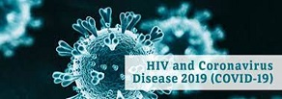

[Taken from: https://www.cdc.gov/hiv/basics/livingwithhiv/index.html
Accessed on 01 September 2021]

Write paragraphs on COVID-19.

Use the following as guideline.

- Identify TWO ways to protect yourself against COVID-19. (2x1) (2)

- Discuss the importance of making informed decisions about your safety during the
COVID-19 pandemic. (2x2) (4)

- A learner in your class has lost someone to COVID-19. Recommend TWO ways how
your class could support him / her to cope with the grief. (2x2) (4)

(10)

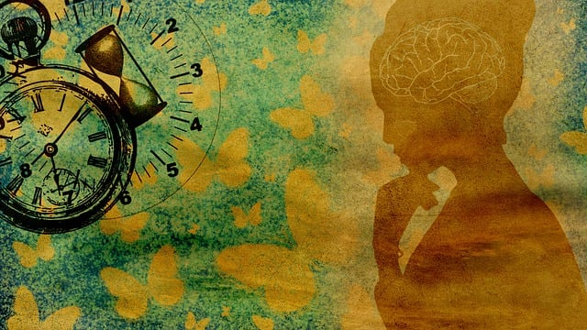
ACTIVITY 4: FINAL REFLECTION
Complete the reflection now that you have covered this section. Use key words and short sentences to answer the questions.
What have I learnt regarding prevention of COVID-19:

What stood out for me was:

Facts I didn’t know before this lesson:

How well have I worked, and can I improve?

Did the lesson help me to understand COVID-19 better?

Did this lesson help me to make more informed decisions around my own health?

