


Lesson 3 – Worksheet MEMO

Activity 1:
Indicate with a YES or NO if the following emotional “moments” have ever happened to you?
Circle YES or NO.

Feel unsure about yourself | YES | NO
Sometimes highly argumentative and angry | YES | NO
Want to try new things and take risks | YES | NO
Worry about the way you look | YES | NO
Become interested in the opposite sex | YES | NO
Aware of feelings of attraction in your body and interest in sex | YES | NO
Start to question what you believe and your values | YES | NO
Argue with your parents | YES | NO
Sometimes feel that no one understands you. | YES | NO
Look for excitement | YES | NO
Become irritable very easily | YES | NO
Sometimes have mood swings- happy and then sad within a moment. | YES | NO
Worry that you are different from your friends | YES | NO
Feel very adult one moment and then very young the next. | YES | NO

Learners will give personalized responses to this activity.

Activity 2:
Read the following article and answer the questions that follow.

Everything You Wanted to Know About Puberty

Change Can Feel Kind of Strange
Just as those hormones create changes in the way your body looks on the outside, they also create changes on the inside. While your body is adjusting to all the new hormones, so is your mind. During puberty, you might feel confused or have strong emotions that you've never experienced before. You may feel anxious about how your changing body looks. You might feel overly sensitive or become easily upset. Some teens lose their tempers more than usual and get angry at their friends or families.
Sometimes it can be difficult to deal with all of these new emotions. Usually people aren't trying to hurt your feelings or upset you on purpose. It might not be your family or friends making you angry — it might be your new "puberty brain" trying to adjust. And while the adjustment can feel difficult in the beginning, it will gradually become easier. It can help to talk to someone and share the burden of how you're feeling — a friend or, even better, a parent, older sibling, or adult who's gone through it all before.
You might have new, confusing feelings about sex — and a lot of questions. It's easy to feel embarrassed or anxious when talking about sex, but you need to be sure you have all the right information. Some teens can talk to their parents about sex and get all their questions answered. But if you feel funny talking to your parents about sex, there are many other people to talk to, like your doctor, a school nurse, a teacher, a school counsellor, or another adult you feel comfortable talking with.

Developing Differently
People are all a little different from one another, so it makes sense that they don't all develop in the same way. No two people are at exactly the same stage as they go through puberty, and everyone changes at his or her own pace. Some of your friends may be getting curves, whereas you don't have any yet. Maybe you're sick of being the tallest girl in your class or the only boy who has to shave.
But eventually everyone catches up, and the differences between you and your friends will even out. It's also good to keep in mind that there is no right or wrong way to look. That's what makes us human — we all have qualities that make us unique, on the inside and the outside.
[Taken from: https://kidshealth.org/en/teens/puberty.html], Accessed on 6 June 2023]

- Underline the emotions in the extract you might experience during puberty.
- Why is it important to ask questions about sex even if you’re embarrassed?
Without asking questions you would remain confused and maybe make wrong choices because of lack of knowledge.

- Describe TWO ways in which you can manage your emotions during adolescence.
You could play sport to manage emotions and the endorphins released make you feel good.
You could laugh with your friends or family as it will make you feel happy.

- What advice would you give your friend who is often depressed because he/she has no visible signs of puberty taking place?
Remind your friend that everyone experiences puberty at different times. They will experience puberty at the right time.

Activity 3:

  - Using the prompts in the table below, reflect on how well you understood the content in the lesson as well as the video clip (https://www.youtube.com/watch?v=0O1u5OEc5eY) you just watched.
Rate your understanding by choosing:
1 - I still don’t understand
2 - I still have some questions
3 - I feel confident and I understand

3.1 | Reflection Questions | Answer 1 or 2 or 3
3.1.1 | I understand how hormones impact my emotions.
3.1.2 | I understand why I have more conflict with my parents.
3.1.3 | I understand why peer relationships are so important.
3.1.4 | I feel I am a good influence on my friends.
3.1.5 | I struggle to understand my emotions and sometimes find myself making dangerous spontaneous decisions.

Learners will give personalized responses to this activity.

3.2. Reflecting on the video clip (https://www.youtube.com/watch?v=0O1u5OEc5eY), answer the
following questions:

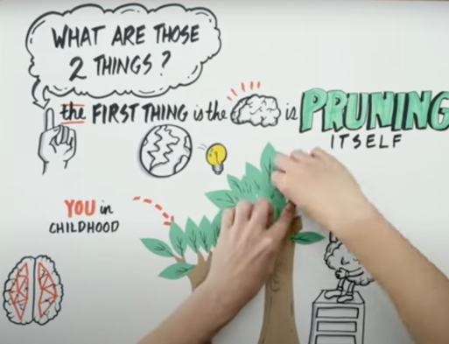
3.2.1 List THREE ways you think your brain would be pruning
itself?
Could say- not involved in lots of different extra murals,
not the same friends you had in primary school, become
more independent from your parents.

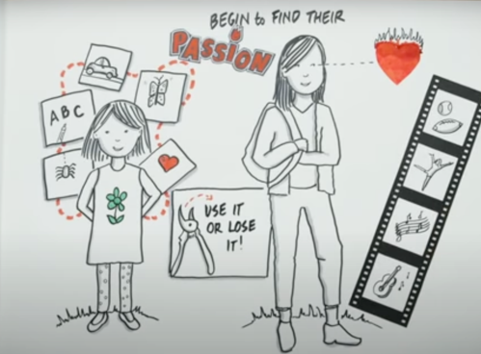
3.2.2 Identify TWO passions that you feel are important now during your teen years.
Any TWO- Could be sport, academics, friendship etc.

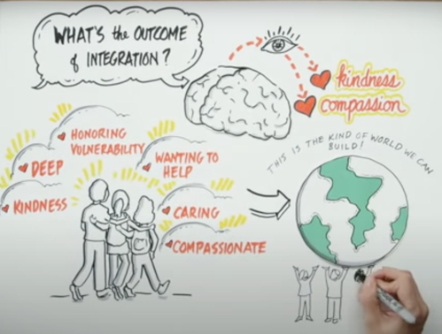
3.2.3 Which of these character values would you like to grow
into?
How would you have a positive input in other relationships?
Could be any e.g. Compassionate- then I would be more
helpful to my friends when they’re going through
something difficult.

3.3 We have all been influenced by peer pressure somewhere along the way.
Write THREE suggestions you would give to a friend on how to say NO to peer pressure and
the long-term benefits (for themselves) in doing so.

- A confident 'no thanks' or 'not for me' will make it clear that you are not interested and build respect that you are not a “pushover” in the years to come.
- Using humour to deflect pressure or attention will change the subject and help you move away from the issue.
- Be direct and say you don't appreciate feeling pressured.
- Get support and talk to someone you trust that can give you tips on how to say “NO”.

Activity 4: Homework
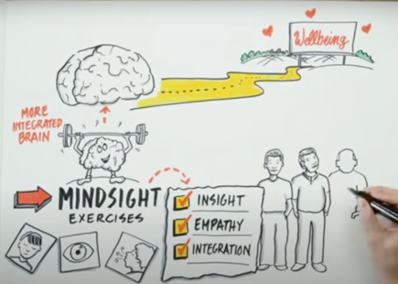
In the video clip, there were some wonderful words of wisdom on the positive impact of adolescence on the brain.

You will need to go and research the term “mindset” and find FIVE activities you could do to improve your adolescent brain as it grows.

Learners will give personalized responses to this activity.

