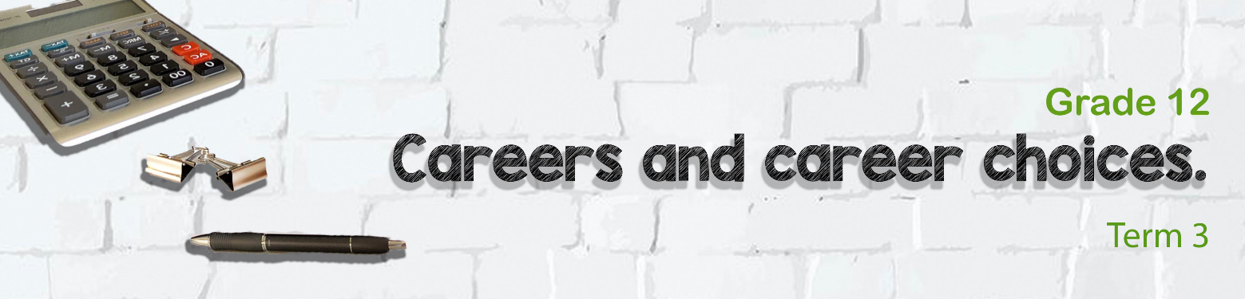

Lesson 2 - Worksheet
Activity 1: Complete the following definitions from your PowerPoint.
In the space provided make notes on the specifics of the Labour Relations Act.
THE LABOUR RELATIONS ACT (_______)
Act 66 of 1995

Freedom of association and general protection
- The Labour Relations Act created structures for the purpose of ___________________________________ as well as for bargaining and statutory councils.
- The bargaining councils, statutory councils, Commission for Conciliation, Mediation and Arbitration (________________) and Labour Courts are involved in settling disputes

Collective bargaining is promoted by the Act
It is the desired method of settling wages and conditions of employment.
Registered trade unions have the right of access to the workplace.
An office bearer is an official representative of the trade union and is entitled to reasonable leave during working hours
The employer is obliged to ______________________________________ to a trade union representative

______________________________________________________
- Workers have the right to join trade unions and employers have the right to form employers’ associations
- No person may be discriminated against because he or she joined ________________________________________________________.

Activity 2: HOMEWORK ACTIVITY (Examination Preparation)
EMPLOYMENT EQUITY ACT (___________)
Act 55 of 1998
To eliminate ___________________________ and promote equal opportunity for all employees in the workplace.
To implement _______________________ that ensures equal representation in all categories and levels in the workforce
This means that the employment policies of all businesses must prohibit _________________against employees on the basis of race, sex, gender and disabilities
They also have to apply ______________________________________________________ to provide opportunities for people from formerly disadvantage groups to advance within the workplace.
BASIC CONDITIONS OF EMPLOYMENT ACT (___________)
Act 55 of 1998
No employer may employ a child ___________ years of age
Children under the __________ are prohibited from working in inappropriate places such as casinos and bars.
CHILD
LABOUR
MEAL BREAKS
NOTICE PERIOD
An employee must have a meal interval __________after five hours work.

The notice period for _____________________________.
If an employee has worked for longer than __________, four weeks notice is required.
Should an employee be on probation but does not meet the required standard of performance, ____________ must be given.

An employee may only work overtime if an _____________________ between the employer and employee.
Employees who work on ____________ must receive double pay, or one and a half times his or her normal wage if they normally work on a Sunday.
Should an employee work on a public holiday, _________ the normal wage.
An employee is entitled to _______________ fully paid leave.
If an employee works __________ the maximum hours per day are ___ hours.
If the employee works ____ days a week, the maximum hours per day are ______ hours.
Employees are entitled ____________ leave per year
Or _____________ one day for every 17 days of work completed.
PAYMENT
WORK TIME
LEAVE
Complete the following questions to the best of your ability. We will talk about
this exam format in the next lesson.
SECTION A (COMPULSORY)
Answer ALL the questions in this section.
QUESTION 1
1.1 | Various options are provided as possible answers to the following questions.  Choose the correct answer and write only the letter (A–D) next to the question  number (1.1.1 to 1.1.3). e.g. 1.1.4 E.

1.1.1 | The labour law that protects against racial discrimination in the workplace
 | A B  C D | EEA  LRA  SADTU  BCEA

1.1.2 | A trade union will negotiate on behalf of the workers for
 | A B C  D | Resolve disputes between employer and employee Be present at job interviews to ensure fairness in process Improved health and salary benefits  All of the above

 |  | 1.1.3 | According to labour regulations, the following situation calls for redress in the workplace:
 |  |  | A B C D | An employee who is working four hours overtime a day Four months maternity leave for working females  An employee who is working sixty hours a week  Monitoring employees' calls during working hours
1.2 | Give ONE word/term for EACH of the following descriptions. Write only the word/term next to the question numbers (1.2.1 to 1.2.3).

1.2.1 | A law that provides the legal right for paternity leave for a father to be present when his wife has a baby.
 |  | (1)
1.2.2 | A document that affirms the democratic values of human dignity, equality and freedom.
 |  | (1)
1.2.3 | An independent authority that resolves labour disputes.
 | An independent authority that resolves labour disputes. | (1)
QUESTION 2
2.1 Discuss THREE ways that the labour laws provide protection to the employer.
(3x2) (6)

2.2 Discuss THREE ways that the labour laws provide protection to the employees.
(3x2) (6)

Activity 3: Take a moment to reflect on what you have learnt about yourself
today.
- Many people have lost their jobs as a result of the recent COVID-19 pandemic and loadshedding. Reflect by giving your own opinion on:
- How ethical it was to fire the employees?
- The emotional effect / impact it had on employers to let people go?
- Did the law really protect workers?
____________________________________________________________________________________________________________________________________________________________________________________________________________________________________________________________________________________________________________________________

- Rate your understanding of the following labour laws we learnt about today. Revise the LABOUR LAW that you rate yourself the lowest.
(1 - needs work and 5 - very capable.)

* LRA______________
* EEA ______________
* BCEA_____________

