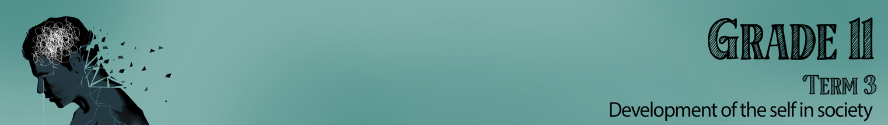


Lesson 2 – Worksheet MEMO

Activity 1:
Read the article below with your group and answer the questions that follow.
The Surprising Ways Social Media Influences Your Health Choices
By Sarah Garone, NDTR, is a nutritionist.

With the average person now spending over two hours a day on various social media platforms, it’s only natural that the friends and influencers we follow online affect our real-world decisions around our well-being. Here’s a look at some of the surprising ways users say social media has fuelled their health — or harmed it.

Pro vs. con: How does social media showcase health?
The pro: Social media can provide health inspiration
Sometimes, getting images of good-for-you foods in your line of sight provides the oomph you need to opt for veggies at dinner — and feel awesome about it. Aroosha Nekonam, who struggled with anorexia, says “They inspired me to push through my recovery so I too could focus on physical strength.”
The con: Social media can foster unrealistic expectations of health
While drool-worthy Buddha bowls and Crossfit bodies can fire us up for health, there can also be a dark side to these glowing wellness themes. When the images we see online present perfection, we may end up feeling that healthy eating and physical fitness are unattainable, or only for a select few. Additionally, following diet culture accounts that constantly glorify thinness or make judgements about types of food is stressful.

Pro vs. con: How does social media let us talk about health?
The pro: Social media can be a safe space to get support and discuss health
Though the impersonal nature of connecting with others from behind a screen receives criticism, the anonymity of social media actually has its advantages. When a health condition is too painful or embarrassing to talk about in person, an online forum can provide a safe space.
The con: Social media can become an echo chamber of negativity
If someone you follow focuses solely on the negative aspects of a health condition, or if a group only bemoans the difficulties of weight loss, it’s possible your own mental and physical health could be affected or influenced for the worse.

Pros vs. cons: How accessible is health content on social media?
The pro: Social media provides access to helpful products and health information
Social media has largely taken the place of resources like cookbooks for recipes, physical videos for at-home workouts, and a dusty old medical encyclopaedia for answers to health questions. And the reach of the internet means we hear about health products and helpful information we’d probably have been ignorant of 30 years ago — and, often, that’s a positive thing.
The con: Social media can promote false “experts” and advertise unhealthy products
Taking health advice from influencers whose only qualification is a massive following may come with unfortunate consequences. “I went through a really dark period where I was following so many fitness/healthy influencers and was fully convinced that they knew everything about how to live a ‘healthy’ life,” says Brigitte Legallet. “It resulted in a pretty dark time full of over-exercise and food restriction.”

The opposite can be true, too. For folks with a history of disordered eating or an eating disorder, seeing calorie counts, food swaps, and food judgment-based posts can be triggering. They may feel guilt or shame around their current habits or fall back into a pattern of disordered eating.

Getting the most out of social media for health
Try setting boundaries around how much time you spend on social media in the first place.
Then, take stock of the influencers and friends you follow and the groups you’re a member of. Do you find them inspiring you toward better living, or weighing you down? Delete or unfollow as needed.
And if you feel the standards of perfection putting you at risk of unhealthy patterns, pay attention.
Palinski-Wade also encourages a reality check: “Use social media for inspiration and creative ideas, but be realistic with it.
Finally, if you’re seeking health information, remember that the number of followers isn’t necessarily an indicator of expertise. It’s best to get answers to health questions from a credentialed professional in the real world than an influencer on Instagram.

[Taken from: https://www.healthline.com/health/social-media-choices#get-the-most-out-of-social-media
Accessed on 6 June 2023]

Answer the following questions in your group:

- How social media negatively impacts your opinion about a healthy lifestyle?
Social Media could influence my belief on what is healthy and influence future decisions on my health choices.

- How this knowledge on social media influences your decisions around health and why?
It could convince me to believe certain diet fads as true. When I see the videos of how many others have supposedly lost weight in a short time, I would consider spending money or trying something that now seems believable.

- As a group, list FIVE suggestions NOT mentioned in the article of how to protect yourself against the negative influence within social media.
Test the information found- research to see if its true.
Read reviews on a new diet product on other sites. Don’t just read the comments below as many are fabricated by false accounts to advertise the product.
Ask your friends or adults on what they think about that advice/ product.
Speak to a health professional like a dietician before trying a crazy diet. If you feel you need to lose weight, rather learn to understand what food is good for you than looking for a short cut.

Activity 2:
Look at the images below and answer the questions that follow.
For each image you need to identify:
- Is it poor decision making or lack of knowledge or both? Motivate your answer.
- What could be done to prevent you from landing up in such a situation?
E.g. Work accident- 1) Lack of knowledge about safety procedures and use of work equipment,
2) Learn how to use the dangerous equipment like electric saws at work and
follow safety procedures.
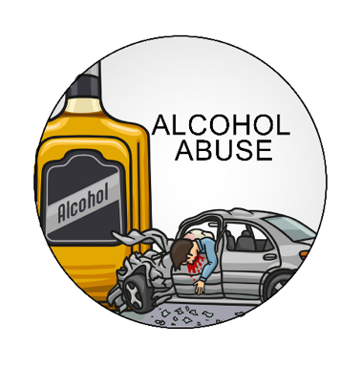
- Lack of knowing the impact alcohol has on you and the ability to drive a car.
- Travel as a group with a designated driver that has not had any alcohol.

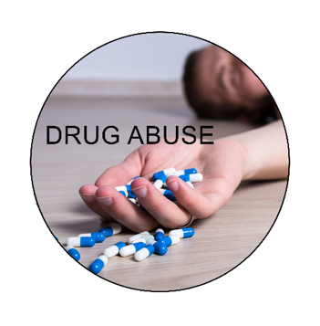
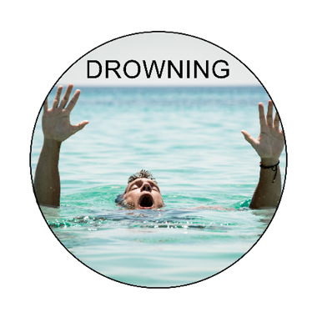
- Not being able to read signs that say no swimming or not learning how to swim.
- Learn to swim well and follow instructions in certain areas. Swim in groups.

- Without the knowledge of the dangers of drugs and understanding the impact it would have, a person could get addicted.
- Do research before making spur of the moment decisions influenced by others.


- Without the knowledge of what causes fires, individuals could leave a fire on and go to sleep or leave gas on.
- Knowing how to be safe at home and prevent situations that cause fires.

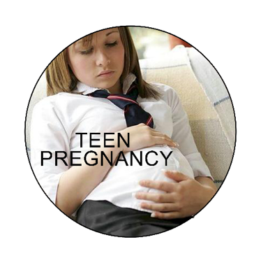
- A lack of understanding of the impact of unprotected sex.
- Preventing a situation where you make impulsive decisions based on emotions rather than rational thought.

Activity 3:
Read the following article and answer the questions that follow:

Why our children cannot read for meaning at Grade 4 level
By Oyio Sondlo
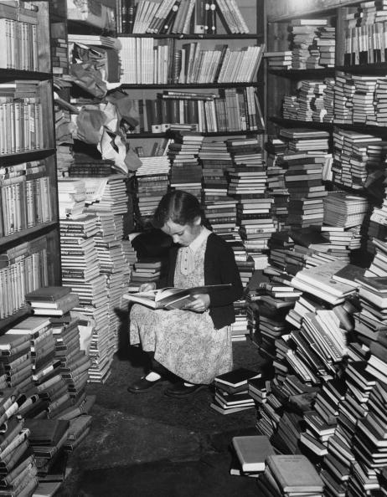
We are 29 years in since apartheid officially ended in South Africa, but the inequalities persist.
The recent Progress in International Reading Literacy Study report shows that 82% of our learners in grade 4 cannot read for meaning.
In particular, this report shows that the attitudes and habits of learners, teachers and communities about reading are at highly disappointing levels. Reading, writing and learning seems to be a dying culture in most South Africans’ schools and homes.
If the habit of reading is not inculcated at a young age then it might go on to become a stubborn setback in adulthood.
This poses a major risk in the overall development of a young adult and it might threaten their potential to lead a successful professional life.
Education is a social function that grows out of the seeds of a community context. Parents, teachers, organisations, learners, the media, leaders and community members have the power to determine what should be the core mission of their schools.
In other words, unless the community begins to see schools as sites of personal development, articulation of skills, cultivation of cultural and family values, and the enabling of curiosity and critical thinking habits then nothing will be done to hold schools accountable for what they teach children. In addition, if homes themselves are not conducive environments for non-formal learning then the efforts of the schools are handicapped.
These challenges are further compounded in previously disadvantaged schools. The majority of these schools are located in townships. These are communities faced with layers of human challenges, which get transferred to schooling.
In addition, communities and the government need to play their role in governing public schools. This situation needs to change. Parents and families must get involved in the education of their children and they must establish a daily connection with their teachers. Furthermore, the different stakeholders responsible for education must come together more than ever before to tackle the development of our children.
The creation of a learning culture is also the responsibility of a community.
[Taken from: https://mg.co.za/thoughtleader/opinion/2023-02-21-why-our-children-cannot-read-for-meaning-at-grade-4-level/ Accessed on 6 June 2023]

Answer the following questions in your group:

- How does poor literacy impact lifestyle choices?
Without being able to read, there is a lack of opportunity to get an education and improve quality of life with a sustainable job.

- How does low income and poverty play a role in the influence on low literacy in South Africa?
It’s a vicious cycle. Without income. Learners end up in poor schools with limited resources, illiterate parents struggle to help their children to learn and can’t afford to send their learners to schools where they can learn.

- Identify THREE examples of how the township environment in South Africa impacts on the social well-being of a child.
- Lack of safety because many homes do not have lockable homes and children are forced to always be on the lookout for danger.
- Increased crime in these communities because of poverty causes fear and insecurity amongst children
- Gang violence where families are forced to pay protection fees. When there is no money, the fear can cripple a household.
- Due to floods in poverty stricken communities, there in an increased risk of disease.
- Due to poverty, a lack of healthy foods to eat and so children develop diseased like kwashiorkor that is caused by a lack of protein in their diet.

- Give TWO strategies on how a school environment could partner with parents and the community to improve literacy skills.
- A school could offer adult reading lessons. This would improve the interest in reading and their own literacy. They would then be able to help their own children.
- A school could facilitate a mentor program where older learners help younger learners that struggle with reading.
Activity 4:
Answer the following questions as you reflect on what you have learnt today.

- Name THREE factors that negatively impact lifestyle that you feel your school needs to be educated about.
- What positive influence could you have in addressing these issues at your school?
- What advice would you give the RCL to develop a campaign that addresses poor decision making amongst teenagers.
Learners will give personalized responses to this activity.

