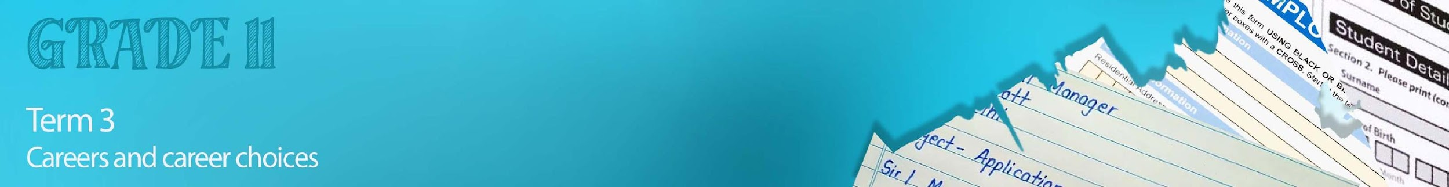


Lesson 2 – Worksheet MEMO

Activity 1:
In order to develop skills for your CV, you need to gain experience. In the space below, provide THREE examples of how you could be involved in the following:
Job shadowing | - Spend a day at the aquarium to  - get hands-on experience of the workplace,  - how the systems work,  - the culture of the organisation you are working for.  - Spend some of your school holiday working in a hotel to understand the hospitality industry and ask questions from the people who might become your professional connections.  - Job shadow at an engineering firm to understand the nature of the engineering career. You get to finally find out what the job's perks and specific challenges are.  - also find out if you have the soft skills (big thing  these days) needed for the job  - finally, a new perspective on how the things really  work in reality?
Informal Jobs | - Washing cars  - Working at the restaurant as a waiter  - Mowing lawns

Activity 2:

Go to the site https://standout-cv.com/pages/cv-no-experience and follow the prompts to write your own CV. Use the screenshot steps below to help you plan:

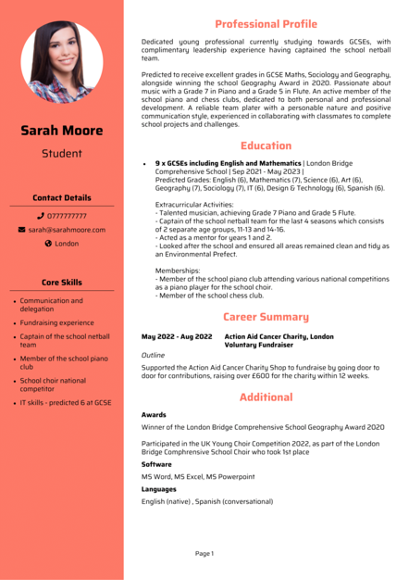
1)Contact information
2) Work history
3) Education
4) Skills:
5) Professional Summary
6) Finalise

Learners will give personalized responses to this activity

Activity 3:

Complete the Skills Learnt Poster in your groups of FOUR.
Learners will give personalized responses to this activity

Activity 4:

Reflect by completing the following:
- Name ONE skill that was identified on a poster that you struggle with and explain how you can improve yourself in that area.
- Name ONE challenge you find working on a project with a team.
- Evaluate your own administrative skills by describing TWO strengths and weaknesses.

Learners will give personalized responses to this activity

