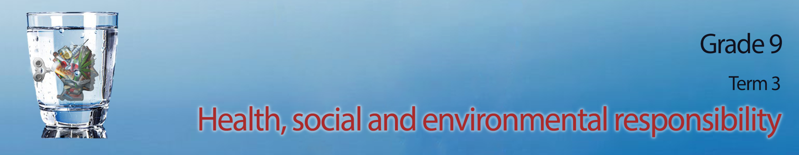
Lesson 2 - Worksheet MEMO

Activity 1:
There are many reasons people become violent. In the space below, add another THREE reasons to this list:
Possible reasons may include: Possible suggestions:
- frustration with authorities and so they take the situation into their own hands
- they themselves were victims of abuse and followed in the same pattern
- low self esteem and self worth
- side effects of drug and alcohol abuse
- a lack of compassion of others
- feel like there is no other way to solve their problems other than violence
- history of abuse
Activity 2:
Using the information you have learnt today and the answers to your questionaries, your group will now have an opportunity to anaylse the information you collected. An infographic is a poster that takes the data we collect and puts it in a visually interesting way so that the average person understands the statistics. Your teacher will allocate a violence category for your group to reflect on. Use all the questionnaires of the members of your group to collect statistics for your poster. Then work as a group to create this poster that will go up on the wall in your class.
Use the following points as a guideline:
- Include a heading for your poster
- Indicate whether men/ women/ children were the victims
- include a summary of reasons for violent acts
- include summary of impact on the victim and those around them.

Activity 3: Individual Activity
(Complete for homework if not completed in class)
Study the image below and answer the questions that follow.
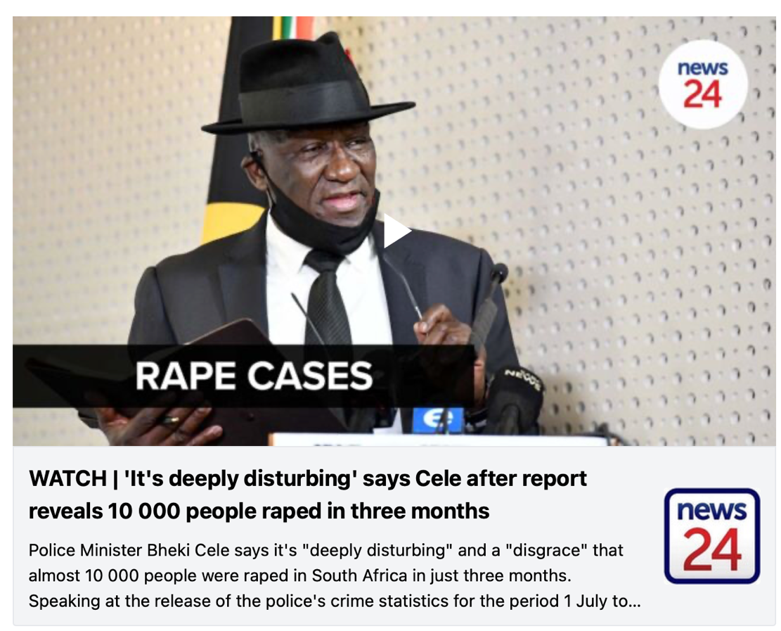
[Taken from https://www.news24.com/news24/southafrica/news/krugersdorp-rapes-what-we-know-so-far-about-the-horrific-incident-that-shocked-sa-20220731 Accessed on 1 August 2022]

  - Define the term ‘rape culture’ with reference to this image. (1x2)(2) (Lower Order)
Any valid statement for TWO marks
Where people have become used to sexual violence and it has become the norm ✓. The result is that rape seems normal and people almost don’t care anymore. ✓ This image references 10 000 people in south Africa being raped in three months. Sadly, this confirms that rape is almost accepted in South Africa as just another statistic of violence. ✓

3.2 Discuss TWO possible reasons for the high levels of violent crime in South Africa. (2x2)(4) (Middle Order)
Any TWO of the below or any relevant answer for TWO marks each
(i.e. ONE mark for statement and ONE mark for qualifier / explanation)
- There is a history of crime in South Africa✓ some communities have used violence to solve their problems for many years✓
- Lack of effective legal services ✓ with the increase of crime, it is harder for the police to address all these areas as they themselves are then in danger ✓
- Lack of consistent punishment ✓ many feel they will not be punished for their crimes, or the severity of the crime is not as serious ✓
- Increased gang led communities ✓ resulting in communities living in fear as gangs battle for power in the local community. ✓

3.3 Recommend TWO ways that an individual can deal proactively with the rape culture in SA.
Motivate your answer. (2x2)(4) (Higher Order)
Any TWO of the below or any relevant answer for TWO marks each
(i.e. ONE mark for statement and ONE mark for qualifier / explanation)
- Educate ✓ that this culture exists from a young age so that young boys and girls grow up learning that it is not acceptable ✓
- Speak up ✓ take a stand against sexist comments and things that oppress women ✓
- Men get involved / set an example ✓ men need to show other men that oppressing women and treating them inferior is not acceptable ✓
- Respect the women in your life ✓ intervene when you see something becoming potentially violent ✓
Request for government to take more action ✓ with stricter punishments and more laws and policies to address the inequality. ✓
(10)

Activity 4: Reflection Activity
Each learner will have an individual response in this reflection.

