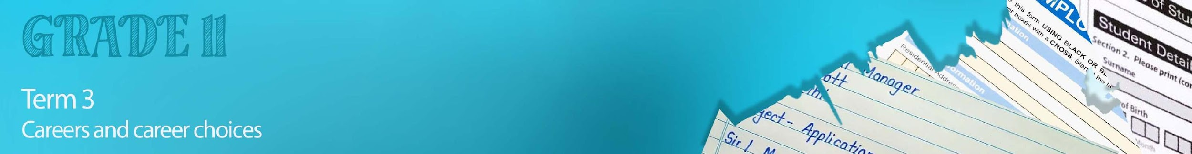


Lesson 2 - Worksheet

Activity 1:
In order to develop skills for your CV, you need to gain experience. In the space
below, provide THREE examples of how you could be involved in the following:
Job shadowing | 1)  2)  3)
Informal Jobs | 1)  2)  3)

Activity 2:

Go to the site https://standout-cv.com/pages/cv-no-experience and follow the prompts to write your own CV. Use the screenshot steps below to help you plan:

1) Contact information

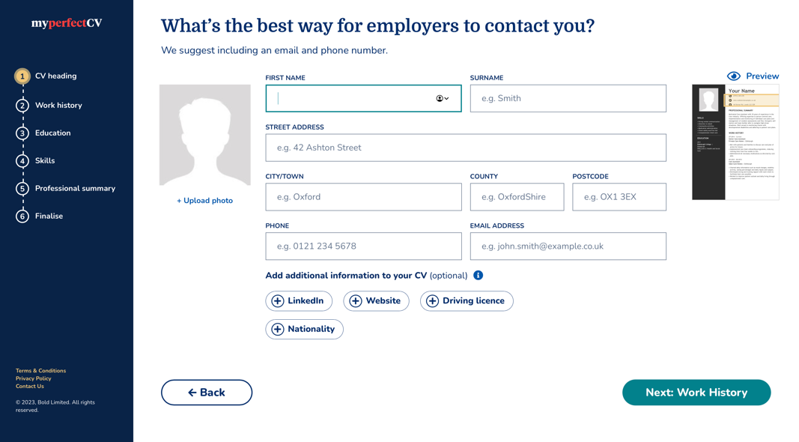

2) Work history

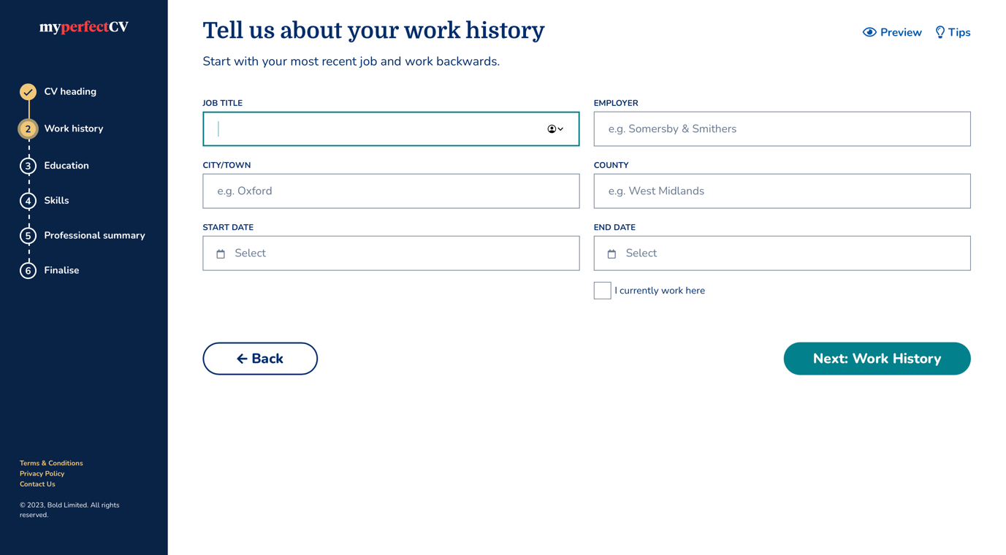

3) Education

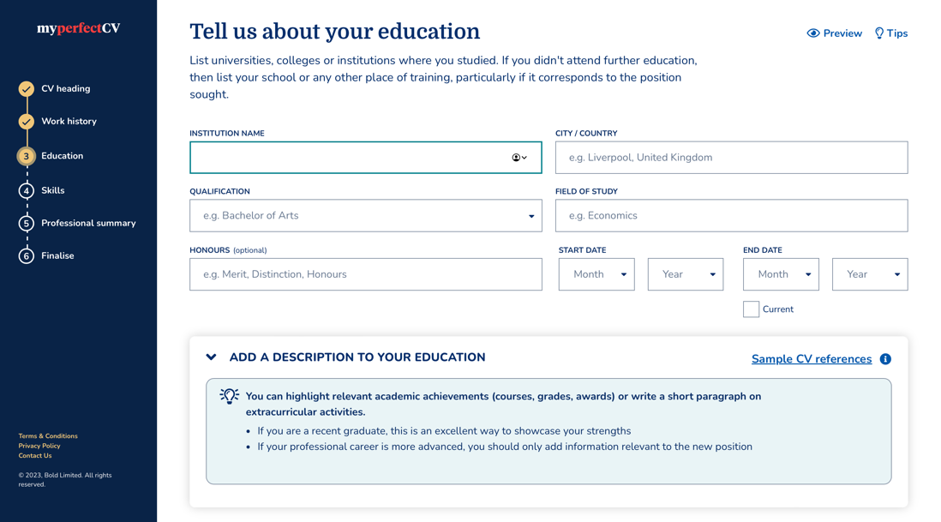

4) Skills:

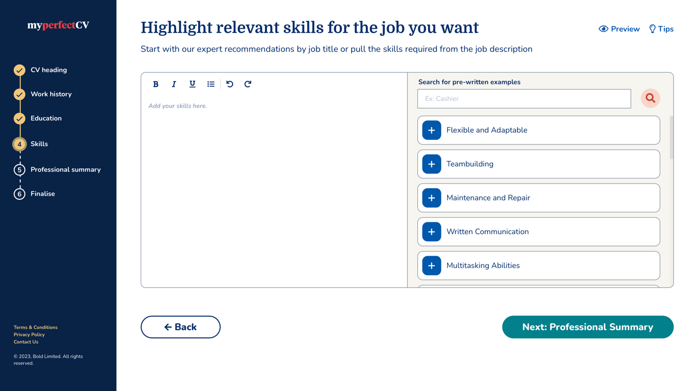

5) Professional Summary

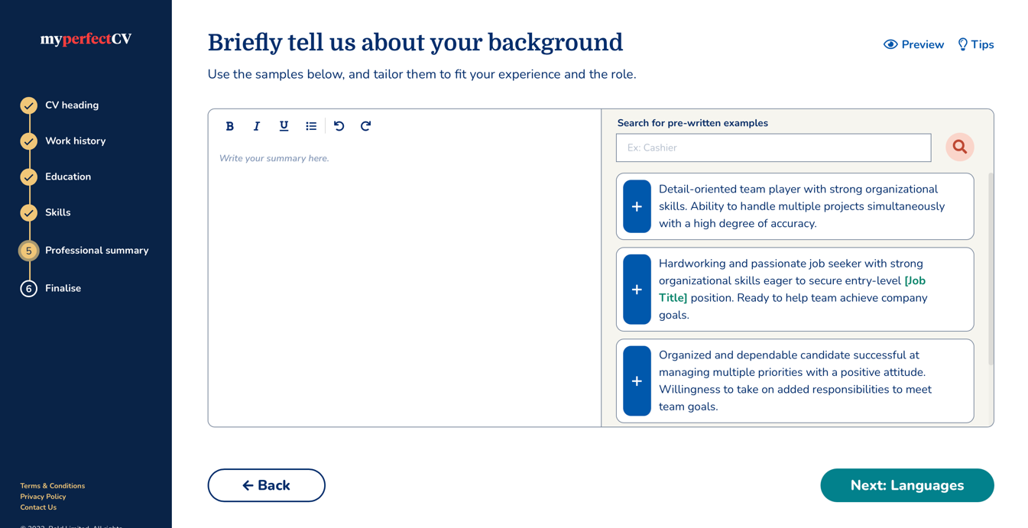

6) Finalise

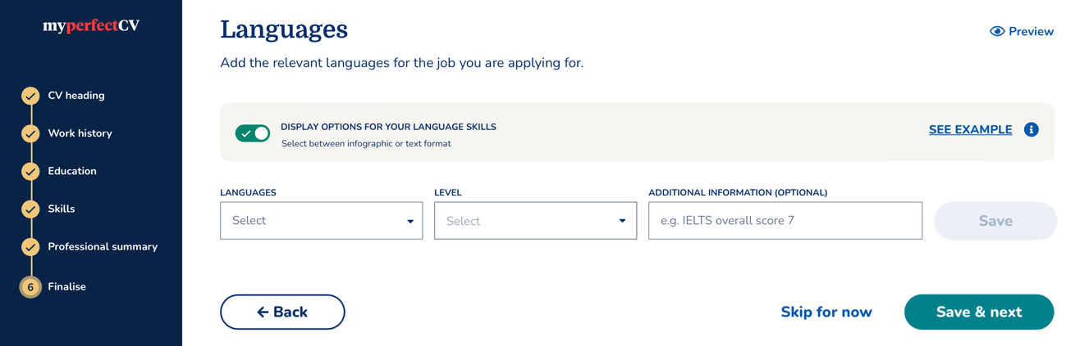

Activity 3:

Complete the Skills Learnt Poster in your groups of FOUR.

Think of projects that you have worked on with classmates over the years at school. Describe ONE project on your poster. Then, in your groups brainstorm FIVE of the skills you learnt working in a group and name THREE roles that you often find in a group.

Activity 4:

Reflect by completing the following:
- Name ONE skill that was identified on a poster that you struggle with and explain how you can improve yourself in that area.

- Name ONE challenge you find working on a project with a team.

- Evaluate your own administrative skills by describing TWO of your own strengths and weaknesses and think of how you could improve these weaknesses.

