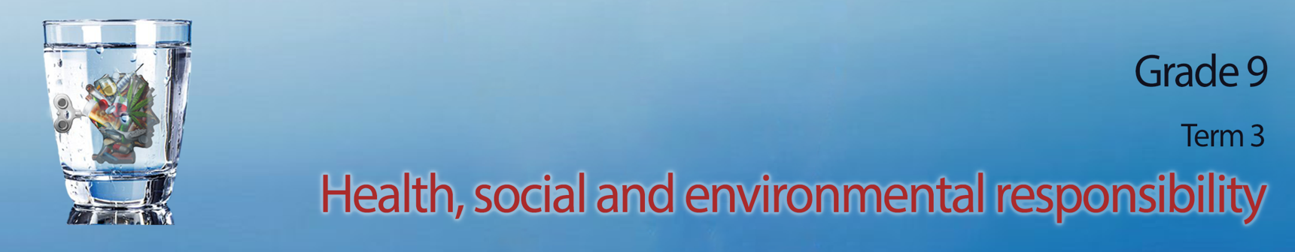
Lesson 2 - Worksheet

Activity 1:
There are many reasons people become violent. In the space below, add another THREE reasons to this list:
Possible reasons may include:
- frustration with authorities and so they take the situation into their own hands
- they themselves were victims of abuse and followed in the same pattern
- low self esteem and self worth
- side effects of drug and alcohol abuse

Activity 2:
Using the information you have learnt today and the answers to your questionaries, your group will now have an opportunity to anaylse the information you collected. An infographic is a poster that takes the data we collect and puts it in a visually interesting way so that the average person understands the statistics. Your teacher will allocate a violence category for your group to reflect on. Use all the questionnaires of the members of your group to collect statistics for your poster. Then work as a group to create this poster that will go up on the wall in your class.
Use the following points as a guideline:
- Include a heading for your poster
- Indicate whether men/ women/ children were the victims
- include a summary of reasons for violent acts
- include summary of impact on the victim and those around them.

Activity 3: Individual Activity
(Complete for homework if not completed in class)
Study the image below and answer the questions that follow.
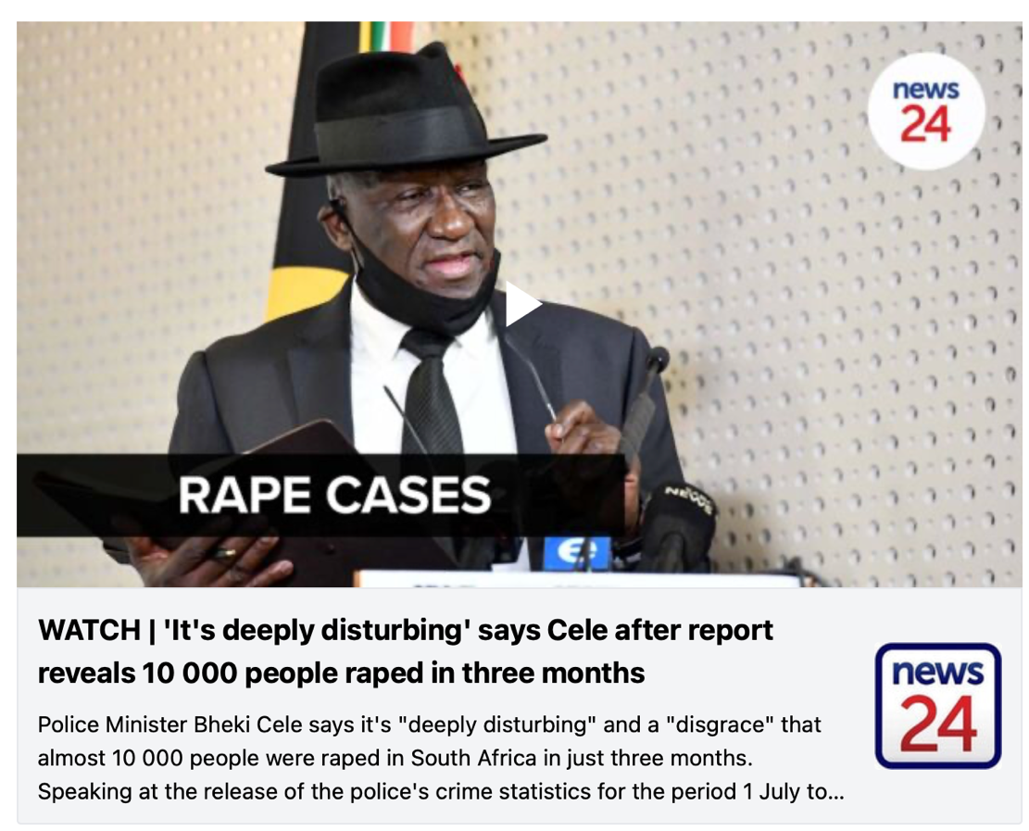
[Taken from https://www.news24.com/news24/southafrica/news/krugersdorp-rapes-what-we-know-so-far-about-the-horrific-incident-that-shocked-sa-20220731 Accessed on 1 August 2022]

  - Define the term ‘rape culture’ with reference to this image. (1x2)(2) (Lower Order)

3.2 Discuss TWO possible reasons for the high levels of violent crime in South Africa. (2x2)(4) (Middle Order)

3.3 Recommend TWO ways that an individual can deal proactively with the rape culture in SA.
Motivate your answer. (2x2)(4) (Higher Order)

(10)
Activity 4: Reflection Activity
Answer the following questions:
4.1 How do you stay positive in the face of all the news on violence in South Africa?

4.2 Identify ONE aspect of the content covered in the last two lessons that you would like to do
additional research on.

4.3 What advice would you give your school friends on how to ”be safe” when going out to parties
in your community at night?

