
Lesson 1 - Worksheet

Activity 1: Complete the definitions of the following terms:

VALUES

PEERS

MEDIA

CONSE-QUENCE
Activity 2: Values exploration
Answer the following questions to see what our values are about alcohol consumption.
When you see adults who abuse alcohol, what are some of your immediate impressions about them?

If you are at a party and your best friend is very drunk and putting themselves in danger, what would you do?

If you could send a message to everyone on Earth regarding alcohol, what would it be?

What would you like people to think of you when you are not under the influence of alcohol?

Take your above responses into consideration and circle some of the values that best describe you from the options below.
Dependability Reliability Loyalty Commitment Consistency Honesty Creativity

Good humor Compassion Motivation Positivity Respect Education Fitness

Service to others Perseverance Passion Optimism

Activity 3: Goals exploration
Meaningful goals can give you direction and a purpose in life. Answer the following questions regarding your goals and the impact that alcohol usage can have on them.
  - What is your dream job?
_______________________________________
  - How would falling into the trap of underage drinking hinder you from pursuing your dream job?
_____________________________________________________________________________
_____________________________________________________________________________
2.1 If you could choose one talent that you would like to share with the world, what would it be?
_____________________________________________________________________________
_____________________________________________________________________________
2.2. How would alcohol abuse prevent you from sharing your talent with the world?
_____________________________________________________________________________
_____________________________________________________________________________
3. What characteristics would there be in a person that inspires other people to achieve their goals?
_____________________________________________________________________________
_____________________________________________________________________________
4. What inspires you most from the story of Xolani that you can apply to your life?
_____________________________________________________________________________
_____________________________________________________________________________

Activity 4: Dear Me…
You will have time to start this activity in class and finish it for homework. Bring it back to class in an envelope with your name and surname on it. Your teacher will return this letter to you in the last LO lesson of the year.
Instruction:
Write a letter to yourself on this postcard that you will read at the end of the year. Be specific and include details of the goals that you would like to achieve this year. You can include short term goals.
Choose to focus on the following areas:
- Relationships with friends/family
- Academic goals
- Sports/Health goals
- Value goals

Finish your letter off with an oath to yourself that you won’t make bad choices this year that will impact you achieving your goals.

Activity 5: Reflection Activity
- Circle THREE emotions you experienced during this lesson.
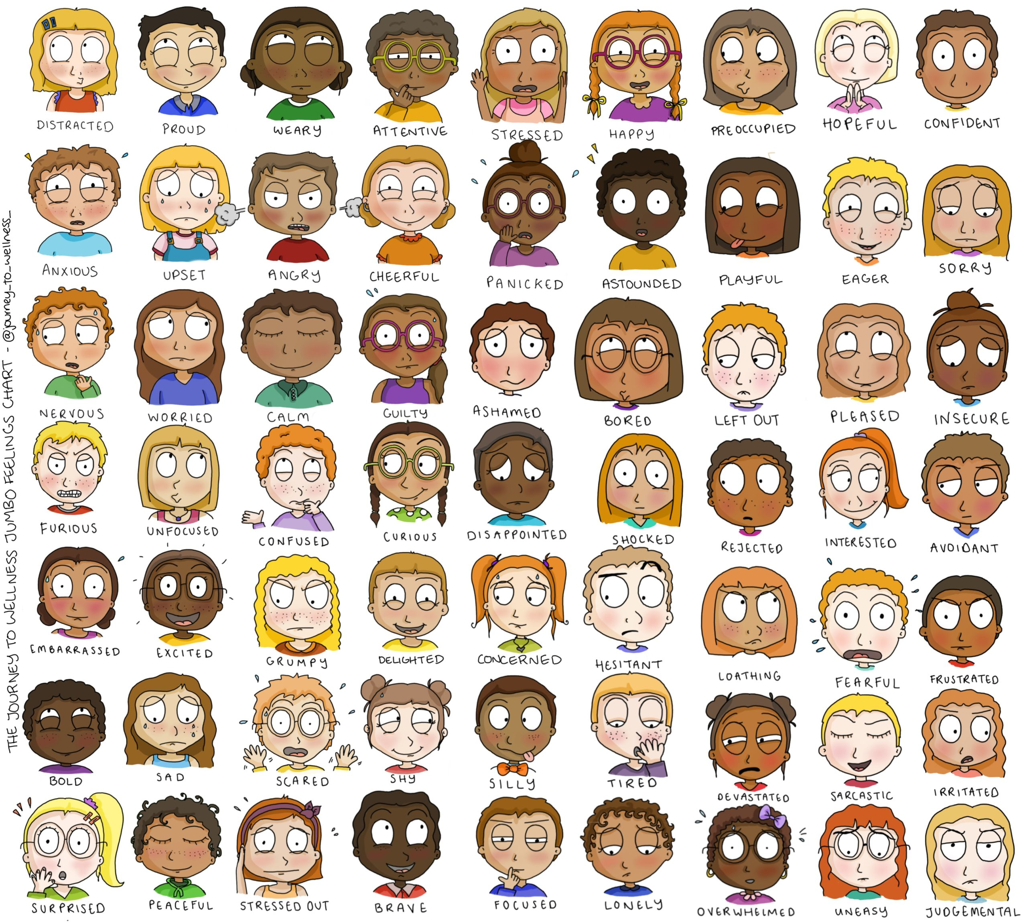
- What goals were difficult to make about your future and require you to do more research?
________________________________________________________________________________________________________________________________________________________________________________

- Who would you feel comfortable talking to for advice about subject choices later this year?
________________________________________________________________________________________________________________________________________________________________________________

