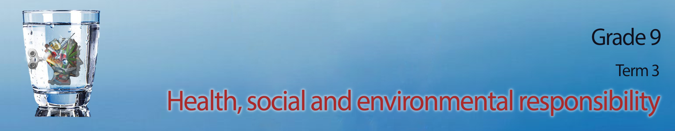

Lesson 1 – Worksheet MEMO
Activity 1: Complete the definitions of domestic abuse below by including an example
of each.
PHYSICAL ABUSE: when someone uses physical abuse to force to hurt someone else.
E.g. a man hitting his wife we he is angry (in most cases bodily harm)

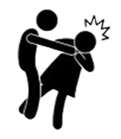
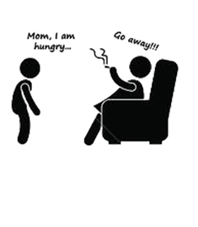

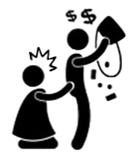
SEXUAL ABUSE: when someone is forced into a sexual activity against their own will even if they had consented in the past.
E.g. A woman being touched inappropriately on her privates by someone else.

DAMAGE TO PROPERTY: When someone destroys property to show their power and authority.
E.g. A woman breaking cups and plates by throwing them at the wall because she is angry with her husband.

VERBAL / EMOTIONAL ABUSE: when someone uses words to intentional cause emotional trauma. This could include manipulative behavior out of fear of further abuse.
E.g. A child being told they are worthless and not meeting their essential needs like providing food. (Verbal (you say hurtful things which hurts your feelings (emotional).

Activity 2:
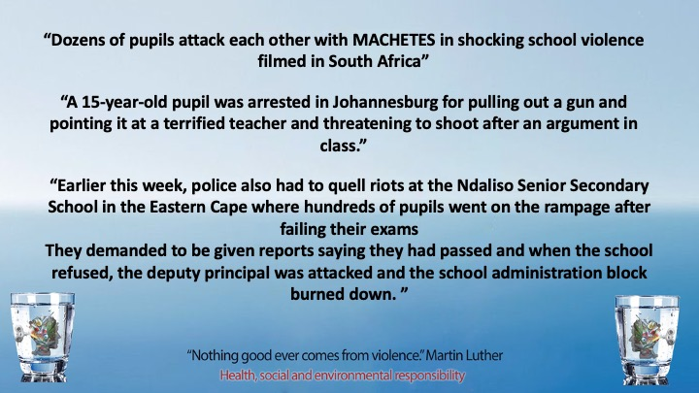
These examples of violence in schools were recorded in an online article. In your groups discuss the following questions and mind map your answers on the page your teacher has given to you.
- Do you think this is a realistic representation of violence in South African schools?
- Statistics show that violence is on the increase in SA schools. Why do you think this is?
- Why are teenagers afraid to report intimidation types of violence like bullying?
- Assess the negative impact of bullying on an individual?
- What could you do as a Grade 9 class to have a voice against violence amongst your peers? Recommend THREE strategies. Motivate your strategy.

Guide this discussion amongst learners and allow for different opinions. We will return to similar questions later on in the seriers of lessons. Grade 9’s love to try and solve problems. The aim of this discussion is to spur on problem solving rather than just accepting that the problems exist.

Activity 3:
You need to research why there is violence in families, communities and among friends and peers as well
as the impact that violence has on the individual and the community.
- Complete this questionnaire below from your own point of view

- What example of violence have you seen before firsthand?

- Why do you think the person acted violently?

- What impact did this act of violence have on you or those around?
- Do you think anything could be done to prevent this kind of violence from happening again?
Please explain your ideas.

Learner will have personal responses for this activity.

HOMEWORK!!!!
- Before the next lesson, you will need to have interviewed FIVE different members of your community. This could include a parent, neighbor, school friend etc. Bring the answers to these interviews to class. You will need this data in the next lesson. (You are welcome to Include another THREE questions of your own to this questionnaire.)

- Identify which of the following describes your relationship to the interviewer:
parent community member school learner sibling friend teacher

- What example of violence have you seen before firsthand?
- Why do you think the person acted violently?
- What impact did this act of violence have on you or those around you?

Activity 4: Reflection Activity

In the space provided write an inspirational quote for your peers to encourage them to stand up against violence:

Each learner will have an individual response in this reflection but ensure that it evokes a positive response of reconciliation.

