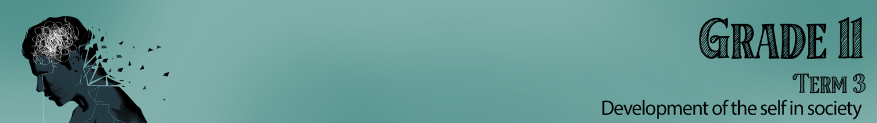


Lesson 1 – Worksheet MEMO

Activity 1:
Provide an example of each of these areas / domains of your life in the spaces below:

It’s important to me to be a good friend.

I have goals to improve my health by seeing a dietician
I can recognize what makes me feel sad or happy.

I enjoy running with my dog.
It’s important to me to attend church every week.

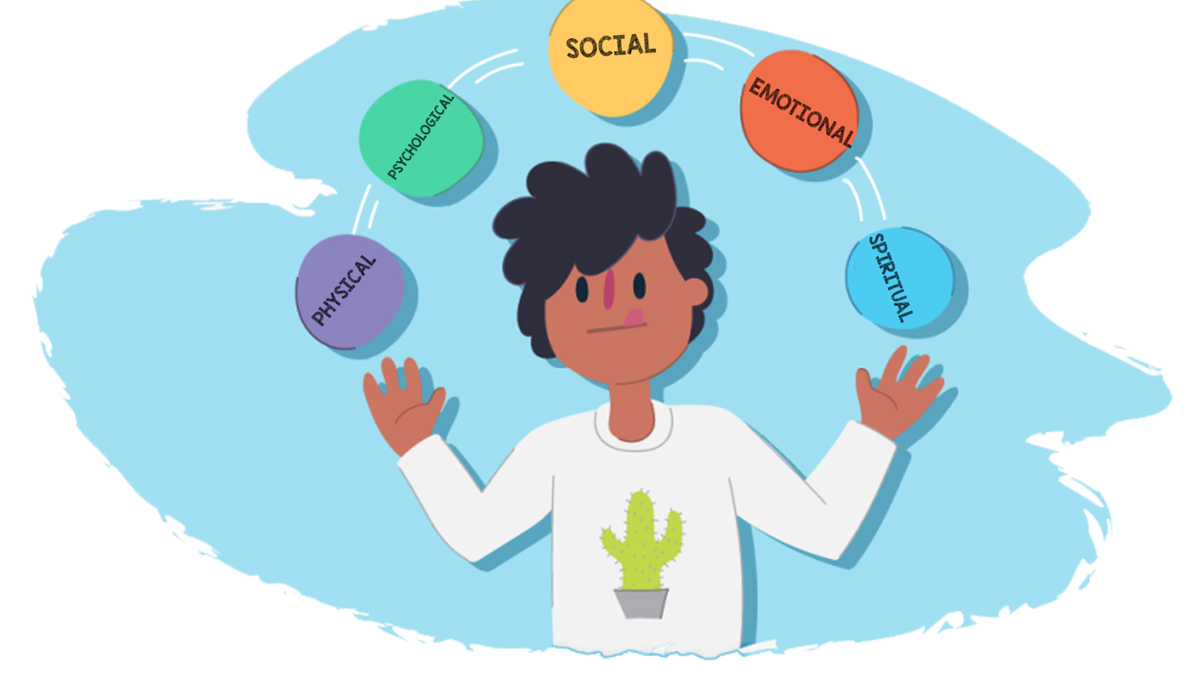
These FIVE areas make up each individual person.

Activity 2:
Khanye needs your help balance his life. Look at the list below for some tips.
E.g. Physical- Not doing enough exercise. Advice- start walking your dog twice a week to build
fitness and improve health.

Domain of Life out of balance: Social, Psychological
Advice:
Clean up your act! Stay away from drugs and unprotected sex. This is just the beginning of so many possible things going wrong in the future including addiction, HIV, STI’s.

Domain of Life out of balance: Physical
Advice: Get a full night’s sleep and put your phone off before bed

What it means to live a healthy lifestyle:
Physical | - Get enough sleep. You need about 10h sleep a night.  - Get at least 30min of exercise every day.  - Spend more time outdoors walking in the fresh air.  - Eat healthy. Be aware of what you eat and how it affects your body.  - Avoid fast food and excess sugar.  - Drink lots of water, your body is made of 60% water. You need water to maintain balance in your body.  - Stay drug free
Emotional | - Practice expressing your feelings appropriately. Do not keep your emotions locked inside you. Learn to express anger, love, grief and guilt.  - Make each day count. Enjoy living in the moment and build up an emotional language.
Social | - Be kind and helpful to other people.  - Be known for being a good and faithful friend.  - Choose your friends wisely. People you can rely on in tough times.
Psychological: | - Make informed, wise decisions  - Be self-disciplined. Manage your time and be self-motivated to complete tasks.  - Learn from your past experiences in terms of how you handled situations. Identify negative behaviour within yourself and the best way to behave in the future.  - Set goals for the future.
Spiritual: | - Be content with not rushing around and always being around people. Learn to find peace in the quiet moments by yourself.  - Enjoy being outside, walking amongst the trees, on the beach and enjoying the warm sun.  - Reflect and appreciate the value of being human. Become a person who is grateful for the small things in life. Pray, meditate, sing spiritual songs and read spiritual uplifting verses.  - Join a religious or faith group. Become part of a community with similar values and beliefs.  - Choose what you will believe and then stick to it.

Activity 3:
Complete the worksheet below by choosing the most likely: Almost Always, Sometimes, Never. Each response will give you a total. Read the comments at the end of the activity to see how you have done.
Learners will give personalized responses to this activity.
 |  | Almost Always | Sometimes | Never
1 | I enjoy being a teenager and am happy with my life. | 2 | 1 | 0
2 | I find it easy to relax and express my feelings freely. | 2 | 1 | 0
3 | I manage stress well. | 2 | 1 | 0
4 | I find it easy to communicate my emotions to my parents, siblings or a special someone. | 2 | 1 | 0
5 | I can identify my emotions when I feel them and why I feel them. Eg. I know I’m sad because I feel alone. | 2 | 1 | 0
 | Emotional Score:
1 | I eat a variety of foods each day, including seven or more servings of fruits and vegetables. | 2 | 1 | 0
2 | If I eat at a restaurant I choose to eat something healthy rather than just something that will taste great. | 2 | 1 | 0
3 | I limit the amount of fizzy drinks and take-away meals I have. | 2 | 1 | 0
4 | I avoid skipping meals. | 2 | 1 | 0
5 | I limit the amount of salt and sugar I eat. | 2 | 1 | 0
 | Nutrition Score:
1 | I engage in moderate exercise for 20–60 minutes, 3–5 times a week. | 2 | 1 | 0
2 | I sleep at least between 6-8h a night. | 2 | 1 | 0
3 | I maintain a healthy weight, avoiding being overweight or underweight. | 2 | 1 | 0
4 | I do exercises to develop muscular strength and endurance at least twice a week. | 2 | 1 | 0
5 | I spend some of my leisure time participating in physical activities such as gardening, bowling, golf, or baseball. | 2 | 1 | 0
 | Exercise Score:
1 | My friends call me when they need to share about something they’re going through. | 2 | 1 | 0
2 | When I feel angry or frustrated at someone, I feel I can still listen to their point of view. | 2 | 1 | 0
3 | When I feel down even though I just want to hide, there is someone I could trust and I can talk to. | 2 | 1 | 0
4 | I participate in group activities (such as church and community organizations) or hobbies that I enjoy. | 2 | 1 | 0
5 | I have close friends, relatives, or others I can talk to about personal matters and call on for help. | 2 | 1 | 0
 | Score:

What Your Scores Mean
Scores of 9 and 10–Excellent! Your answers show that you are aware of the importance of this area to wellness. More important, you are putting your knowledge to work for you by practicing good health habits. As long as you continue to do so, this area should not pose a serious health risk. It’s likely that you are setting an example for your family and friends to follow. Since you earned a very high test score on this part of the test, you may want to focus on other areas where your scores indicate room for improvement.
Scores of 6–8–Your health practices in this area are good, but there is room for improvement. Look again at the items you answered with a “Sometimes” or “Never.” What changes can you make to improve your score? Even a small change can often help you achieve better health.
Scores of 3–5–Your health risks are showing! You may need more information about the risks you are facing and about why it is important for you to change these behaviors. Perhaps you need help in deciding how to successfully make the changes you desire.
Scores of 0–2–Your answers show that you may be taking serious and unnecessary risks with your health. Perhaps you are not aware of the risks and what to do about them. You can easily get the information and help you need to improve, if you wish. The next step is up to you.
(To see how your health habits affect your longevity potential, take the quiz at http://www.livingto100.com.)

Activity 4: Reflection
Maybe after today’s lesson, you feel you need to make some changes in your own lifestyle. Take these last few minutes to reflect. You will need to finish this activity for homework.
Remember this is about your own health!

Recall the below five areas that make up each individual from Activity 1:
Physical- refers to your body and being physical fit, eating healthy and sleeping enough. You would try to maintain this balance.
Psychological- refers to the mental or emotional state of a person. It also includes the desire to improve yourself by avoiding risky behaviour and apply yourself in your education to be the best person you can be.
Social- You have a good relationship with your family and friends. You take part in community events and volunteer where you see a need.
Emotional- You are able to explore, express and control your emotions. You are able to recognize and influence the emotional responses of others. This can also be referred to as emotional intelligence (EQ)
Spiritual- You follow a religious belief that you have chosen. You follow the values of your religious belief and find peace and hope in meditating and praying.

Now that you remember, start by thinking about what you have learnt today about a balanced lifestyle. Look at your score in Activity 3 (Lesson 1 – Worksheet).

For each domain on the next page, start by reflecting on:
- WHERE you are at (now)
- WHERE you would like to be realistically
- Now think of ONE action you could do to make that a reality. Put a plan in place for the following week to see how you can action this plan.

Physical  WHERE am I at now:  WHERE would I like to be realistically:  ONE action I can take to make this a reality: | Psychological  WHERE am I at now:  WHERE would I like to be realistically:  ONE action I can take to make this a reality:
Social  WHERE am I at now:  WHERE you would like to be realistically:  ONE action I can take to make this a reality: | Emotional  WHERE am I at now:  WHERE you would like to be realistically:  ONE action I can take to make this a reality:
Spiritual

WHERE am I at now:

WHERE would I like to be realistically:

ONE action I can take to make this a reality:

Learners will give personalized responses to this activity.

