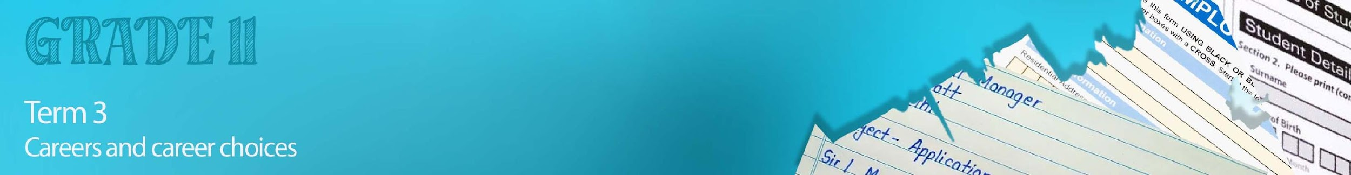


Lesson 1 – Worksheet

Activity 1:
You are required to do some research on jobs available. Using the following, research THREE jobs available.
https://southafrica.jobzz.net/
https://za.indeed.com
https://www.careers24.com/jobs/lc-south-africa/
https://za.linkedin.com/jobs/available-jobs?position=1&pageNum=0

Start by refining your search:
- indicate the province you are living in
- an area that you might be interested in as a career in the future e.g. Accounting
Choose THREE jobs and write the relevant information seen in the advertisement into the table.
See the example below:
Potential income

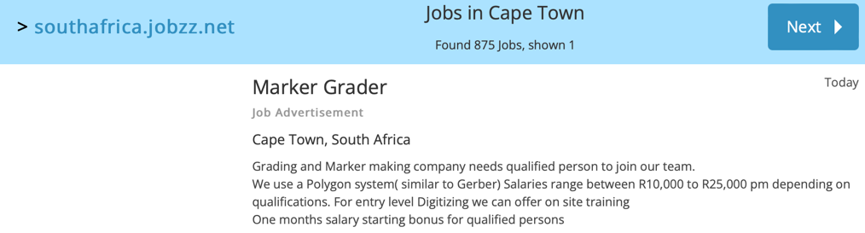
Title of job vacancy
Location of the job
Skills required/ taught.

 | Title of job vacancy | Location of the job | Skills required/ taught | Potential income
1
2
3

Choose one of the job vacancies above to use in Activity 3!
Activity 2:
Follow the link https://www.gov.za/issues/finding-job-0 and then answer the questions below on what you have learnt about applying for a job in South Africa.
1. | Name the THREE document links the department of labour provides as guidelines for applying for a job:
2. | What is a CV and why should I be honest when applying?
3. | What is the purpose of the job interview?
4. | Name TWO reasons why you should read the Basic Conditions of Employment Act.
Activity 3: Homework
Choose one of the careers you researched in Activity 1. You will now need to write an application letter for this post. Make sure you take note of the tips from the presentation listed below:
- Start by typing your letter on a computer.
- Use the correct format for a formal letter.
- Indicate where you came across the information about this job vacancy.
- Express what skills/ values you have that would benefit the company.
- Include past job experience and what you have learnt.
- Concluding thoughts …
- Remember to include the mention of attaching your CV to the application.
Activity 4:
Quickly reflect on today’s lesson and the tips/ideas that you would take away from it. Compose a short reflection in the form of a “Tweet” (no more than 120 characters in length) on what stood out to you.
