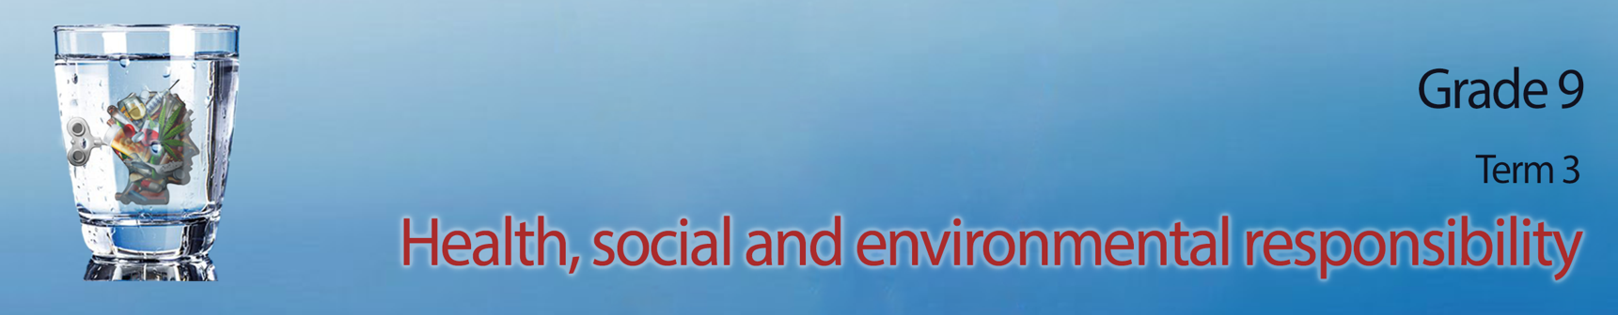

Lesson 1 - Worksheet
Activity 1: Complete the definitions of domestic abuse below by including an example
of each.
PHYSICAL ABUSE:

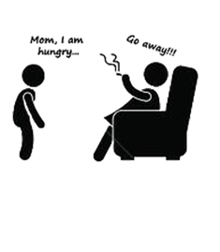



VERBAL / EMOTIONAL ABUSE:

SEXUAL ABUSE:

DAMAGE TO PROPERTY:

Activity 2:
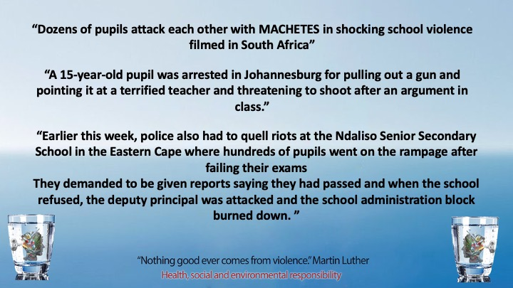
These examples of violence in schools were recorded in an online article. In your groups discuss the following questions and mind map your answers on the page your teacher has given to you.
- Do you think this is a realistic representation of violence in South African schools?
- Statistics show that violence is on the increase in SA schools. Why do you think this is?
- Why are teenagers afraid to report intimidation types of violence like bullying?
- Assess the negative impact of bullying on an individual?
- What could you do as a Grade 9 class to have a voice against violence amongst your peers? Recommend THREE strategies. Motivate your strategy.

Activity 3:
You need to research why there is violence in families, communities and among friends and peers as well
as the impact that violence has on the individual and the community.
- Complete this questionnaire below from your own point of view

- What example of violence have you seen before firsthand?

- Why do you think the person acted violently?

- What impact did this act of violence have on you or those around?
- Do you think anything could be done to prevent this kind of violence from happening again?
Please explain your ideas.

HOMEWORK!!!!
- Before the next lesson, you will need to have interviewed FIVE different members of your community. This could include a parent, neighbor, school friend etc. Bring the answers to these interviews to class. You will need this data in the next lesson. (You are welcome to include another THREE questions of your own to this questionnaire.)

- Identify which of the following describes your relationship to the interviewer:
parent community member school learner sibling friend teacher

- What example of violence have you seen before firsthand?
- Why do you think the person acted violently?
- What impact did this act of violence have on you or those around you?

Activity 4: Reflection Activity

In the space provided write an inspirational quote for your peers to encourage them to stand up against violence:

