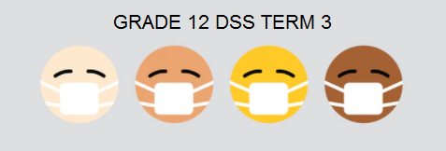

Lesson 1 - Worksheet

Activity 1: PARTNER ACTIVITY

- What are psychosomatic illnesses?

- How could religious factors result in an unwanted pregnancy?

- How could the cultural practice of wife inheritance cause the ill health (physical and emotional) of a woman?

- Explain the role that social factors play in crime and violence.

Activity 2: GROUP ACTIVITY

YOU HAVE BEEN PROVIDED WITH FIVE SHORT ARTICLES ABOUT VARIOUS CELEBRITIES AND THE LIFESTYLE DISEASES FROM WHICH THEY REPORTEDLY SUFFER OR HAVE SUFFERED. COMPLETE THE TABLE BELOW, USING THE ARTICLES PROVIDED:
 | ARTICLE A | ARTICLE B | ARTICLE C | ARTICLE D | ARTICLE E
NAME OF CELEBRITY
LIFESTYLE DISEASE
CAUSES

ARTICLE A: Masechaba Molete
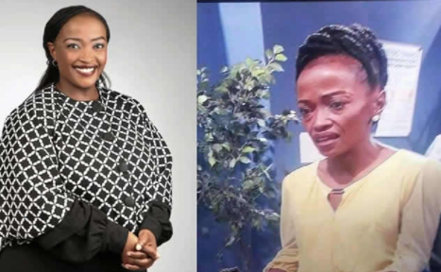
Actress Maseshaba Moshoeshoe, better known for her role in TV soapie Scandal as Mmadika shook the world when she appeared in a dramatic weight loss television series. Since then, she has revealed that she has been diagnosed with hypertension. The 36-year old was diagnosed with hypertension (or persistently high blood pressure) in 2015. “My doctor’s primary advice was to stop smoking, as I smoked heavily every day and had started at age 16, so had smoked for 15 years at that stage. I slowly cut my cigarette intake down from 20 smokes a day to my current levels. I don’t smoke at all at work, and have up to three cigarettes at night, with coffee”.
https://sasoapies.com/actress-maseshaba-moshoeshoe-dramatic-weight-loss-worries-mzansi-pics/

ARTICLE B: MICHAEL DOUGLAS

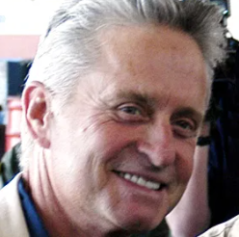
Actor and husband of Catherine Zeta-Jones, Michael Douglas has long struggled with an addiction to smoking. It was announced on August 16, 2010, that Douglas was suffering from throat cancer (later revealed to have actually been tongue cancer), and would undergo chemotherapy and radiation treatment. Douglas subsequently confirmed that the cancer was at stage IV, an advanced stage. Douglas attributed the cancer to stress, his previous alcohol abuse, and years of heavy smoking.
https://en.wikipedia.org/wiki/Michael_Douglas

ARTICLE C: TAMARYN GREEN

Johannesburg – Miss SA 2018 Tamaryn Green was brought to tears on Thursday when she discussed her battle with Tuberculosis (TB) at a press conference in Johannesburg. Green contracted TB as a third year medical student when she was exposed to patients with TB. Students who are stressed about exams and working professionals with demanding jobs can be at a greater risk of re-activating the TB strain already present in their bodies.
https://en.wikipedia.org/wiki/Tamaryn_Green


ARTICLE D: ROBERT MARAWA
Renowned sports journalist and TV personality Robert Marawa was only 35 when he suffered a heart attack in 2008. Marawa’s doctor attributed the event to the celeb’s hectic lifestyle – namely eating unhealthily, pushing himself too hard and not getting enough sleep and downtime. Following his heart attack, Marawa says he eats much more healthily, exercises often, and makes an effort to relax and de-stress on a daily basis to ensure that his cholesterol and blood pressure levels are maintained at a healthy low. He also takes aspirin and cholesterol medication.
https://clicks.co.za/health/article-view/what-you-can-learn-from-celebrities-with-heart-disease


ARTICLE E: ZOMBO
Even if you're not a Kwaito fan, you probably have heard of or seen the blond in-your-face artist whose face was always covered with sunglasses at parties and shows come day or night.
Tebogo Ndlovu popularly known as Abashante member, Zombo passed away in 2008 soon after revealing his HIV status on SABC1’s Live. Before his death, Zombo confessed that he had been sexually promiscuous and that he had no recollection of who may have infected him. Zombo took a commendable step by disclosing his HIV status to his fans. Hopefully, he sobred them to the reality that the idea of invincibility is a fallacy and that responsible behaviour is essential for the times in which we live.
http://archive.kubatana.net/html/archive/opin/080228fm.asp?sector=HIVAID

Activity 3: INFORMAL ASSESSMENT

Answer the following short questions to assess your understanding of the lesson today:

- Define the term disaster. (2)

- Provide ONE psychological factor that could lead to illness. (1)

- Provide ONE social factor that could lead to illness. (1)

- Provide TWO examples of poor eating habits and the resulting lifestyle disease
that they could cause. (2x2) (4)

