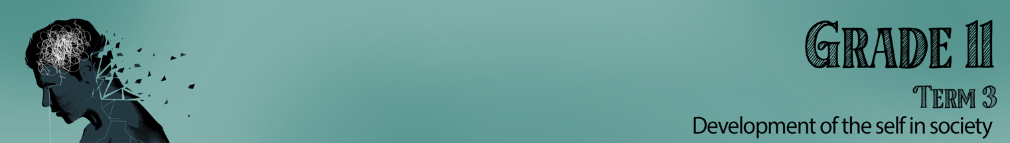
Content Summary

Lesson 1: Healthy and balanced lifestyle choices - Maintaining physical, psychological, social, emotional and spiritual health

Firstly, you need to understand what it would mean to have a “balanced life”.
Let’s start by briefly looking at your last week. What do you do in a typical day? Do you have 3 meals a day? Play sport? Spend time with friends? How about if we talk about looking at your whole week? As we look at what makes up a balanced life, keep comparing each of these domains to your own life to see where your life might be a little unbalanced.
A balanced lifestyle means that there is harmony between the different parts of your life. Have you ever found yourself so hungry that you put so much food on your plate, way more than you could possibly eat. It is important to learn how to create harmony between the different parts of our lives. So how do we do that?
First, we must understand what makes up those different parts. Let’s look at these aspects in more detail.
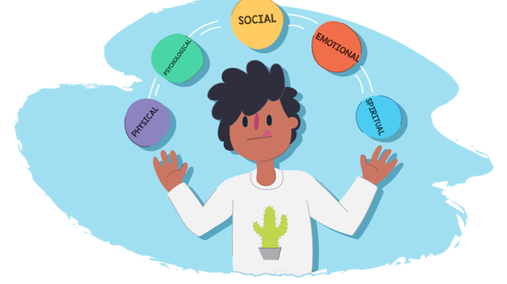
Physical- This refers to your body and being physical fit, eating healthy and sleeping enough. You would try to maintain this balance.
Psychological- This refers to the mental or emotional state of a person. It also includes the desire to improve yourself by avoiding risky behaviour and apply yourself in your education to be the best person you can be.
Social- You have a good relationship with your family and friends. You take part in community events and volunteer where you see a need.
Emotional- You are able to explore, express and control your emotions. You can recognize and influence the emotional responses of others. This can also be referred to as emotional intelligence (EQ)
Spiritual- You follow a religious belief that you have chosen. You follow the values of your religious belief and find peace and hope in meditating and praying.

Healthy nutrition and being physically active

We can see that balance in life is necessary to be happy. One of the areas that most people struggle to find balance is in exercise and nutrition. Some of us might think that we have to be running 5km every day and living on lettuce in order to be healthy. We lack the knowledge to know what our bodies really need. Some of us are even convinced that by some magic tablet or diet, we can lose weight quickly. Knowledge helps us from believing all these false trends.
Researchers have calculated that on a given day, 34.3 percent of children and adolescents ages 2 to 19 eat junk food. Two-thirds of them take in at least 25 percent of their calories from these meals.
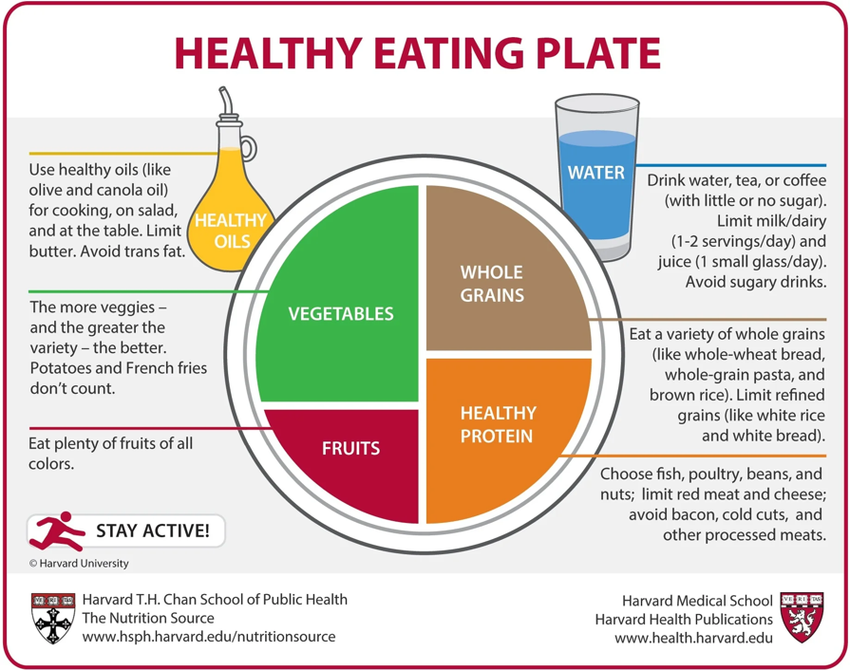
Have you ever wondered how to eat healthy? Sometimes we just don’t eat healthy because we don’t really know what that looks like.
If you imagine that every time you sit down to eat a meal, you use a medium size dinner plate and you divide your plate according to the divisions in the healthy plate example. These measurements will help you see what you should be eating.

Why are items high in sugar unhealthy?
- Eating sweets causes your blood sugar levels to rise for a short while, and then crash soon after. Fluctuating blood sugar levels lead to anxiety, mood swings, fatigue, headaches, and cravings for more sugar.
- High sugar foods damage your teeth. Since sugar is easily digestible, the harmful bacteria in your mouth feast on it and multiply rapidly. The result is tooth decay which causes bad breath and pain.
- High sugar foods impact your immunity. Organisms like bacteria and yeast thrive on sugar, so eating a lot of sweets could cause them to multiply disproportionately, making you more likely to fall sick.
- High sugar foods make you gain weight. When it comes to sweets and candy, it’s hard to eat just one piece, right? They’re so small that you don’t realize how many you’re eating. You start with one or two, then eat a few more, and before you know it you’ve eaten a whole handful. These sweets consist of empty calories that are digested quickly and use up your body’s minerals during digestion. They have no proteins, healthy fats, vitamins, minerals, or enzymes.
- High sugar foods make you resistant to insulin, which can lead to diabetes, cancer and what not. Insulin is the hormone that enables glucose (blood sugar) to enter cells from the bloodstream. Eating too much sugar can prevent insulin from working as it should, making the cells resistant to it. This is known as insulin resistance, and it can lead to several health conditions like metabolic syndrome, obesity, cardiovascular disease, cancer and Type 2 diabetes.
- High sugar foods get you addicted. Sugar is like a drug, since it activates the reward center in the brain, making it addictive. Unlike natural foods, eating sugar triggers the release of a significant amount of dopamine, leading to cravings and addiction.
- High sugar foods damage your heart. Sugar affects the pumping mechanism of your heart, increases abdominal obesity, raises your triglyceride, bad cholesterol (LDL), blood glucose and insulin levels, and increases your chances of suffering from heart failure.
- High sugar foods harm your brain. Research shows a direct link between sugar consumption and cognitive decline, so lay off the sweets if you don’t want Alzheimer’s!
(Full article- https://www.indiatimes.com/health/healthyliving/10-ways-sugar-sweetly-but-surely-hurts-your-health-244124.html )

Lesson 2: Healthy and balanced lifestyle choices

We weren't always this unhealthy. 100 years ago, people did not struggle with obesity or overindulgence or stress the way we do today. Heart disease and colon cancer happened seldom. Why? Food was grown in gardens and most families only had one parent working, meaning home environments were more stable and less stressful. Families ate home cooked meals rather than the processed meals today. Sadly, many of the choices in lifestyle we make today is because we don’t realise the impact our choices today will have on our health in the future.

Every choice we make has a consequence. If we make a bad choice like taking drugs, there will be negative consequences like death from drug abuse. In the same way, a positive choice like choosing to work hard at your schoolwork, would result in the positive effect of passing your Grade 11 year.

Poor decision-making skills. The process of making these choices requires decision making skills. You need the knowledge to know what decisions to make to prevent the negative outcome.

There are some events that happen to you that are not planned or intended, but that will cause injury or damage. For example, a car accident. A serious accident may harm aspects of your lifestyle choices.

But there are some types of accidents that can be prevented because there is something you could do to avoid it.

Sometimes the situations we find ourselves in are definitely not what we intended. I don’t think many teenagers plan to get pregnant in their teens … but decisions were made that resulted in teen pregnancy.

Unsafe attitudes and behaviours & unsafe environments: We could say that the attitude and belief of this teenager towards sex impacted their choice of behaviour. If they had agreed to using condoms or abstaining from sex, they would have prevented the pregnancy. Maybe, they had agreed to use a condom, but they were impacted by other factors that could have influenced this situation.

Emotional factors & Peer pressure:
Peer pressure could play a part and influence the attitude of this couple. The influence of friends’ opinions on sex even social media could put pressure on this couple to make unhealthy decisions.
- Alcohol abuse could impair judgement and influence the decision to be physically active to the extent of having unprotected sex.
- There could be emotional factors. Maybe one of this couple was emotionally insecure or incredibly sad and these emotions hindered their confidence to stop themselves from having sex.
- The environment plays a huge part. By choosing to be in her boyfriend’s bedroom with the door closed, knowing no one else is at home is dangerous.

Socio-economic aspects: Poor literacy, low income, poverty, and unfavourable social environments: Socio-economic factors greatly impact lifestyle choices. Sometimes the area you live, your parents’ income and how you grew up has influenced you without you having an opportunity to make your own choices. Some of the factors are:
- Education
- Environment
- Low income
- Lack of healthcare
- Crime

In South Africa we also struggle with many of these factors as well as poor literacy.

Lesson 3: Risky behaviour and situations
Substance use and abuse, unsafe sexual behaviour, risk of pregnancy, teenage suicides; poor hygiene and dietary habits, unsafe road use

Today we will look at how our attitudes and risky behavioural choices have a direct impact on a balanced lifestyle.

If you were driving a car and caused the accident because of your alcohol abuse- this is an example of risky behaviour.

Now, if you were a passenger in a car and someone else drove into your car and that person was driving drunk. You could not control the accident that occurred. This is an example of an accident.

Risky behaviour affects your personal safety and that of the people around you.
An accident is out of your control, it is not planned and causes injury or damage.

Much of what you have read about today and in the last lessons has dealt with the negative influences on your lifestyle choices. Today we focused on risky behaviour and how the impact of those decisions will affect our future.

The articles we looked at addressed:
- Substance abuse like drugs and alcohol
- Unsafe sexual behaviours
- Risk of teen pregnancy
- Poor hygiene
- Unsafe road practices
These are not the only examples of risky situations. South Africa is also desperately struggling with an increase in teen suicide and teenagers struggling with unhealthy dietary habits.

In light of all these discussions, you need to choose to “tip the scales”. This means being a person that will not follow the crowd, but rather choose to live in a way that will directly (positively) influence the success of your future dreams and goals.

Lesson 4: Risky behaviour and situations
Impact of unsafe practices on self and others: Physically, emotionally, spiritually and socially
Teen suicide impacts not only the life of the individual that is tragically lost through death but also the family, school and friends of those left behind. Worldwide we have seen an increase in teen suicides post-COVID, as teenagers face increased pressures.

I think we can see it’s not quite as simple as saying that a show was the only influence causing an increase in teen suicides. An individual could be experiencing problems with friends at school, unable to talk to their parents, struggling with depression and this show just highlights those issues.

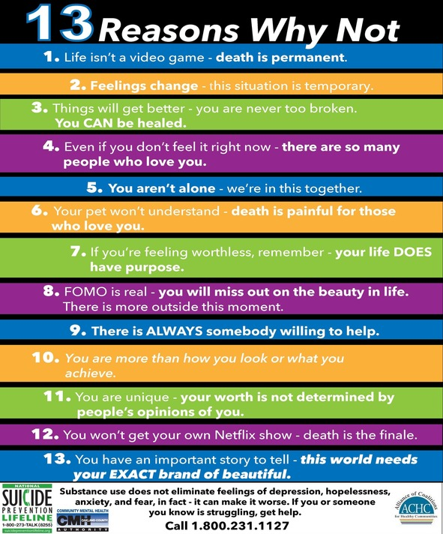
Lesson 5: Risky behaviour and situations:
Individual responsibility for making informed decisions and choices: Prioritising personal safety, seeking support and advice to change risky behaviour

The reality is that as human beings, we will make mistakes. But we need to know when we have messed up, so that we’re able to own our mistakes and make things right. This means taking responsibility for our actions and taking responsibility for our decisions. For example:

Example 1:
Someone in your class cheated on a test. You know for a fact that they did. This person messed up the curve for the test. You received a D on the test. Do you tell the teacher? Why or why not?
Example 2:
Your friend does not have enough money to go to the soccer game. He/she wants you to sneak into the game with him/her without paying. What would you do?

Tough decisions like these might be easier to some people than others. No one can make these decisions for you. So how do you make the decision?

7 Steps to decision making:
- Identify the decision you need to make.
- Gather information about the decision.
- Identify your different options or choices.
- Give at least one consequence, impact or effect of each option. (weigh the evidence)
- Choose the best option and act on your decision.
- Take action.
- Evaluate your decision: Are you happy with the outcome of your decision?
If you were in a similar situation in the future, would you make the same choice?

As we’ve mentioned before, the outcome of our decisions or choices ALL have some kind of consequence. Decision making is necessary to make responsible choices where we have considered the outcomes before we act.

Substance abuse will ALWAYS impact decision making in a negative way. Alcohol and drugs cloud your mind and prevent you from making sensible decisions. Peer pressure could result in you taking drugs, impacting your health and maybe even lead to death in the long run.

Remember this activity: “Take the step, make the change”. In this poster you need to 1) highlight 6 steps that you believe a teenager should take to break bad habits that result in a negative lifestyle. Think of all the issues we have addressed over the last few weeks. Focus on ONE issue when doing your poster. 2) You need advise learners on 5 places they can find help to overcome these issues.

Lesson 6: Factors that impact positively on lifestyle choices
Positive role models, e.g.
- Parents, peers and others
- Personal values
- Belief system
- Religion
- Social skills
- Positive cultural influences
- Economic conditions

It is important to have someone in your life that you can look up to or who motivates you to make healthy lifestyle choices. The lifestyle and values of this person could inspire you to be a better person. When we take on the positive behaviour, values, or actions of such a person as our own, we could also become a positive influence in our communities. We refer to such a person as a positive role model. Maybe you found it difficult to this of someone.

Your parents (or guardians, or person who plays that role in your family) could also be positive role models to you. Often, young children model the behaviors they see in their parents.
As teenagers, parents can have a positive effect in lifestyle choices by:
- Being supportive, encouraging and open to communicating on any topic.
- Reminding their children they a precious and valuable and loved.
- Educating their children on sexuality and the importance of decision making.
- Teaching their children about what is right and wrong and learning that choices have consequences.
- Modelling good lifestyle habits by eating healthy and exercising.

Once you have spent some time thinking, I’m sure you could list many more ways that your parents could be positive role models.

Not only people you know like your friends and peers could be a positive influence on you, but also your faith or religion could impact your lifestyle.

Being involved in a religious group in your community, would enable you to meet other people in your local community who are making a positive impact in their communities.

Your religious community might believe and teach certain values that would have a positive impact on yourself and those around you.
Eg. The Christian faith teaches you to forgive others when they have offended you. The Muslim faith promotes a healthy eating lifestyle.
Most religions teach how to live in peace and to accept one another regardless of our differences.

In the same way your cultural beliefs could have a positive influence on your lifestyle. Maybe you live in a community where sexual behaviour before marriage is disapproved of. This will protect you from teen pregnancy and other sexually transmitted infections (STI’s) if you listen to the advice of the community. Sometimes it’s just the traditions followed by a cultural group that remind you that you are not alone. E.g. Joining the Kaapse cloppers on 2de Nuwe Jaar for their celebration.
Your economic condition could also influence your lifestyle. Having money to purchase the healthy food you want to eat or pay for the gym contract where you could go exercise safely, makes it easier to make these positive changes. However, the reality is that not everyone has this privilege.

It is good to recognize the positive influence that these different media platforms could have. You could learn to cook a healthy meal on Facebook/ Instagram from a group of friends, follow sports heroes in the news and in sports matches, or watch a series that challenges you.

However, it’s important to manage your social media usage. Remember to put some boundaries in place so that you don’t waste time. E.g. No cell phones at the dinner table, when spending time with a friend, put the phone away and talk face to face. (If you need more ideas look at https://au.reachout.com/articles/5-ways-to-tame-your-social-media-use )

