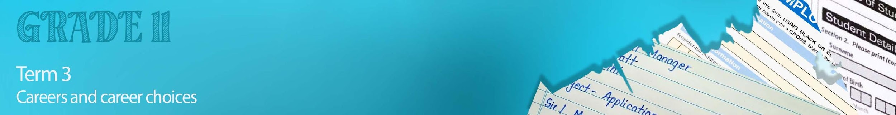

Lesson 5 – Worksheet MEMO


Activity 1:
You will now need to click on the link to the following site. https://www.universities.com/news/10-students-who-overcame-massive-obstacles
This site includes videos of 10 stories from people across the world that have achieved despite / notwithstanding challenging socio-economic conditions. Choose to watch TWO stories and answers the questions below:
- Discuss the socio-economic challenges that the people in the videos faced.
- What do these videos teach you about perseverance?
- Critically evaluate how they overcame their challenges.
- Name TWO ways in which each person has inspired you to achieve your dreams.

Learners will give personalized responses to this activity

Activity 2:

The following questions will help you prepare for your examinations at the end of the year. Answer these questions by working through your notes, using your Content Summary and applying your problem-solving skills.
Question 1:
Various options are provided as possible answers to the following questions. Choose the correct answer and write only the letter (A–D) next to the question number (1.1.1 – 1.1.4), for example 1.1.5. E.

1.1.1 Being a teacher is an example of:

- Skilled labour
- Unskilled labour
- Practical labour
- Semi-skilled labour

1.1.2. How can a grade 11 learner make themselves more likely to receive a bursary?

- Apply for bursaries that don’t apply to their field of study.
- Organise a gift or financial incentive for the bursary committee.
- Submitting incomplete applications online at the last possible moment.
- Ensure that they have suitable and many diverse accomplishments.

1.1.3. Which of the following is an example of a work-related skill that was developed during Covid-19?

- Proficiency in professional online technology.
- Ability to remain inactive for long periods.
- Overcoming boredom by starting a hobby.
- Independence when living with family members.

1.1.4 Which of the following is a reason why you must NOT lie on your CV:
- The company would decide not to hire you for the job or any future jobs.
- Interviewers could be disappointed when you don’t live up to expectations.
- A heavy fine for committing fraud by illegally misrepresenting yourself.
- All of the above
(4x1)(4)

1.2. Give ONE word/term for EACH of the following descriptions.
Write only the word/term next to the question number (1.2.1 to 1.2.4).

1.2.1 Type of tertiary education that leads to the awarding of an academic degree, diploma or certificate. Higher Education✔ (1)

1.2.2 The system that awards certain values to matric marks depending on course requirements when applying for university.
Academic point system✔ (1)

1.2.3 A short, concise document that summarises your skills, experience and abilities.
Curriculum Vitae/ CV✔ (1)

1.2.4 The self-driven skill applied by a business, employer or employee, taking responsibility for their mistakes or actions.
Accountability✔ (1)
(4x1)(4)
Question 2

Study the cartoon below and answer the questions that follow.

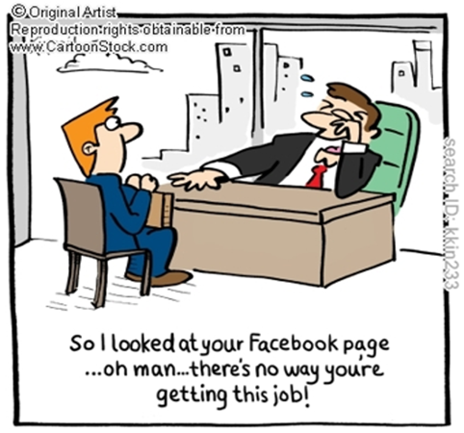

[Adapted from: https://www.cartoonstock.com
Accessed:12 June 2022]

Write paragraphs on competencies and social media usage in the job application process.
Use the following as a guideline:

- Define the term ‘competencies’ and give THREE examples of positive ethics that are part of
required workplace competences to enhance employability. (1+3)(4)

Competencies are …

- A combination of needed skills (soft and technical) relative to the job one is interested in.
- Various acumen/insights/knowhow/set of skills that a person may develop for a given workplace.
- A person’s particular abilities to complete a task well.
- Skills that allow people to handle situations in a professional manner.
- When some is capable of doing something successfully/ at a high standard.

AND
Positive ethics include …

- Respect (co-workers/supervisors)
- Punctuality
- Conscientiousness/carefulness/diligence
- Successful completion of tasks
- Dependability
- Consciousness of what to do
- Team player/ability to operate in teams
- Accountability
- Adapting to change
- Excellence
- Wanting to do your job
- Having enthusiasm
- Readiness to take new challenges
- Preparedness to think out of the box/ innovative
- Willingness to work
Any THREE of the above for ONE mark each

- Analyse the impact of unethical usage of social media on high schoolers’ attempt
to be taken seriously in the world of work. (2x4)(8)
High school learners could avoid…

- Sharing/ posting any posts that contain fake news as this indicates that they did not check the validity of any posts before sending/ sharing with others which could make a hiring agent question their attention to detail and in doing so, the hiring agent may pass them over for fear that they will do a half job.
- Posting any photos where they are drinking/drunk/ seem like they are drinking or drunk , as drinking excessively is not a healthy behaviour which could lead potential employers to think that they party/ drink excessively regularly and will not hire them for fear that they will bring the company’s name into disrepute/ come to work intoxicated.
- Allowing friends/ followers to tag them in inappropriate/ offensive content by publicly distancing themselves from this content through comments/ asking to have the post deleted/ reporting content as inaction implies that they agree with/ support the content and manager may need to discipline such people who could spread such views within the company/ associate the company with such views.
- Posting provocative/ nude/ sexually explicit content which depicts themselves or others in compromising situations which could suggest that they do not consider such content/behaviour inappropriate and this could lead to managers/ other staff lose respect for them.
- Defaming colleagues/ high profile individuals/ other people by naming and shaming them on social media for something that was said or done that they don’t agree with which could lead to legal action against them, especially if the allegations aren’t true and many companies might feel the need to distance themselves for fear of being caught up in said legal action.
- Disparaging previous companies/ employers/ colleagues by moaning about them on statuses/ posts/ comments which could make their current company/ employer/ colleagues wonder if they will also be a target and this could lead to a lack of trust and distance between them and their co-workers.
Any TWO of the above for FOUR marks each
(i.e. To be awarded the full FOUR marks for an ANALYSIS question:
candidates must give a statement, () elaborate on the statement, ()
qualify the statement () and give an outcome. ())

- Critically discuss how certain work ethics such as irresponsible usage of social media
could harm an employee’s attempts to develop his/her career. (2x4)(8)

Employees may…

- Be called in/subpoenaed/summoned by their superiors to talk about their social media usage/their profanity on social media which could be embarrassing for all involved and could lead to a work environment where they feel too uncomfortable to perform at their best.
- Experience rumours being spread by those in their office who are discussing/ twisting their social media content and these rumours could stick leading to colleagues never viewing them in a positive/ professional light which could cause feelings of social isolation and dissatisfaction at work.
- Face disciplinary action for their posts/ social media content if it does not align with the company’s values/ morals which could make them look bad in front of management/ go on their record and this could make it likely that they will be passed over for promotions/ new opportunities.
- Co-workers may lose faith in their abilities if they are able to view them acting ridiculously on social media which could mean that they actively try to avoid working with them meaning that these employees are constantly finding it difficult to work with those in their company.
Any TWO of the above for FOUR marks each.
(i.e. To be awarded the full FOUR marks for a CRITICALLY DISCUSS question:
candidates must give a statement, () elaborate on the statement, ()
qualify the statement () and give an outcome ())
(20)

Question 3

Study the cartoon below and answer the questions that follow.

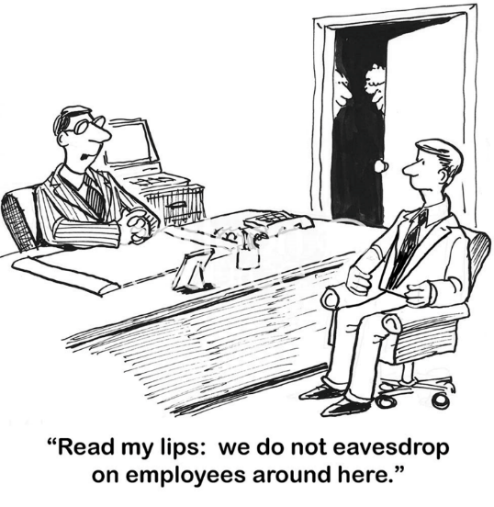

[Taken from: https://ips-dc.org Accessed on 6 June 2023]

Write paragraphs on ethics in the workplace.
Use the following as a guideline.

- Define the term ‘ethics’ and provide THREE reasons why employees need to
practice good ethics in their workplace. (1+3)(4)
Ethics:
- Norms, principles or standards that govern a person's behaviour or the conducting of an activity.✔
- A philosophy that creates a system for what is considered right and wrong behaviour✔
- Thoughts around one’s values and how one should act in accordance with those values. ✔
AND

Good workplace ethics are important because they…
- Create unity within the workplace ✔
- Allow everyone to feel safe / not discriminated against ✔
- Make everyone feel like a valuable member of the workforce.✔
- Increase company productivity.✔
- Create a good name for the company.✔
- Widen the clientele / attract more customers to the business✔
- Make customers believe in the company’s products✔
Any THREE of the above for ONE mark each

- Analyse TWO ways in which a company could break down should employees not
have good ethics in the workplace. (2x4)(8)

If there is no good ethics it could cause …
- Distrust within the company✔ as employees don’t know who to trust ✔ making it less likely that they will work together in harmony✔ causing high levels of conflict / lack of effective communication in the workplace.✔
- Employees not to do their job to the best of their ability✔ which could encourage other team members to do the same✔ thus the company becomes less productive ✔ and may not be able to meet its deadlines / deliver quality goods. ✔
- Foster a culture of lying / corruption within the workplace✔ making it very difficult to identify and rectify the problems within the company✔ which could cause a company to go into a downward spiral and close,✔ causing many to eventually lose their jobs. ✔
- Employees to treat each other with disrespect✔ making it more likely that there will be conflict in the workplace✔ which could lead to lawsuits✔ causing a financial drain on the company.✔
- Employees to become dissatisfied with their work environment ✔ and they may complain to outsiders ✔ which could create a negative name / image for the company ✔ and they may eventually lose customer support / find it difficult to get new customers. ✔
Any TWO of the above for FOUR marks each
(i.e. To be awarded the full FOUR marks for an ANALYSIS question:
candidates must give a statement, () elaborate on the statement, ()
qualify the statement () and give an outcome. ())

- Evaluate what impact implementation of corrective measures could have on
employees’ work ethics. (2x4)(8)

Possible answers may include the following:
- Allow the employee to become aware of the repercussions of their behaviour when a boss / manager / Human Resources person / higher authority sits down to highlight the problem✔ and therefore want to change because they do value their workplace and now have a better understanding of how their actions can cause harm to their company✔ however, they could also feel personally attacked✔ and purposefully bring the company’s name into disrepute out of spite.✔
- Make the employee feel valued ✔as someone took the time to invest in their personal growth and position in the company✔ however they may also feel targeted or singled out ✔ leading to resentment towards their job / company.✔
- Create a sense of fear of repercussions✔, which could cause employees to quickly change their behaviour to a more professional / ethical approach ✔ working under a constant state of fear may cause employees to panic / feel overly policed✔ leading to silly mistakes as they were too scared to concentrate properly✔
- Help motivate employees to work harder ✔as they are able to find incentives / encouragement to reach their targets✔, however, it could further demotivate employees✔ who may feel that they are trying their best and it simply isn’t good enough / not recognised. ✔

Any TWO of the above for FOUR marks each
(i.e. To be awarded the full FOUR marks for an EVALUATION question:
candidates must give the first a statement, () and qualify it (). Additionally, the learner should
give another statement () and qualify that statement. ())
(20)


Activity 3: Reflection

As we come to the end of this lesson and the end of your content for this term. Reflect on where you stand with your career dreams and career choices.

- Rate your level of understanding in the career and career choices areas covered over the past few weeks:
- Based on your ratings in the above question, which area do you need to revise and do further research in?
- Consider the questions you answered in Activity 2, which questions did you find the most
challenging?
Learners will give personalized responses to this activity

