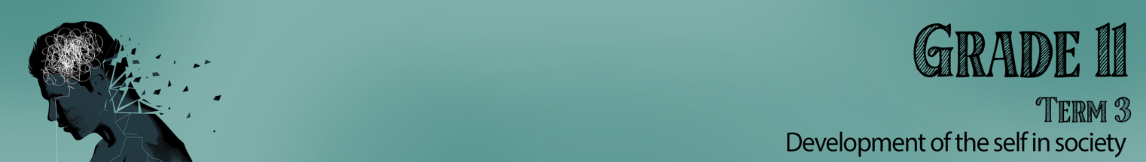

Lesson 5 – Worksheet MEMO

Activity 1:
Using the 7 steps to decision making, complete the table below.

7 Steps to decision making:
- Describe the decision you need to make.
- Gather information about the decision.
- Identify your different options or choices.
- Give at least one consequence, impact or effect of each option.
- Choose the best option and act on your decision.
- Take action
- Evaluate your decision.
Choose ONE of the following scenarios below. Using the 7 steps to decision making above, consider the best solutions. (See if you can produce a well-considered solution.)

- After school, some of your friends hang out at a nearby gas station. You decide to go with them one afternoon because your mom was going to be late picking you up. Once you get there, a couple of your friends pull out a cigarette and start smoking. They offer you a puff. What do you do?
- You are at a friend’s house. His parents have gone out for the evening. Your buddy heads straight for the liquor cabinet. You never have drunk alcohol before and you know your parents disapprove of underage drinking. But your friend promises, “You can’t smell liquor on your breath.” What do you do?
- You are at the mall with your best friend. You go into your favourite store. Your best friend picks up a really cool shirt and quickly stuffs it in her book bag. She tells you that she does it all the time and has never gotten caught. You had been looking at that shirt for a couple of weeks. What do you do?
- Trish would like to get some tattoos, but her parents are against it. They think she will regret the decision when she’s older. Trish wants to live in the moment and feels that tattoos will help express her individuality. She doesn’t have the money. What should she do?

Describe the decision you need to make.
Gather information about the decision.
Identify your different options or choices.
Give at least one consequence, impact or effect of each option.
Choose the best option and act on your decision.

The action that will be taken.
Evaluate your decision.

Learners will give personalized responses to this activity.

Activity 2:

Take a moment to think of ONE negative outcome for each of the following:
- Influence of drugs
- Alcohol
- Peer pressure

Peer Pressure / Alcohol
You could make rash decisions that put you in an unsafe situation like going home with people you don’t know.
Influence of drugs / Alcohol
There is also the possibility of teen pregnancy and even death if there is an overdose.
Alcohol / Influence of drugs
You could feel ashamed of your behaviour and not feel like you can talk to your parents. Resulting in it impacting your relationship with your parents

Activity 3:

As we finish off this lesson, walk past the different posters that were made in the previous activity, then complete the questions below.

- Name ONE issue that was addressed on a poster that you found was very creatively done - you think it will catch the eye or attention of your peers too!

- Name ONE idea for breaking habits in your own life that you learnt during the lesson today.

- Evaluate how effective you are in decision making, based on the 7 steps covered today.

Learners will give personalized responses to this activity.

