
CONTENT SUMMARY
Lesson 1:
The job contact:
- Investigate and report on the core elements of job contract:
- Discuss worker rights and obligations;
- Elaborate on conditions of service
How does the job contract provide protection to the employer / employee?
This section will prepare you by understanding the laws in South Africa that will protect you as an employee and employer. Some of you might already have a part-time job earning a little extra money. Maybe some of you intend finding work when you finish your examinations at the end of the year. Do you know how to apply for a job? What rights you have?

- An employment contract can be defined as: the contract that a company makes with an employee. The contract of employment specifies the terms and conditions that will apply between the company and the employee in the new relationship.
- It serves as a legal and binding contract between employer and employee
- An employment contract is signed by the employee and a representative of the organization
- An employment contract may not contradict the Basic Conditions of Employment Act (BCEA). This includes rules and regulations about the right to fair labour practices.
- Act is the term given to a legislation or law passed by parliament.
- Equity is the term used in a law e.g. Employment Equity Act, this term means to bring in fairness and justice into a specific area.
- Affirmative Action is a policy that aims to increase opportunities in the workplace or education to underrepresented parts of society by taking into account an individual's color, race, sex, religion, or national origin.
- Employee: The employee is the new person who will start work.
- Employer: An employer is the term given to the person employing someone.

Summary of the Core Elements of a Job Contract:
- Appointment
- Duration
- Employee duties
- Service hours
- Remuneration
- Leave (annual leave, special leave, maternity leave, family responsibility leave)
- Termination
- Signatures

As an employee, you have certain responsibilities to your new employee. These expectations will appear in the job contract. The employer knows that you also have certain rights. E.g. Once you have completed a month’s work, you have a right to receive a month’s salary. Your responsibility is to do your work well.
In South Africa we have the Basic Conditions of Employment Act which is there to:
Ensure fair labour practices such as reasonable working hours fair remuneration for work done and sufficient notice before termination of employment are sustained at all times.
Remember this is LAW in South Africa. It is there to protect you and the employer.

Lesson 2:
Labour laws:
Identify, define and discuss:
- Labour Relations Act (LRA)
- Employment Equity Act (EEA)
(Principles of equity and redress)
- Basic Conditions of Employment Act (BCEA)
How do the labour laws provide protection to the employer / employees?

THE LABOUR RELATIONS ACT (LRA)
Act 66 of 1995

Freedom of association and general protection  - Workers have the right to join trade unions and employers have the right to form employers’ associations  - No person may be discriminated against because he or she joined a union or employers’ organization. | Collective bargaining is promoted by the Act.  It is the desired method of settling wages and conditions of employment.  Registered trade unions have the right of access to the workplace.  An office bearer is an official representative of the trade union and is entitled to reasonable leave during working hours.  The employer is obliged to disclose relevant information to a trade union representative. | Freedom of association and general protection  - The Labour Relations Act created structures for the purpose of collective bargaining, as well as for bargaining and statutory councils.  - The bargaining councils, statutory councils, Commission for Conciliation, Mediation and Arbitration (CCMA) and Labour Courts are involved in settling disputes.

EMPLOYMENT EQUITY ACT (EEA)
Act 55 of 1998

To eliminate unfair discrimination and promote equal opportunity for all employees in the workplace. | To implement affirmative action that ensures equal representation in all categories and levels in the workforce. | This means that the employment policies of all businesses must prohibit discrimination against employees on the basis of race, sex, gender and disabilities. | They also have to apply affirmative action principles to provide opportunities for people form formerly disadvantage groups to advance within the workplace.

BASIC CONDITIONS OF EMPLOYMENT ACT (BCEA)

LEAVE  Employees are entitled to 21 days consecutive leave (taking all 21 days together) per year  Or by agreement one day for every 17 days of work completed. | WORK TIME  If an employee works six days a week, the maximum hours per day are eight hours.  If the employee works five days a week, the maximum hours per day are nine hours. | PAYMENT  An employee may only work overtime if an agreement was reached between the employer and employee.  Employees who work on Sundays must receive double pay, or one and a half times his or her normal wage if they normally work on a Sunday.  Should an employee work on a public holiday, double the normal wage.  An employee is entitled to 21 consecutive days fully paid leave.
CHILD LABOUR  No employer may employ a child of under 15 years of age.  Children under the age of 18 are prohibited from working in inappropriate places such as casinos and bars. | MEAL BREAKS  An employee must have a meal interval of 60 minutes after five hours work. | NOTICE PERIOD  The notice period for six months’ service is one week.  If an employee has worked for longer than one year, four weeks’ notice is required.  Should an employee be on probation but does not meet the required standard of performance, one week’s notice must be given.

Lesson 3:
Equity and redress
- Elaborate on the principle of equity and redress (see Lesson 2)
- Recruitment process: general trends and practices
- Discuss the functions of trade unions and organized labour
In term 1 we looked into job applications and briefly touched on the recruitment process. Let’s see if you can remember the names of TWO digital platforms where you can apply for a job.
- LinkedIN
- Facebook

Before we get started, let’s just refresh our memory on these basic definitions.
- Recruitment: Finding suitable people for a particular job.
- Trade union: an organisation that represents the interests of their members in the workplace.
- Federation: this refers to a group of organisations that is made up of smaller trade unions. E.g. COSATU
- Redress: a way to correct or fix something that is wrong or unfair.
- Collective Bargaining: negotiation of wages and other conditions of employment by an organized body of employees.
- Obligations: refers to the duties/ responsibilities that must be done because it is law.
The list of places you can think of where you might find a job advertised.
- Social media platforms like WhatsApp groups, Linkedin
- Facebook
- Internet- places like job seekers
- E-recruitment- registering on an internet site by creating a profile
- Newspapers

Before you can start looking for a job you will need a CV and career portfolio. The CV lists your qualifications for academic employment and the career portfolio serves as a visual picture of your skills. This is really helpful coming out of school when you don’t have much work experience.

Here are a few helpful steps if you choose to go the e-recruitment route.
- When you’ve found the job you wish to apply for. Make sure you have your CV saved as a pdf ready to upload.
- Complete some online tests to see if you are suitable for this job.
- Make sure you complete EVERYTHING on the online application.
- Include photos on your CV of yourself.

Trade unions and organised Labour:

The unions are there to represents the interests of their members in the workplace. They participate in collective bargaining on behalf of their members. E.g. wage negotiations
In the workplace you would find an office bearer that represents the union. They have the right to:
- Enter the workplace and hold meetings as well as recruit members.
- Members from trade unions have the right to elect representatives at their workplace.
- Authorise the employer to deduct subscription levies for the union.
Trade union representatives are also called shop stewards. They have the right to:
- Assist colleagues with grievances in the workplace.
- Get special leave to attend union meetings.
- Check whether employers are keeping the law in their treatment of employees.
- Get information form the employer to check that the employee can fulfil their duties e.g. dates of disciplinary hearings.

Lesson 4:
Work ethics
• Work ethics and societal expectations
• The value of work: How work gives meaning to life
Revision:
- CCMA- the Commission for Conciliation, Mediation and Arbitration
- EEA- Employment Equity Act
- LRA- Labour Relations Act
- BCEA- Basic Conditions of Employment Act
- COSATU- Congress of South African Trade Unions
- Name two groups of people the LRA does not apply to:
Secret service, Nursing unions, National Defence Force.

Let’s start by taking a look at some important definitions you need to know in this section.
- Self-Actualisation: to achieve your potential and feel good about yourself.
- Principle: in the context of work, it’s the basic rule that explains how something works.
- Dismissal: the act of ordering someone to leave, “being fired”.
- Work Ethics: Being part of a work environment requires a level of responsibility. You need to be the kind of person that others enjoy working with. These ethical and moral standards show us what is right and wrong and are based on how you respect yourself, others and your surroundings. Every work environment has certain ethical rules they expect you to follow. For example, its unacceptable to steal the work stationary no matter where you work. People with a work ethic, work hard and do a good job no matter where they work.
- Societal Expectations: what people believe you should do or how you should behave in the work environment. For example, society expects you to:
- Work if you are able to
- Fulfil your potential
- Help build the nation
- Have work ethics
- Pay your taxes
- Contribute towards the economy
- Mentor others and pass on your work experience
- Create jobs for others
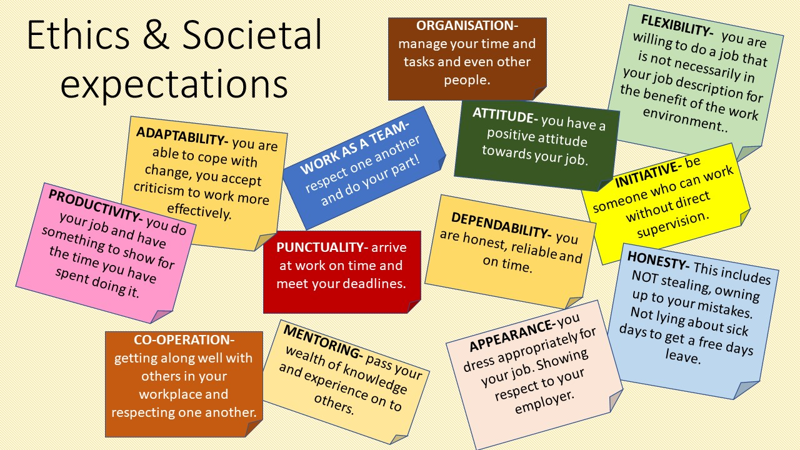

There is such a feeling of value and fulfilment that comes with working. When you earn your first pay check, I promise you, you’ll feel on top of the world. Why? Because of the sense of achievement. However, we will only find value in our work if we have passion- that means enjoying the work we do. That is why it’s important to choose a career you will enjoy. If you have meaning in life and feel fulfilled in your work, you have self-actualisation.

