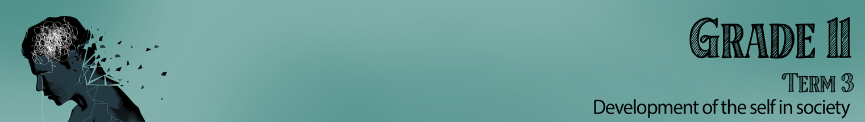


Lesson 4 – Worksheet MEMO

Activity 1:
In reaction to the Netflix series, write a response that you would post on their Instagram page:
“13 Reasons Why NOT”
(Think of your friends, family and people you love when making this list below.)

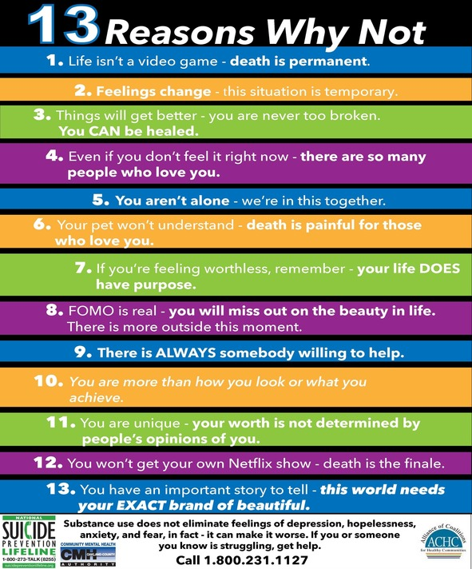
Activity 2:
You will need to identify the emotional, physical, social and spiritual impact this misconduct has had on the group, individual, family identified in each column of the following scenarios:

Scenario | Social | Spiritual | Physical | Emotional
There is an increase in learners who smoke weed at breaktime and then come to class totally high. They could not concentrate and disrupted the class.  When asked why they did it?  “I felt it would relax me.” | The other learners in the class can’t concentrate when there is so much disruption.  Sometimes these learners get aggressive and have been known to threaten the teacher or other learners. | Some religions are very strict on the use of drugs and would judge not only the learners but their families for allowing this behaviour. | The effect of smoking weed could result in cases of schizophrenia and addiction.  With this addiction there will again be a ripple effect into all other areas of an individual’s well-being. | Learners could feel that they are relaxed and have no inhibitions, but the weed would also remove fear and so they could do something dangerous and not regret it at the time.
A group of 1st team rugby boys were chosen to make the Craven week for rugby. They were sent home when 7 of them were tested positive for drugs and found guilty of using banned substances.  When asked why they did it, they said “They needed to bulk up to fit into the team and be strong.” | This kind of publicity would be embarrassing for the school, the learners representing the school and impact their chances in the future rugby selections.  Drug use goes onto their record. | Some religions are very strict on the use of drugs and would judge not only the learners but their families for allowing this behaviour. | In the long term, these kinds of drugs cause weight gain and put pressure on the heart and other organs. | The disappointment from being kicked out after all the work to get to craven week might result in an individually struggling with anger or even spiralling into depression.

