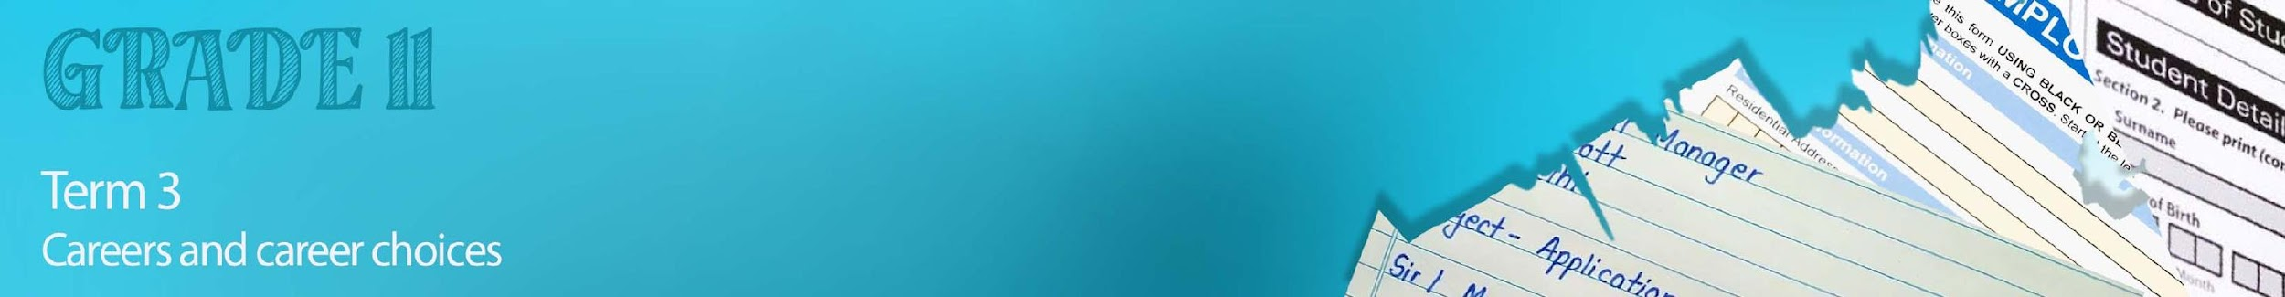

Lesson 4 – Worksheet MEMO

Activity 1:
Read the article below as a group and discuss the questions that follow. Choose a group leader to present feedback to the class.
Why Blue-Collar Work Can Give Gen Z A Fresh Competitive Advantage

Little to no education debt, low barrier to entry and a great career that stretches their skills: blue collar fields are winning the hearts and minds of Gen Z. The blue-collar world is reinventing itself—and Gen Z is here for it. Bringing their tech-savvy to bear on traditionally low-tech trades, they’re reframing the home service industry from the inside out. And why not?

Once you get past the outdated stereotypes of blue-collar work being somehow ‘lesser’ than white-collar careers, it’s easy to see just how much the trades have going for them. Blue-collar trades like plumbing, construction, electricity, landscaping, cleaning, handiwork and others offer low barriers to entry. This is great news for Gen Z, who tend to be much more averse to debt than their millennial counterparts. But it’s not the only thing that’s attractive about a blue-collar career.

This dynamic only contributes to the already growing need for more skilled-trades workers. According to Jobber’s Home Service Economic Report, the demand for skilled-trade jobs is far outpacing the supply of qualified workers to fill them. This is good news for plumbers, electricians, HVAC technicians and other trade professionals, who are now much less likely to encounter work shortages. In a recent poll, Jobber asked 1,000 respondents about entrepreneurship and what type of businesses they would open if given the opportunity. The results underscored several persistent misperceptions about the trades. According to the survey, only 20% of millennials were encouraged to pursue vocational school and only 9% of Gen Z were encouraged to start their own businesses. Half of Gen Z surveyed felt entrepreneurs with university degrees are likely to be more successful, while only 28% of Baby Boomers believed this to be true.

Social media is one arena where Chan and other industry leaders are subverting the stereotypes surrounding the trades. “Regularly posting content on TikTok and Instagram is a great way to build your brand as a business and entrepreneur,” he says. Leveraging social media has helped Chan build a large referral network and create new streams of revenue with sponsored partnerships. “I’ve actually been able to attract most of our employees through social media,” he says.

The necessity for skilled tradespeople is more pressing than ever—and it’s not something that fluctuates with a tough economy. That’s one reason that trades professionals deserve a little more respect. “
Now is an ideal moment for young people to seriously consider a blue-collar career. “
[Taken from: Why Blue-Collar Work Can Give Gen Z A Fresh Competitive Advantage (forbes.com) Accessed on 8 Junie 2023]

Answer the following questions as a group and prepare feedback for the class:

- What do you understand about the outdated “stereotypes” regarding blue collar workers?
Blue collar workers are ‘less’ than white collar workers, meaning that they might be seen as socially and economically inferior and that people doing these trades are less capable or less intelligent than those who went to university and who received a degree level education.

- Discuss ONE of the benefits of blue collar work?
- They are ‘low-barriers to entry’ meaning that it does not require the same level of qualification, but as you work, you can work on qualification
- As you study these professions you can earn a salary (earn as you learn).
- Apprentices seldom go into debt as they are qualifying.
- These jobs are in high demand so there is seldom a shortage of work opportunities because.
- There are also skills which allow you to gain employment all over the world.

- How has blue collar work changed recently and how does it appeal to Gen Z?
- Traditionally manual jobs now have a more technological element to them. This appeals to Gen Z as they enjoy being able to develop and use technology to make the work easier, more efficient or better.

- How can social media enhance blue collar industries?
- Blue collar workers can build their brands using social media as a marketing tool.
- Employers can reach out to potential employers and offer them employment via social media.
- Blue collar businesses can network with other companies via social media and so work together.

- How do you view the blue collar industry? Have the ideas discussed in the article changed your perceptions of this economic sector? Elaborate on your response.
- Learners’ own personal response.

- Reflect on some of the needs in your community where you could either join this industry or even start your own company.
- PROMPT: Think: The construction development industry; The solar panel installation industry; The tourism industry, The clean water industry etc.

