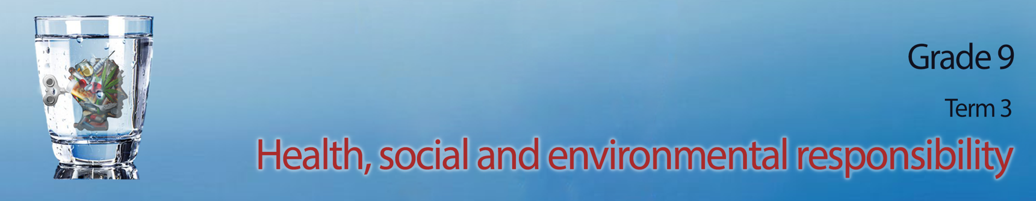

Content Summary
Lesson 1: Health and safety issues related to violence:
In this series we are going to look at different social issues relating to violence. This theme is a continuation of the same theme in Grade 8 where we looked at gender based violence and how to prevent violence against women. GBV is one of many different kinds of violence we see in South Africa.
We have seen that violence can be:
- Physical: when someone uses physical abuse to force to hurt someone else. (in most cases bodily harm)
- Verbal or emotional: when someone uses words to intentionaly cause emotional trauma. This could include manipulative behavior out of fear of further abuse.
- Sexual abuse: when someone is forced into a sexual activity against their own will even if they consented on the previous occasion.
Violence can take on many different forms and appear in different places. This includes:
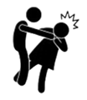
Domestic violence is the term given to violence that takes place in the home. This type of violence could be subtle which means that its not always easily recognizable. Often the abuser wants to control the home environment and the people in it. The abuser wants to scare the victim into submission so they do not fight back and try and leave the situation.
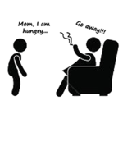
Violence at a school environment is on the rise in South Africa. Sometimes this violence has been occurring for a while but goes unreported until someone gets seriously injured or dies. Some learners feel intimidated or afraid to report this behavior.
- Physical: when learners are fighting, hitting, pushing or tripping others
- Verbal or emotional: when someone slanders another learner by spreading rumours. This could include bullying over social media platforms.

- Sexual abuse: this could include a learner forced into (intimidated) a sexual activity with a teacher or other student.
Violence in the community occurs between the different groups of people that live in a geographical area. We can also see examples of physical, emotional, sexual and damage to property in communities. In South African communities we have seen an increase in gang violence and xenophobia.
In some communities, gangs fight over control and often innocent victims are caught in the middle. Some gangs threaten the community to pay a “safety tax” to ensure their protection by the community gangs. If community members resists, they are often murdered or tortured.
Xenophobia is when groups within a community act upon their prejudice towards foreigners in their community. Sometimes this results in foreigner’s homes being burnt, individuals being tortured or murdered.

Lesson 2: Impact of violence on individual and community health and safety:
It’s so sad to hear of how many people have been victims of violence in our families and communities. I think its especially difficult when you know the person that used violence to get what they want.
There are many reasons why people become violent. Some of those include:
- frustration with authorities and so they take the situation into their own hands
- they themselves were victims of abuse and followed in the same pattern
- low self esteem and self worth
- side effects of drug and alcohol abuse
- a belief that you as an individual are better than others and have a right to treat others violently
Sadly, abusers are often respected in their communities and come across as polite individuals. In these instances it is difficult for the victim to speak about the abuse because they would be afraid of not being believed. Remember we cannot stop people directly from being violent or blame ourselves for not trying to stop them. You could end up getting hurt in the process. There are ways of reporting individuals like this. We will look at this in more detail in the lessons to come.
Violence will always cause some kind of hurt whether it is a physical and visible hurt or something more internal. It is these internal injuries that often take a long time to heal and sometimes a person will even need assistance to process the trauma of the abuse. Violence can directly impact the health and safety of both the victim and the community.
Sadly, there are communities that cannot control their violent members. Some families move out of these areas towards other areas that they feel are safer for their children. Law enforcement increases in these areas and the innocent community members are afraid of being caught in the middle of the violence (between the violent members and the law enforcement).
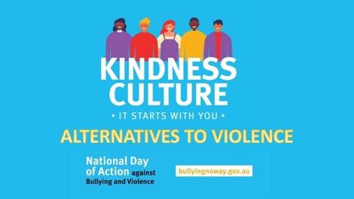
Lesson 3: Alternatives to violence: problem-solving skills and managing conflict
It is difficult to overcome tendencies towards violence. The good news is it is not impossible. Much of the effectiveness of these solutions comes from communicating where a person can find help and teaching them life skills on how to manage situations differently.

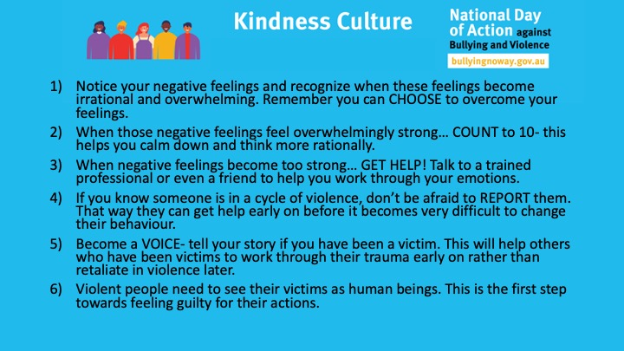

Lesson 4: Protecting oneself and others from acts of violence: where to find help National health and/or safety promotion programmes.
In this lesson we look at what you can do to prevent violence and where to go if you need help. Do you remember when we mentioned that it is important to be a listening friend. You cannot solve another person’s problems, but you can be there to listen. Sometimes, however, a person who has experienced a trauma like physical or sexual abuse will often need additional help to overcome the long term effects.
Actions you can take to protect yourself from danger and feel safe:
- If you feel in danger, try to get away immediately and go somewhere safe like the police station or a friend’s house.
- Avoid being alone and walking in places at night alone. Try going out with your friends in groups which will be much safer.
- Avoid drugs, alcohol and people that use these substances because these substances cause people to lose inhibitions and make dangerous choices.
- Do not carry any weapons. You might think it makes you feel safe, but it also opens the door to violence.
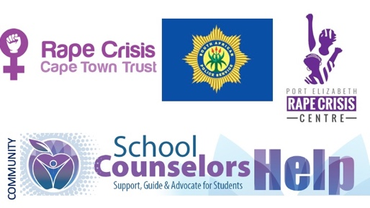
Being an individual within a community means that there are others that can help in times of violence. Each community has different resources or support centres for victims of violence. An individual can go to a local support group like the Rape Crisis Centre or a police station. These specialised units will find out what happened and provide the necessary counselling and support on what to do next.

There are several organisations in South Africa that could help if you have been exposed to violence.
If you go directly to the SA government website at https://www.gov.za/GBV, you will find there is advice on what to do if you have been abused in anyway. There is a direct link to services like Thuthuzela Care Centres in many different communities that will offer support to rape survivors. At a centre like this you would be able to report the case directly and get the necessary support to open a case and get counselling.
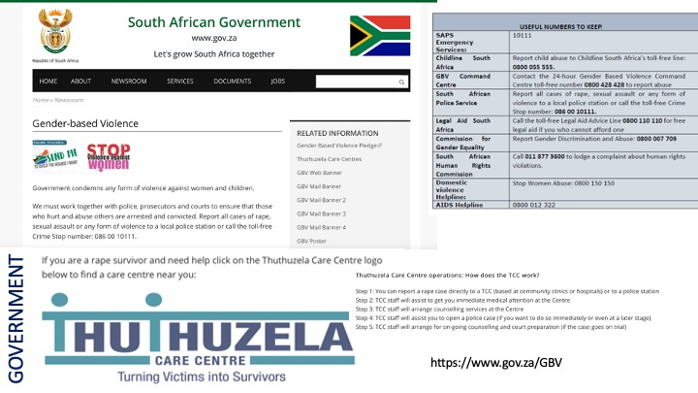

Remember, there is a chance that you might not have experienced violence yourself but we need to be sensitive because there are so many around us that have. Be the kind of person that builds a “culture of kindness”.

