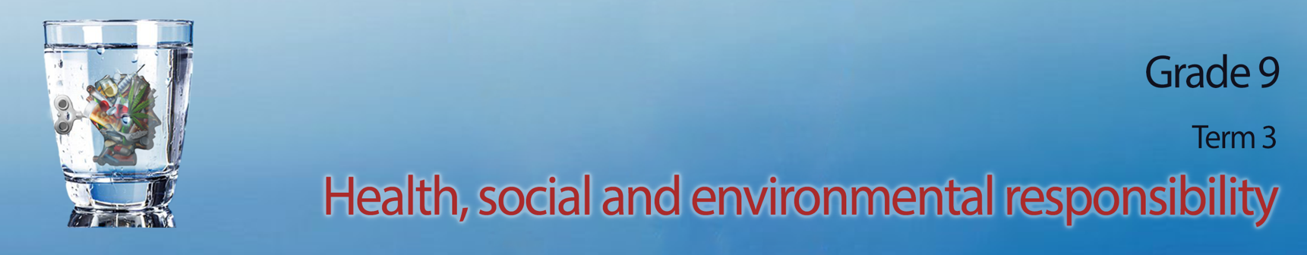
Lesson 4 - Worksheet

Activity 1: Add another THREE points to the list below on HOW you can protect
yourself from violence.

- If you feel in danger, try to get away immediately and go somewhere safe like the police station or a friend’s house.
- Avoid being alone and walking in places at night alone. Try going out with your friends in groups which will be much safer.
- Avoid drugs, alcohol and people that use these substances because these substances cause people to lose inhibitions and make dangerous choices.
- Do not carry any weapons. You might think it makes you feel safe, but it also opens the door to violence.
- .
- .
- .

Activity 2:
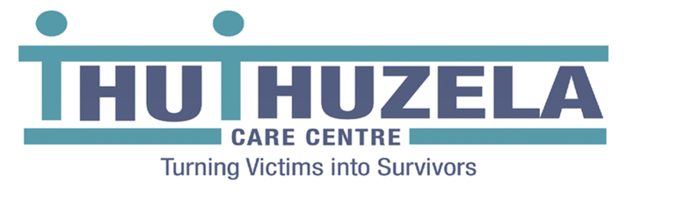
In the PowerPoint presentation your teacher covered THREE different areas that you could get help as a victim of violence. Use the list below that were covered in the PowerPoint and write them into the BUBBLE that they belong in. Also include what help they can offer the viictim of violence.


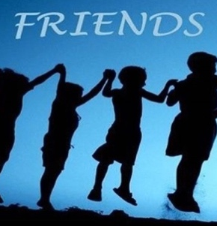

https://www.gov.za/GBV

Individual

Community

Government

Activity 3:
Question 1.1: Multiple Choice (4 marks)
Choose the correct answer and write down the letter only.
1.1.1 Bullying, blackmail, threats and manipulation are examples of:
- Domestic violence
- Psychological violence
- Collective violence
- Physical violence (1)
1.1.2 The best way to manage conflict is to:
- Give in to what the other person wants
- Compromise to create a feeling of a win-win situation
- Try to fight back and make sure you are heard
- Rather walk away and avoid the conflict (1)
1.1.3 Which of the following is a way to protect yourself from violence:
- Carry a weapon with you
- If people want to fight with you, fight back
- Walk around on your own
- Try resolve the conflict by talking (1)
1.1.4 The constitutional document that ensures that all South Africans are treated fairly and equally:
- The Bill of Rights
- LO textbook
- Human Rights charter
- South African Schools Act (1)

Question 1.2: Filling in the missing word (4 marks)
Complete the sentences below by using the words in the word-bank. You may use each word only ONCE.

Psychological SPCA Counselling Sustainable
Individual Rural Assault Emotional
Community Intimidation Guidance Abuse

1.2.1. | Physically attacking someone is known as a crime of ___________________ | (1)
1.2.2. | Volunteering for an organization such as the SPCA is a form of ___________ responsibility. | (1)
1.2.3. | _________________ violence occurs when someone's self-esteem is slowly destroyed through manipulation. | (1)
1.2.4. | The process that occurs when an abused child is helped by a qualified adult to explore difficulties such as stressful or emotional feelings is known as _________________. | (1)

Question 1.3: Short questions (8 marks)
1.3.1 Describe TWO ways how violence could impact emotionally on teenagers in a household. (2x2)(4)

1.3.2 Evaluate the negative impact of violence in communities where it is experienced as a common incidence. (2x2)(4)

(16)
Activity 4: Reflection Activity
Here is your last chance to leave a memorable quote that can make a change. First walk through the other quotes still up on the wall in the class from previous lessons. Now choose a quote or phrase that inspires others to choose kindness over violence. Write your quote in the space below and then on the page your teacher has given to you.

