
GROUP 1 (Substance Abuse)
‘Teens smoking weed are playing Russian roulette with their mental health’
https://randfonteinherald.co.za/416804/teens-smoking-weed-are-playing-russian-roulette-with-their-mental-health-or-marijuana-is-no-innocent-drug-addiction-expert/
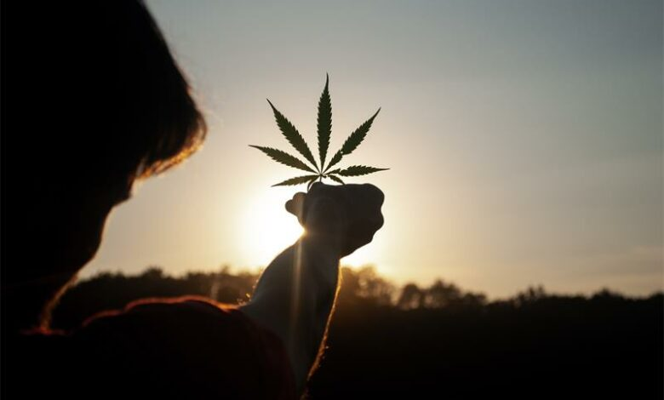
Substance abuse among teenagers is on the rise and it’s not tik or heroin that parents should be worried about. Evidence shows that heavy and regular cannabis use in childhood and adolescence has a more severe and long-lasting negative impact when compared to marijuana use in adulthood.

Younger brains tend to be more vulnerable to the negative impact of weed than the brains of adults. The cognitive deficits seen in adolescents are similar to those seen in adults, but they are more long-lasting and less likely to be reversible after cannabis use is stopped. These deficits include problems with attention, learning, and memory.
According to a summary of the evidence by the World Health Organisation, using marijuana with a higher THC content ‘may increase the risk for schizophrenia and lower the age of onset of the disease’.
This is especially true for people who start smoking the drug before adulthood. A 15-year follow-up study, that included data from over 50 000 men in Sweden, found that those who tried cannabis by the age of 18 were 2.4 times more likely to be diagnosed with schizophrenia than those who did not.
Long-term heavy cannabis use in children and adolescents is also associated with negative consequences later in life such as having a low income, being unemployed, and using other drugs.

INSTRUCTIONS:
Your group will need to use the questions below to help you prepare for the presentation. Each group will have a News Reporter who will interview two members of the group. The aim of this presentation is to highlight the main issue (risky behaviour) highlighted in each article and the impact it has had on individuals and the local community.
Your presentation will be in the form of a 2min interview per group by an imaginary reporter from CNN. You may be creative and make it interesting but remember, you only have 2min per group to present.

Your interview must include:
- An explanation of why this is an example of risky behaviour.
- How lack of knowledge, attitude and poor decision making have influenced this outcome?
- How socio-environmental factors influence these situations?
- THREE suggestions on how you (as high school learners) could educate your peers on the dangers of this behaviour.

GROUP 2 (Unsafe Road use)
Statistics show thousands of young people dying in road accidents
https://www.iol.co.za/pretoria-news/news/statistics-show-thousands-of-young-people-dying-in-road-accidents-6835a537-d89d-4f02-a493-e33362891c19
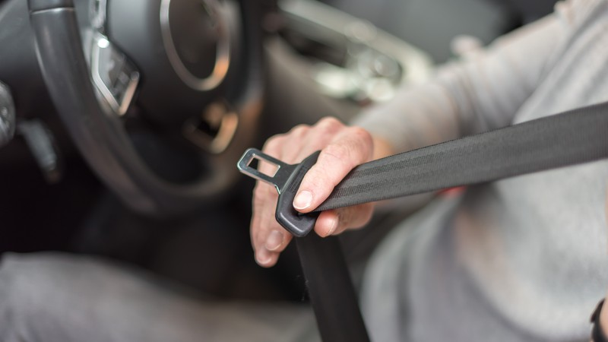
Pretoria - South Africa is experiencing an alarming epidemic of deaths amongst its youth due to road accidents that have killed a total of 8 547 young people between the ages of 21 and 34 years on the roads between 2019 and 2021.
The worst affected category is among those aged 30 to 34 years, with 3 661 of them dying.
Spokesperson for the RTMC Simon Zwane said these alarming statistics should actually serve as a clarion call to young people to prioritise road safety. Factors that contribute to the high number of road fatalities among the youth include persistent risk-taking behaviour such as reluctance to use safety belts, driving at speeds that are too fast and driving under the influence of alcohol.

Chief executive for the RTMC advocate Makhosini Msibi said South Africa faces a crisis on its roads and most of the victims are the economically active age group that is needed for the development of the country. “It is saddening to read in road crash investigation reports that in most cases people die on the roads because of failure to use safety belts. In many instances it has been found that safety belts have been cut off or tied under the seats of the vehicle and thus could not be used to save lives,” said Msibi. What scares me the most is that every festive season and Easter holidays we receive reports about road carnage and fatalities but the deaths and accidents do not seem to end. It is now like an annual song we sing about safely and drinking and driving. We are in trouble," said Mathews Phasha.
INSTRUCTIONS:
Your group will need to use the questions below to help you prepare for the presentation. Each group will have a News Reporter who will interview two members of the group. The aim of this presentation is to highlight the main issue (risky behaviour) highlighted in each article and the impact it has had on individuals and the local community.
Your presentation will be in the form of a 2min interview per group by an imaginary reporter from CNN. You may be creative and make it interesting but remember, you only have 2min per group to present.

Your interview must include:
- An explanation of why this is an example of risky behaviour
- How lack of knowledge, attitude and poor decision making have influenced this outcome?
- How socio-environmental factors influence these situations?
- THREE suggestions on how you (as high school learners) could educate your peers on the dangers of this behaviour.
GROUP 3 (Unsafe Sexual Behaviour)
Why South Africa's Girls Continue to Experience Violence at School
By Emmanuel Mayeza https://www.globalcitizen.org/en/content/south-africa-schools-gender-based-violence-girls
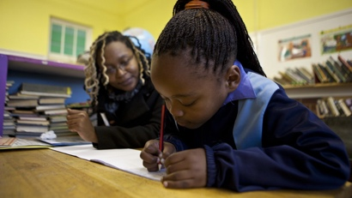
We conducted a study to learn more about South African teenage girls’ experiences at school. Violence emerged as a key aspect of their school life.
Our study took place in an urban high school in South Africa. The location has high levels of unemployment and poverty. The school’s challenges include overcrowding, old and dilapidated buildings, drug use, and violent behaviour by some learners.

The violence that girls experienced took various forms, including sexual harassment. It occurred in various school spaces such as the corridors and in an abandoned building on the school premises.
We heard that boys sexually gazed at girls in the corridors during lunch breaks and gossiped about girls’ physical appearance, their bodies, and their virginity status. Boys commented openly on their desires and demands to have sex with girls. Sexual harassment in the corridors also involved inappropriate touching. All this occurred in the public space of the school’s corridors and was witnessed by other girls and boys. Both boys and girls used drugs such as dagga (marijuana) in the dilapidated building. The pupils said this building was dominated by boys who used drugs and abused girls there during lunch breaks.
Girls also expressed the fear of being coerced into sexual relationships by older boys at school. Girls were beaten up if they refused boys’ proposals for sexual relationships.

Girls suggested it was up to the victim herself to report violence to teachers. Some said the school was too lenient to the offending boys. The school wasn’t doing enough to address the violence. Government, parents, learners, non-governmental organisations, and the broader community should be part of discussions about the root causes of the violence and effective interventions.
INSTRUCTIONS:
Your group will need to use the questions below to help you prepare for the presentation. Each group will have a News Reporter who will interview two members of the group. The aim of this presentation is to highlight the main issue (risky behaviour) highlighted in each article and the impact it has had on individuals and the local community.
Your presentation will be in the form of a 2min interview per group by an imaginary reporter from CNN. You may be creative and make it interesting but remember, you only have 2min per group to present.

Your interview must include:
- An explanation of why this is an example of risky behaviour.
- How lack of knowledge, attitude and poor decision making have influenced this outcome?
- How socio-environmental factors influence these situations?
- THREE suggestions on how you (as high school learners) could educate your peers on the dangers of this behaviour.
CASE STUDY 4 (Poor Hygiene)
Period Poverty: Everything You Need to Know

https://www.globalcitizen.org/en/content/period-poverty-everything-you-need-to-know/
The cultural shame attached to menstruation and a shortage of resources stop women from going to school and working every day. Period poverty is the lack of access to sanitary products, menstrual hygiene education, toilets, handwashing facilities, or waste management.

In addition, a study from 2017 showed that nearly 1 in 5 girls had missed school due to lack of access to period products. But efforts to recognize period poverty as an urgent issue continue to charge forward. Poor menstrual hygiene can cause physical health risks and has been linked to reproductive and urinary tract infections. Girls with disabilities disproportionately do not have access to the facilities and resources they need for proper menstrual hygiene.

Many girls and women also cannot afford menstrual materials. The tampon tax, known as the “pink tax,” is named for the frequent marketing of the color pink toward women. Although some countries around the world have lifted the tax on period products as luxury items, others continue to use it as a form of gender-based discrimination. Period shame has negative mental effects as well. It disempowers women, causing them to feel embarrassed about a normal biological process.
INSTRUCTIONS:
Your group will need to use the questions below to help you prepare for the presentation. Each group will have a News Reporter who will interview two members of the group. The aim of this presentation is to highlight the main issue (risky behaviour) highlighted in each article and the impact it has had on individuals and the local community.
Your presentation will be in the form of a 2min interview per group by an imaginary reporter from CNN. You may be creative and make it interesting but remember, you only have 2min per group to present.

Your interview must include:
- An explanation of why this is an example of risky behaviour.
- How lack of knowledge, attitude and poor decision making have influenced this outcome?
- How socio-environmental factors influence these situations?
- THREE suggestions on how you (as high school learners) could educate your peers on the dangers of this behaviour.

GROUP 5 (Teen Pregnancy)
South African teen pregnancies keep rising
By Mandisa Ndlovu
https://mg.co.za/news/2022-11-11-south-african-teen-pregnancies-keep-rising/
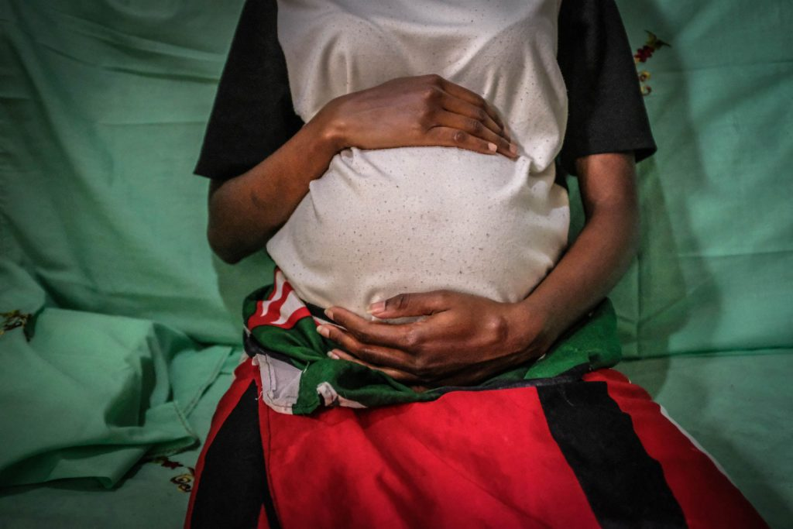
The latest adolescent pregnancy data from Statistics South Africa shows that 90 037 girls aged 10 to 19 years gave birth from March 2021 to April 2022, across all provinces.

Lieutenant Colonel James Chauke of the South African Police Service said police were overwhelmed, with cases of gender-based violence and femicide never seeming to abate.
“The scenes that I see on a daily basis say ‘not anytime soon’. It seems as if the more we arrest, the more we convict, the more brazen the criminals become. They are onto us and it is very sad,” Chauke said.

Chauke noted that early pregnancy and motherhood forced girls to drop out of school, trapping many in a cycle of poverty and being dependent on public assistance.
“It also leaves many stigmatised by society for being teenage mothers or forced into early marriage, to the point that many opt for dumping their babies,” he said.
INSTRUCTIONS:
Your group will need to use the questions below to help you prepare for the presentation. Each group will have a News Reporter who will interview two members of the group. The aim of this presentation is to highlight the main issue (risky behaviour) highlighted in each article and the impact it has had on individuals and the local community.
Your presentation will be in the form of a 2min interview per group by an imaginary reporter from CNN. You may be creative and make it interesting but remember, you only have 2min per group to present.

Your interview must include:
- An explanation of why this is an example of risky behaviour.
- How lack of knowledge, attitude and poor decision making have influenced this outcome?
- How socio-environmental factors influence these situations?
- THREE suggestions on how you (as high school learners) could educate your peers on the dangers of this behaviour.

