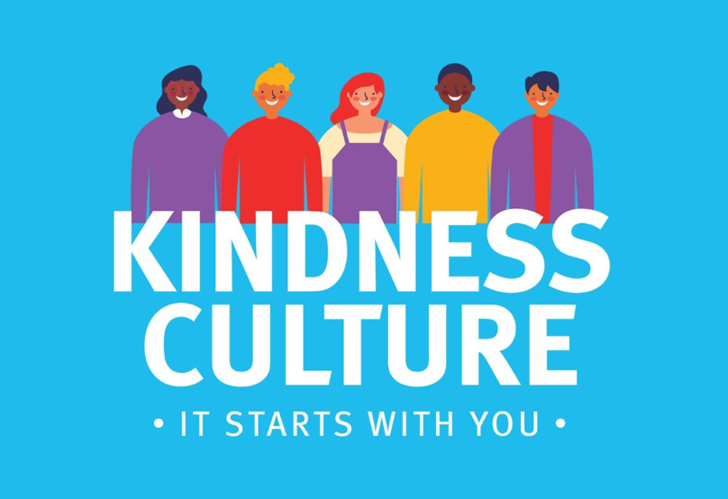
REPORTERS


Activity 2
You have been asked by the SGB to run an educational campaign called No Violence Friday later on this term. Our theme colour is ORANGE! In order to educate your peers effectively, your group will need to find different ways to tell them that there are other ways to overcome violence.

Congratulations! You have chosen the group of REPORTERS. The group leader should carefully read out the instructions to the rest of the group before you get started.

INSTRUCTIONS:
- Your group will first have to decide on their FIVE TOP TIPS to choosing an alternative to violence. Think of the list we covered earlier in the lesson as your group identifies their TOP FIVE.
- Now, you will need to decide on who in the group will play certain roles. You will need someone to be the reported that will do the interviews. Someone to be the cameraman, (who is acting like he/she is recording all the interviews ) as well as a policeman, school learner, parent / community member.
- Work together as a group to develop a few questions that the reported can ask each individual their experience of violence and then their TOP TIP for choosing kindness over violence.
- Try and do quite a few “takes“ of the interview so you keep it short and to the point. All the interviews should total no more than 3 min.
- When your group is ready, you will have opportunity to present to your class.

Your group has 20 minutes to complete this task.

RAPPERS

Activtiy 2
You have been asked by the SGB to run an educational campaign called No Violence Friday later on this term. Our theme colour is ORANGE! In order to educate your peers effectively, your group will need to find different ways to tell them that there are other ways to overcome violence.

Congratulations! You have chosen the group of RAPPERS. The group leader should carefully read out the instructions to the rest of the group before you get started.

INSTRUCTIONS:
- Your group will first have to decide on their FIVE TOP TIPS to choosing an alternative to violence. Think of the list we covered earlier in the lesson as your group identifies their TOP FIVE.
- Now, you will need to work together as a group to write a rap or song communicating these tips. Start by thinking of who the song or rap is aimed at and what you want them to know.
Just a reminder...
- No swearing!
- No profane language or suggestive language.
- No cell phone recordings. Remember this is a safe place!
- Imagine singing this RAP to your sister or mother … would you feel comfortable with the words you chose?

- Take time to practice the rap / song as a group so you can present it to the class.
- The final rap should be no longer that 3 min.
Your group has 20 minutes to complete this task.

POSTER DESIGN

Activtiy 2
You have been asked by the SGB to run an educational campaign called No Violence Friday later on this term. Our theme colour is ORANGE! In order to educate your peers effectively, your group will need to find different ways to tell them that there are other ways to overcome violence.

Congratulations! You have chosen the group of POSTER DESIGN. The group leader should carefully read out the instructions to the rest of the group before you get started.

INSTRUCTIONS:
- Your group will first have to decide on their FIVE TOP TIPS to choosing an alternative to violence. Think of the list we covered earlier in the lesson as your group identifies their TOP FIVE.
- Now, you will need to work together as a group to plan a creative layout for TWO posters. You can use the same information on each poster, they just need to look different.
- 3 group members should each work on a poster.
- This poster will need to clearly communicate to your peers:
- The TOP tips
- The name of the campaign
- What the camapign stands for and why it is important
- Where to get help if you are a victim of violence.
- Take time to make the posters visually appealing and make sure the writing is clear and easilly legible.

Your group has 20 minutes to complete this task.

BADGE DESIGN

Activtiy 2
You have been asked by the SGB to run an educational campaign called No Violence Friday later on this term. Our theme colour is ORANGE! In order to educate your peers effectively, your group will need to find different ways to tell them that there are other ways to overcome violence.

Congratulations! You have chosen the group of BADGE DESIGN. The group leader should carefully read out the instructions to the rest of the group before you get started.
(Your teacher will hand out paper for this activity)
INSTRUCTIONS:
- Your group will first have to decide on their FIVE TOP TIPS to choosing an alternative to violence. Think of the list we covered earlier in the lesson as your group identifies their TOP FIVE.
- Each member of the group will need to desig a badge that can be worn by the grade to communicate their support of NO VIOLENCE FRIDAY.
- This badge must accompany a card that explains your groups FIVE TOP TIPS. Remember to make this colorful and catchy.
- Next to your design, explain your choice of imagerty and what it stands for and how this relates to the campaign.
- Once everyone is finshed, the group must vote on the best design that they will propose to the class.
- The group leader will present the badge to the class.

Your group has 20 minutes to complete this task.

PEACE GARDEN

Activtiy 2
You have been asked by the SGB to run an educational campaign called No Violence Friday later on this term. Our theme colour is ORANGE! In order to educate your peers effectively, your group will need to find different ways to tell them that there are other ways to overcome violence.

Congratulations! You have chosen the group of PEACE GARDEN. The group leader should carefully read out the instructions to the rest of the group before you get started.

INSTRUCTIONS:
- Your group will first have to decide on their FIVE TOP TIPS to choosing an alternative to violence. Think of the list we covered earlier in the lesson as your group identifies their TOP FIVE.
- A peace garden is a temporary space that you are going to plan for in the school grouds where learners can meet. Your group needs to plan what they would have in this area to promote conversations and creating a kindness culture.
- As a group, draw a plan out and list the people you would need to talk to organise your peace garden on NO VIOLENCE FRIDAY.
- What are some activities you could plan for your peace garden to encourage team work and problem solving rather than violence?
- Complete your sketch together with notes and proposals on one A4 sheet of paper and then hand in to your teacher.

Your group has 20 minutes to complete this task.

