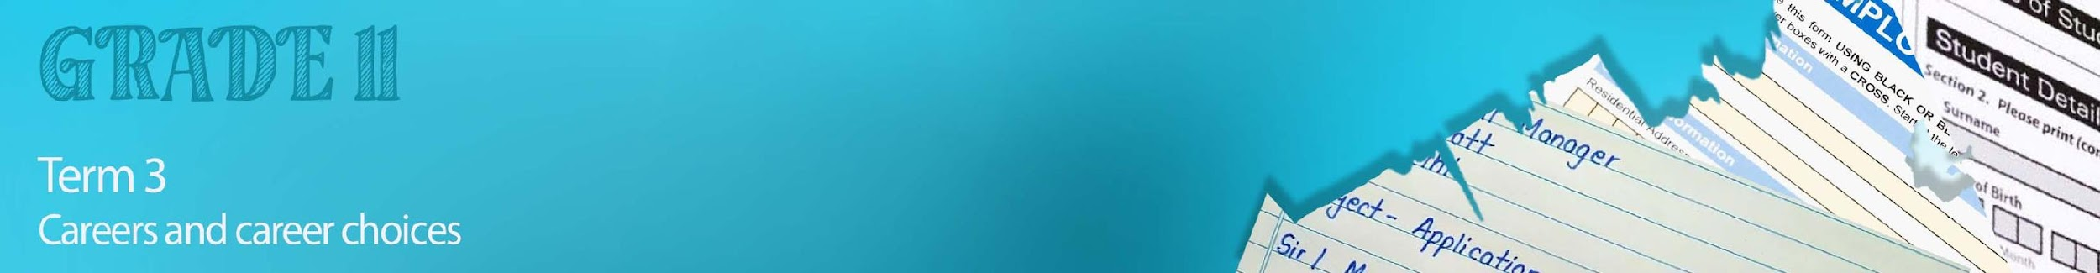


Lesson 3 – Worksheet MEMO

Activity 1:

List FIVE helpful tips you could take on from the Top Interview Tips video.
(https://www.youtube.com/watch?v=HG68Ymazo18)

Any of the following could have been included:
- Posture – Head up, shoulders pulled back, no slouching and no laid-backness.
- Treat everyone in the office with respect.
- Stay calm by taking a deep breath and slowly breathing out.
- Greet everyone in a way that is authentic to you and try to include their name.
- When greeting, make eye contact and use a firm handshake.
- Have a few topical events in mind for potential small talk.
- Be honest with your answers.
- Don’t speak negatively about previous places you have worked.
- Be aware of your movements. Practice polite and confident body language.
- Important to try to leave a good lasting impression.

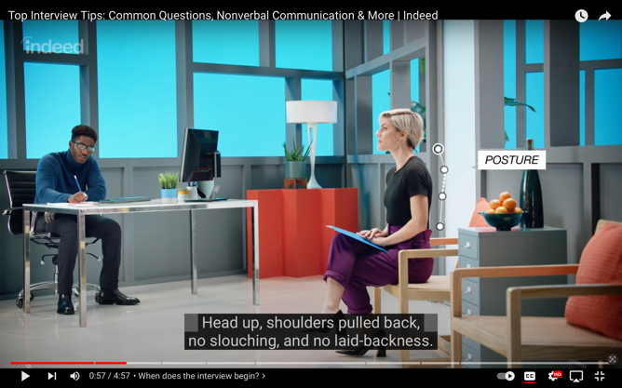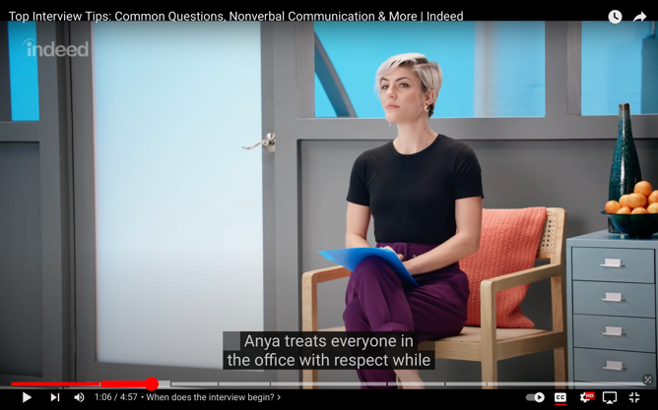
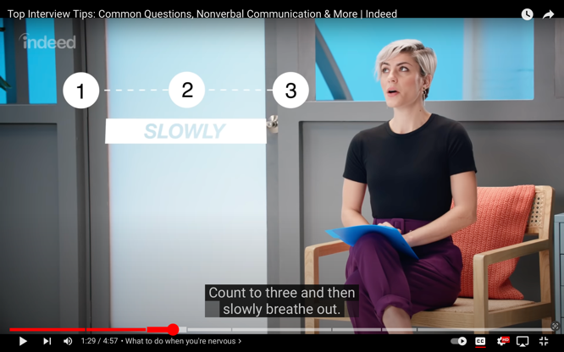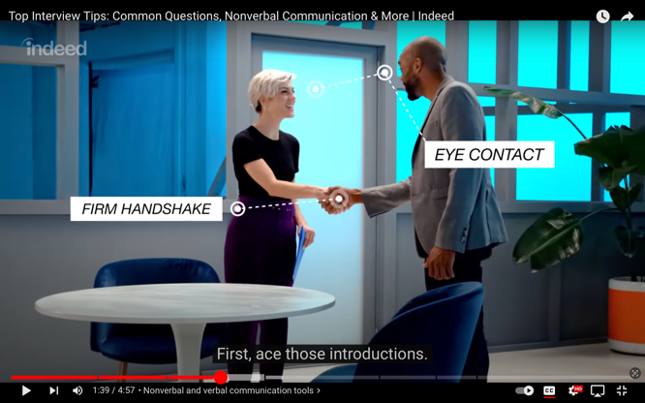
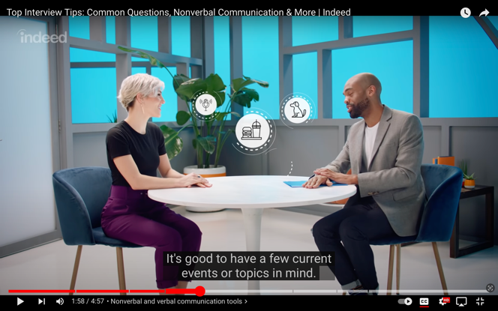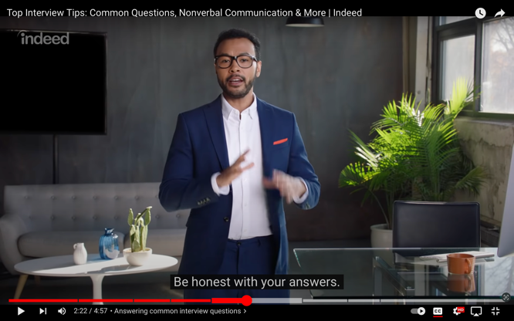
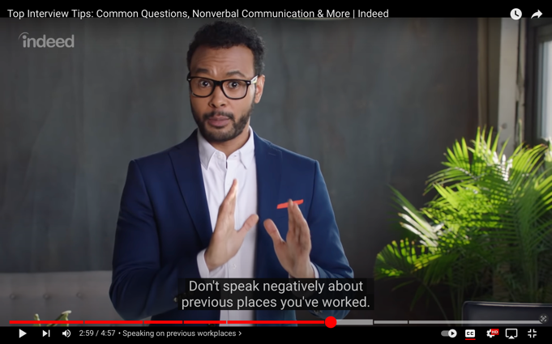
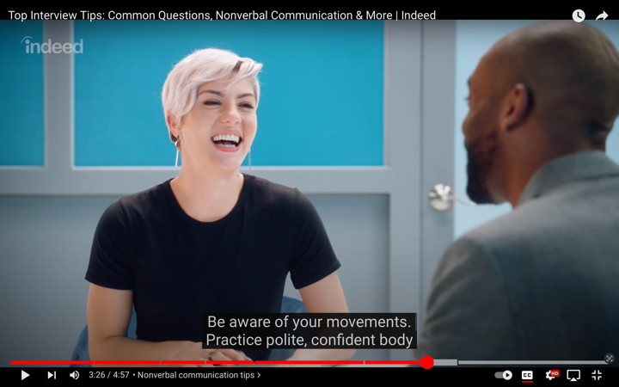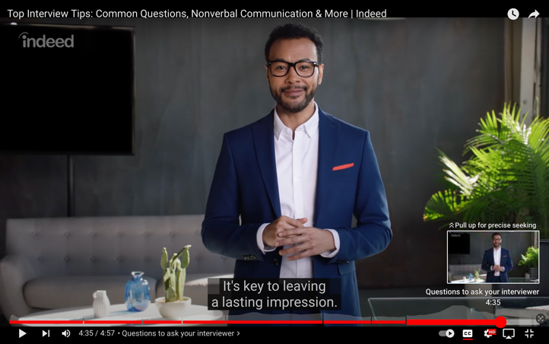

Activity 2:
You will now have only 10 minutes to prepare for an interview that will take place in class with one of your peers. Using the questions below prepare for your interview. Remember you are just making basic notes so you know what you would say in your interview.

Learners will give personalized responses to this activity

Activity 3:
Reflect on your earlier role-play interview before completing the below table.
Indicate by rating yourself with either a 1/ 2 / 3:
Learners will give personalized responses to this activity

