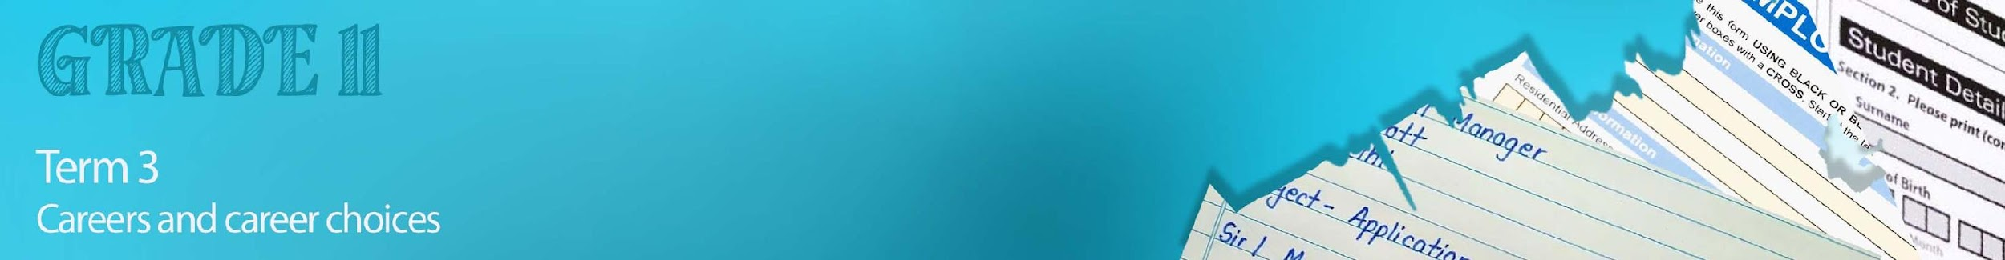


Lesson 3 - Worksheet

Activity 1:

List FIVE helpful tips you could take on from the Top Interview Tips video.
(https://www.youtube.com/watch?v=HG68Ymazo18)

1)

2)

3)

4)

5)

Activity 2:
You will now have only 10 min to prepare for an interview that will take place in class with one of your peers. Use the questions below to prepare for your interview. Remember you are just making basic notes so that you know what you would say in your interview.

Tell us a bit about yourself?

Why are you interested in this job?
Why do you think you’re the right person for the job?
What skills do you have to offer us?
What are some of your most outstanding achievements?
Do you enjoy problem solving?
Describe an example recently of where you used these skills.
At this company we believe in team players. What are some of the skills you would bring to working in a team?
Where do you see yourself in five years’ time?
Do you have any questions for me?

Activity 3:
Reflect on your earlier role-play interview before completing the below table.
Indicate by rating yourself with either a 1/ 2 / 3:
- I didn’t cope well and need to work on this.
- I coped ok but it still needs work.
- I aced it!

 | Reflection Question | Answer 1/2/3
1 | I was able to make eye contact throughout the interview.
2 | I spoke clearly and paused between questions.
3 | I feel confident that I could answer similar questions in a real interview.
4 | I feel confident that I managed to get my opinions across clearly
5 | I understood all the questions asked
6 | I came across as professional but approachable.

Which of these reflection questions did you find the most challenging and why?

_______________________________________________
_______________________________________________
_______________________________________________

