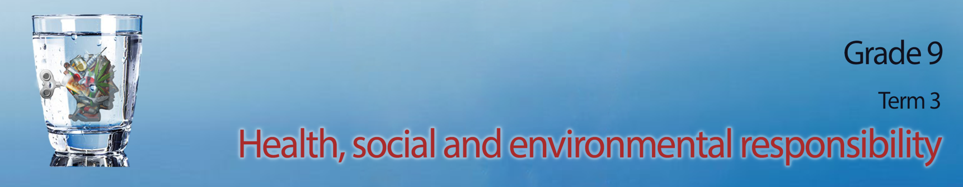
Lesson 3 – Worksheet MEMO

Activity 1: Fill in the missing terms from this list below on Alternatives to Violence:
- Notice your negative feelings and recognize when these feelings become irrational and overwhelming. Remember you can CHOOSE to overcome your feelings.
- When those negative feelings feel overwhelmingly strong … COUNT to 10 -
this helps you calm down and think more rationally.
- When negative feelings become too strong … GET HELP! Talk to a professional or even a friend to help you work through your emotions.
- If you know someone is in a cycle of violence, don’t be afraid to REPORT them. That way they can get help early on before it becomes very difficult to change.
- Become a VOICE- tell your story if you have been a victim. This will help
others who have been victims to work through their trauma early on rather
than retaliate in violence later.
- Violent people need to see their victims as people. This is the first step
towards feeling guilty for their actions.
Activity 2: Follow the instructions on your group’s instruction sheet.
Refer to Lesson 3 – Group Activity

Activity 3: Reflection Activity

Each learner will have an individual response in this reflection but ensure that it evokes
a positive response of reconciliation.

