Grade 8 Task: HEALTH, SOCIAL and ENVIRONMENTAL RESPONSIBILITY
Environmental Health & Nation Building
Research Project

Marking Guidelines
NOTE TO TEACHERS:
Learner answers will be specific to their context and may differ from the responses suggested in this MEMO.
Please allow for any relevant and credible responses
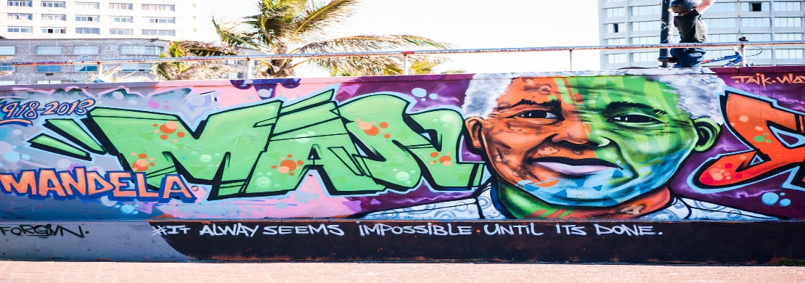
COGNITIVE LEVELS and WEIGHTING:
Question | Lower Order | Middle Order | Higher Order
1.1 | 3
1.2 | 5
1.3 | 2
1.4 | 2
1.5 |  | 4
1.6 |  | 4
1.7 |  |  | 6
1.8 |  |  | 4
SUBTOTAL | 12 | 8 | 10
2.1 | 2 | 4 | 4
2.2 | 4 | 6
SUBTOTAL | 6 | 10 | 4
3 | 5 | 10
4 | 5
SUBTOTAL | 10 | 10
TOTAL | 28 | 28 | 14
WEIGHTING | 40% | 40% | 20%
 | 28 | 28 | 14

SECTION A
HEALTH AND SAFETY ISSUES RELATED TO NATURAL DISASTERS:
Question 1

Conduct research on a Natural Disaster in your community or province within South Africa and a relief organisation that has provided relief efforts.

  - Identify a recent example of a Natural Disaster in your community or province within
South Africa and describe the disaster. (1 + 2) (3)
(Lower Order)
Marks should be awarded as follows:
ONE (✓) mark for identification of the Disaster
and
TWO (✓✓) marks for a well described response

SAMPLE ANSWER:
- FLOODING ✓ in KZN and landslides because of flooding ✓
Heavy rains (far above average rainfall) ✓ resulting in devastating flooding and areas being submerged and washed away. ✓
- WILDFIRE ✓: The most destructive fire South Africa has experienced was the Knysna Fires which occurred in June 2018.✓ The fires displaced around 10,000 people and destroyed an estimated 600 structures. Seven people lost their lives in the fires.✓ Cape Town periodically experience severe fires on Table Mountain that often cause great damage to property and sometimes loss of life.✓
- DROUGHT✓: In 2018, our country experienced one of the longest lasting droughts ever recorded.✓ The government declared it a national disaster and introduced several measures to reduce the consumption of water. Some regions had high temperatures with little rainfall since 2015.✓ Crops failed, livestock were lost, and much wildlife perished. ✓ Cape Town, the Mother City experienced severe water restrictions and came within days of Day Zero.✓
- TROPICAL CYCLONE ✓: The recent Storm Eloise that hit our shores in February this year✓ left 11 people dead.✓
OR
in March 2019, a tropical depression moved ashore Mozambique, ✓ and later moved into the Mozambique Channel, strengthening into Cyclone Idai. ✓ The intense tropical cyclone made landfall near Beira and is estimated to have killed around 1,000 people. ✓

Other possible answers:
- Tornado and severe winds ✓ And relevant explanation ✓✓
- Sinkholes ✓ And relevant explanation ✓✓
- Hailstorms ✓ And relevant explanation ✓✓

  - List FIVE consequences of this kind of Natural Disaster that your community or province
within South Africa is experiencing. (5 x 1) (5)
(Lower Order)
Marks should be awarded as follows:
ONE (✓) mark for a well explained response

SAMPLE ANSWER

- Displacement of people because of losing their homes ✓
- Loss of home, possessions and belongings, things that are sentimental ✓
- Loss of life – people may have been killed due to the severity✓
- Trauma due to the severity of the incident, loss of family members ✓
- Businesses being lost – leading to loss of income for families✓
- Poverty because of job losses✓
- Hunger – crop losses✓
- Illness due to environmental factors ✓
- Infrastructure damages – road, electricity, water. People not having access to these basic services✓
- Damage to the ecosystem and natural landscape✓
- Civil unrest, looting/stealing✓

A similar valid response should be accepted for ONE mark

Natural disasters happen almost every year in South Africa. Loss of life, trauma of survivors, access to clean water, adequate sanitation, food, shelter, and the threat of communicable diseases are all major concerns affecting the management and recovery period of a natural disaster. Measures should be implemented to help people survive such disasters since many natural disasters happen without warning.

1.3 What is your understanding of the term “National State of Disaster”? (1 x 2) (2) (Lower Order)
Marks should be awarded as follows:
TWO (✓✓) marks for a well explained response

SAMPLE ANSWER

National State of Disaster:
- Empowers government to take the measures ✓ that prevented many more people from becoming severely ill and saved countless lives.✓
- State of disaster intends to deal with emergencies such as natural disasters, explosions, terrorism, or sieges, ✓ but it can also be used to deal with “a plague or an epidemic”.✓

A similar valid response should be accepted for TWO marks

1.4 State the name of the Relief Organisation you have identified in your research as well
as the main function of the organisation. (1 + 1) (2)
(Lower Order)
Marks should be awarded as follows:
ONE (✓) mark for identification of the Relief Organisation
and
ONE (✓) mark for a well described response

SAMPLE ANSWER
Example: International Federation of Red Cross Societies. ✓

- Main function is to assist in relief efforts in the aftermath of events such as the Flooding in KZN.✓
- Humanitarian network of responders.✓
- The mission of the IFRC is to inspire, encourage, facilitate, and always promote all forms of humanitarian activities by National Societies.✓
- Preventing and alleviating human suffering, contributing to the maintenance and promotion of human dignity and peace in the world.✓

A similar valid response should be accepted for TWO marks

1.5 Discuss TWO ways that the organisation you have identified has assisted people in your
chosen instance. (2 x 2) (4) (Middle Order)
Marks should be awarded as follows:
TWO (✓✓) marks for each well explained response

SAMPLE ANSWER

Example: International Federation of Red Cross Societies (KZN FLOODING)
- They have provided: hot meals
psychosocial support
protection of family links to affected individuals ✓✓
- Red Cross teams have also distributed mattresses ✓✓
- Provided first aid to displacement centres ✓✓
- Assisting in search efforts to help locate missing people ✓✓

Any TWO relevant answers for TWO marks each.
(i.e. ONE mark for statement and ONE mark for qualifier / explanation)

1.6 Discuss TWO reasons why you think the organisation you identified has been effective
and successful in assisting families and communities affected by the disaster. (2 x 2) (4)
(Middle Order)
Marks should be awarded as follows:
TWO (✓✓) marks for each well explained response

SAMPLE ANSWER

Example: International Federation of Red Cross Societies (KZN FLOODING)
- They were able to mobilise quickly as they are specialised in responding to events such as these ✓ a faster response ensures that help is there sooner rather than later. ✓
- They were able to provide what was needed and assist people with basic supplies as well as medical treatment ✓ A great deal was lost in the disaster, some of which was existing medical supplies. ✓
- Rescue teams were dispatched to help with rescue operations (search and rescue etc) ✓ the faster the response the sooner people could be rescued.✓

Any TWO relevant answers for TWO marks each.
(i.e. ONE mark for statement and ONE mark for qualifier / explanation)
1.7 Recommend THREE ways that your school could contribute to disaster relief efforts
to assist people within communities affected by a Natural Disaster. (3 x 2) (6)
(Higher Order)
Marks should be awarded as follows:
TWO (✓✓) marks for each well explained response

SAMPLE ANSWER

- Collecting non-perishable food items for food banks ✓ this can help in efforts to help those affected with food shortages and non-perishable items do not spoil/last longer. ✓
- Collecting clothes and other items ✓ that people may need because they lost their own✓
- Collecting stationery and books✓ to help learners who need them as they have lost their school belongings ✓
- Raising awareness within the community ✓ to see if community members can assist in any way ✓
- If possible, raise money as donations to aid communities ✓ in various ways depending on their needs which could be area dependent ✓

Any THREE relevant answers for TWO marks each.
(i.e. ONE mark for statement and ONE mark for qualifier / explanation)

1.8 Critically discuss TWO ways how pollution could be an issue following a Natural Disaster
such as the floods in KwaZulu Natal. (2 x 2) (4)
(Higher Order)
Marks should be awarded as follows:
TWO (✓✓) marks for each well explained response

SAMPLE ANSWER

- When a large river floods, many pollutants, such as farm waste, detergents, chemicals from processing plants, and fertilizers from crops, are swept downstream and deposited on land. ✓ These large deposits pollute drinking water and farmland.✓
- Floodwaters deposit sediments, sand and moisture in homes and other buildings.✓ This leads to mould production, and many forms of mould are hazardous to humans. ✓
- Nutrient loading, or the addition of too much plant nutrients (nitrogen or phosphorus), causes algal blooms -or an explosion of algae growth, followed by algal death and decay.✓ The decay processes consume the available free oxygen in the water and kills aquatic life.✓

Any TWO relevant answers for TWO marks each.
(i.e. ONE mark for statement and ONE mark for qualifier / explanation) (30)
NATION BUILDING:
The Spirit of Ubuntu
Question 2
Examine the text below and research the African philosophy of Ubuntu, then answer the questions that follow:
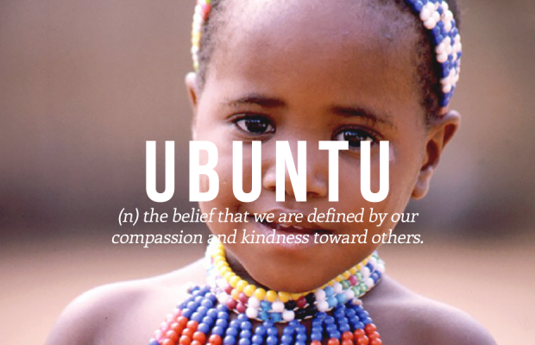
“Umuntu Ngumuntu Ngabantu” or “I am because you are” is how we describe the meaning of Ubuntu. It speaks to the fact that we are all connected, and that one can only grow and progress through the growth and progression of others.
Ubuntu has since been used as a reminder for society on how we should be treating others.

Adapted from: https://www.globalcitizen.org/fr/content/ubuntu-south-africa-together-nelson-mandela/

2.1 Write an essay in which you include the following:

- An explanation of your understanding of the term Ubuntu and what it means. (1 + 1) (2)
(Lower Order)
Marks should be awarded as follows
ONE (✓) mark for each point

SAMPLE ANSWER
Ubuntu means togetherness. ✓
It is a phrase that means we are all connected, all our actions influence others ✓

A similar valid response should be accepted for TWO marks

- A summary of how you can practice the spirit of Ubuntu in your classroom and
amongst your friends at school. Provide TWO ways. (2 x 2) (4)
(Middle Order)
Marks should be awarded as follows:
TWO (✓✓) marks for each well explained response

SAMPLE ANSWER
Learners to provide TWO examples of things they can do
- Thinking about their actions ✓and how they can affect others✓
- Bring kind and respectful towards friends and family✓ we don’t always know what others are going through. ✓
- Being fair in how they treat others ✓ we can’t expect others to treat us kindly if we don’t reciprocate✓
- Not bullying anyone ✓and treating everyone the same✓
Any TWO relevant answers for TWO marks each.
(i.e. ONE mark for statement and ONE mark for qualifier / explanation)
- Motivate TWO reasons why the spirit of Ubuntu is important now more than ever
with regards to all the things the world is facing today (Natural Disasters,
Covid-19 pandemic, conflict in the Ukraine). (2 x 2) (4)
(Higher Order)
Marks should be awarded as follows:
TWO (✓✓) marks for each well explained response

SAMPLE ANSWER
- We live in uncertain times and there are all kinds of things happening not only in South Africa but also around the world, ✓now is the time for us to stand together instead of apart to help and support each other.✓
- People need one another ✓and can help each other through difficult times.✓
- Let our differences bring us together ✓instead of further apart✓

Any TWO relevant answers for TWO marks each.
(i.e. ONE mark for statement and ONE mark for qualifier / explanation)

2.2 Design an A4 poster for your classroom to promote the spirit of Ubuntu. (10)

Use the criteria below to help you in designing your poster:
Your poster must be:
  - Colourful and attractive
  - Have pictures and a slogan
  - Promote the spirit of Ubuntu or remind your class of the principles.
NB: DO NOT PRINT FROM THE INTERNET and/or CUT and PASTE

Criteria | Mark Allocation
Correct paper size | 0  Poster size is incorrect. | 1  Poster size is correct. |  | (Lower Order)
Easy to see, clear headings and well-  spaced on poster | 0-1  Some items of  importance on the poster clear but disorganised. | 1-2  Almost all items of  importance on the  poster are clear and is mostly easy to read. | 2-3  All items of importance  on the poster are clear and easy to read . | (Lower Order)
Neatness, use of colour and images | 0-1  The poster is  somewhat neat, uses some colour and has few pictures. | 1-2  The poster is  acceptably neat, mostly colourful and has made use of relevant pictures. | 2-3  The poster is  neat and colourful and has excellent pictures that are well suited. | (Middle Order)
Content well explained on poster.  Clear that the poster will be useful in the classroom to promote the spirit of Ubuntu. | 0-1  Lacking detailed illustration of theme, lacking detailed examples.  Does not fully promote spirit of Ubuntu. | 1-2  Somewhat detailed  illustration of theme  and few if any  examples given. Content is mostly clear. Somewhat promotes spirit of Ubuntu. | 2-3  Thorough, detailed  illustration of theme and many detailed examples given. Content is clear and easy to understand. Clearly promotes spirit of Ubuntu. | (Middle Order)

Example posters for Marking Guidelines Purposes


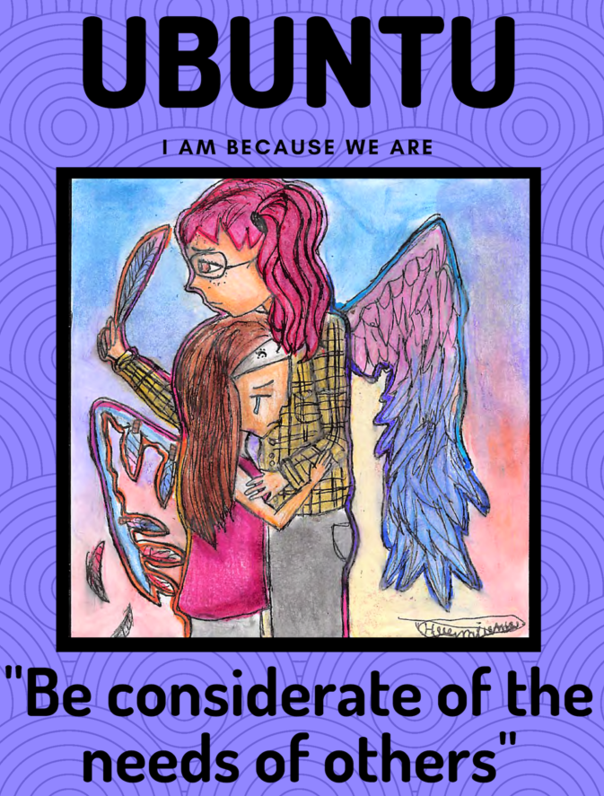

SECTION B

HERITAGE DAY & NATIONAL BUILDING

Question 3
Examine the text below and then answer the questions that follow:

National Heritage Day in South Africa:
September is Heritage Month in South Africa, with National Heritage Day celebrated on 24 September

Conduct research on Heritage Day in South Africa and write an article for your school newspaper
in which you include the following:

- Outline the purpose of Heritage Day in TWO sentences. (2 x 1) (2)
(Lower Order)
Marks should be awarded as follows:
ONE (✓) mark for each point

SAMPLE ANSWER

- A day that encourages us to celebrate our cultural traditions, communities, and heritage.✓
- Heritage Day on 24 September recognises and celebrates the cultural wealth of our nation.✓
- South Africans celebrate the day by remembering the cultural heritage of the many cultures that make up the population of South Africa. ✓

A similar valid response should be accepted for TWO marks

- Briefly explain the origins/history of National Heritage Day (3 x 1) (3)
(Lower Order)
Marks should be awarded as follows:
ONE (✓) mark for each well explained response

SAMPLE ANSWER

- September 24 was previously known in South Africa as Shaka Day, a day commemorating the Zulu King of Shaka. ✓
- He was known for uniting the Zulu clan together and forming the Zulu nation. Every year, South Africans would gather at his grave to honour him. ✓
- In 1995 a request for the day to be confirmed as an official holiday was rejected, it was later decided that the day was needed and would be known as ‘‘Heritage Day.’’✓
- Since then, South Africans have celebrated Heritage Day by remembering the cultural heritage of the many different cultures that make up their nation. ✓
- Events are held across the country with some people choosing to dress up in traditional attire.✓
- There was a media campaign in 2005 that sought to have the day recognized as National Braai Day, to acknowledge the backyard barbeque tradition, but the holiday is still officially recognized as Heritage Day.✓
A similar valid response should be accepted for THREE marks

- Discuss THREE ways how National Heritage Day contributes to nation-building in South Africa. (3 x 2) (6) (Middle Order)
Marks should be awarded as follows:
TWO (✓✓) marks for each well explained response

SAMPLE ANSWER

- Brings all South Africans together to celebrate our heritage as a country✓, this reminds us of who we are as a nation and people. ✓
- Different events are held all around the country to commemorate the day✓ , which provide opportunities to express elements of our heritage.✓
- Many people braai, and get together in groups – families, friends✓ thereby taking part in a uniquely South African activity that celebrates our heritage.✓
- Allows us to celebrate our differences and what makes us unique as a community or country✓ thereby reaffirming that we are the rainbow nation✓.
- Heritage Day is a day when people concentrate on the importance of South Africa’s cultural heritage.✓ as we value that so many different cultures and traditions have contributed to the uniqueness of South Africa. ✓
- The Department of Arts and Culture organizes annual meetings to celebrate Heritage Day by choosing a theme for each year’s Heritage Day celebrations.✓ this provides structure and guidance to the celebrations. ✓

Any TWO relevant answers for TWO marks each.
(i.e. ONE mark for statement and ONE mark for qualifier / explanation)

- Discuss TWO practical ways how you and your peers could contribute to nation building at
your school. (2 x 2) (4)
(Middle Order)
Marks should be awarded as follows:
TWO (✓✓) marks for each well explained response

This is open ended – ideally learners need to give TWO relevant and practical examples that would work in the school environment.

EXAMPLES:
- Suggest initiatives that students can get involved in
- Have a heritage day where students share their heritage and educate their peers – dressing/food.
- Have a braai day at school as a class or school activity… Could become a fundraiser?

Any TWO relevant answers for TWO marks each.
(i.e. ONE mark for statement and ONE mark for qualifier / explanation)
(15)
SECTION C

REFERENCING

You will be marked for your referencing for both Section A and Section B so be sure to follow the instructions regarding the Harvard Referencing Format, attached to this project. You will need to create a reference list (bibliography) according to the Harvard Referencing Style. All pictures will need to have a reference in your reference list as well as a caption underneath each picture.
Please see rubric below for further guidance.

No reference list = ZERO for this section.
See below rubric for more information on mark distribution.

 | 0 - 1 | 2-3 | 4 | 5
Referencing, Presentation, and editing | No reference list = 0  Just URLs/ titles listed = Max 1  Layout Instructions were not followed. Little or no effort went into making the reference list. Fewer than FIVE sources. | An attempted reference list with referencing techniques only partially adhered to.  Important aspects such as name, date and URL are present, but it lacks finer details such as publisher or name of website, etc. | Complete Harvard Reference List. Use of correct referencing techniques. No more than three minor errors or one major error. There is clear effort made to ensure that Harvard formatting instructions were followed. One or two extra sources were included. | A proper and complete bibliography. All sources perfectly referenced and listed alphabetically. Fantastic overall impression. Learner went over and above to ensure that the assignment was thoroughly referenced and included many extra sources.

(5)
(Lower Order)
GRAND TOTAL: 70 MARKS

