GRADE 8 LIFE ORIENTATION

TOPIC:
INTEGRATED PAPER
SECTION B and C only
(DSS, HSER, WOW)
Term 1 & 2
2022

60/90 MINUTES 45 MARKS

PLEASE NOTE: THIS INTEGRATED PAPER CONSISTS ONLY OF SECTION B AND SECTION C
Each question contains components from different topics covered in Term 1 and Term 2.

NOTE TO TEACHERS: Remember, this is a bank of questions and therefore may contain some overlap. Keep this in mind when selecting questions for your paper. Use the table below to help you when choosing your questions.

Weighting (suggested) | Weighting (Actual) | Cognitive level | Bloom’s taxonomy
40% | 7 marks | Lower Order | Level 1&2
40% | 22 marks | Middle Order | Level 3&4
20% | 16 marks | Higher Order | Level 5&6
All essay questions are weighted equally. Learners must complete the full combination related to a particular question.

REMINDER: Teenactiv papers should be considered as a bank of questions from which teachers can choose when creating their own question papers. Controlled test should include components of each topic covered in terms 1 & 2 for 2022.
______________________________________________________________
INSTRUCTIONS AND INFORMATION
- The question paper consists of TWO sections, namely SECTION B and SECTION C.
- The questions in SECTION B are compulsory.
- Answer any TWO questions in SECTION C.
- Read ALL the questions carefully.
- Number the answers correctly according to the numbering system used in this question paper. Start each question on a new page.
- Write neatly and legibly.
- This paper consists of 6 pages and 5 questions. (16 pages including Memo)

SECTION B: (Compulsory)
Answer all questions in this section.
Write your answers in full sentences.
Question 2
Study at the cartoon below and answer the questions that follow.

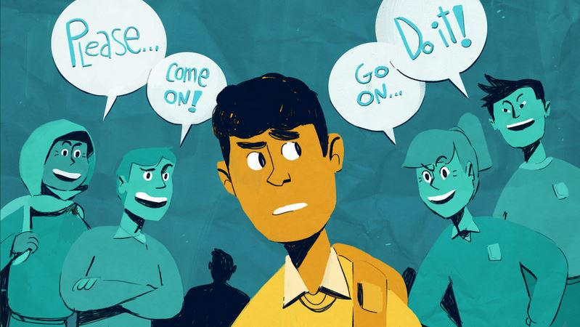

Taken from https://www.southwestcouncil.org/
blog/2019/6/26/under-pressure
(Accessed on 27 January 2022)

2.1 Define the term ‘substance abuse’. (1x1)(1)
(Lower Order)
2.2 Explain ONE way how peer pressure could have positive effects. (1x2)(2)
(Middle Order)
2.3 Why is it so difficult for teens to say “No” to their friends even when they know they
do not want to do something. (1x2)(2)
(Middle Order)
2.4 Discuss TWO ways in which teens can ensure they are making positive friendships. (2x2)(4)
(Middle Order)
2.5 Recommend TWO ways one can stand up to negative peer pressure. (2x2)(4)
(Higher Order)
[13]

Question 3
Read the quote below and answer the questions that follow.
Don't 'BE' because you HAVE to ...
'BE' because you WANT to!
Being yourself is the better choice!
Adapted from https://twitter.com/nopeerpressure
(Accessed 27 January 2022)
3.1 Define the term ’self-concept’. (1x1)(1)
(Lower Order)
3.2 Provide ONE reason why it’s important to be yourself. (1x1)(1)
(Lower Order)
3.3 Explain the importance of positive self-worth during one's teenage years. (1x2)(2)
(Middle Order)
3.4 Discuss TWO ways in which social media can negatively contribute towards the
self-concept teenagers have about themselves. (2x2)(4)
(Middle Order)
3.5 Suggest TWO ways how positive self-talk can boost your self-confidence and in
doing so, your self-concept. (2x2)(4)
(Higher Order)
[12]
[TOTAL SECTION B: 25 MARKS]

SECTION C (Choice)
Answer any TWO questions in this section.
Your responses must consist of paragraphs. Marks will only be allocated for
responses written in full sentences.

Question 4
Read the quote below and answer the questions that follow.

One true friend is better
than a hundred fake ones

Adapted from https://twitter.com/nopeerpressure
(Accessed 27 January 2022)
Write paragraphs on friendships.
Use the following as a guideline.
- Define the term “friendship”. (1x1)(1)
(Lower Order)
- Provide ONE positive impact that a good friend can have on a teen when they are
confronted with drugs. (1x1)(1)
(Lower Order)
- Explain TWO reasons why abuse of alcohol could lead to risky behaviour. (2x2)(4)
(Middle Order)
- Recommend TWO practical rehabilitation options to those teenagers that are struggling with drug abuse, to show that you care and want to support them. (2x2)(4)
(Higher Order)
[10]

Question 5

Read the extract below and answer the questions that follow.

Teenagers are likely to experience sexual fluidity during adolescence, with a new study finding one in five adolescents report change in sexual orientation or sexual attraction during that period of life.

Adapted from https://www.independent.co.uk/life-style/teenagers-sexuality-
change-orientation-adolescence-gay-bisexual-lesbian-a9184926.html
(Accessed 26 January 2022)

Write paragraphs on sexuality.
Use the following as a guideline.
- Define the term ‘sexuality’ and state ONE way how your culture could impact on your sexuality. (1+1)(2)
(Lower Order)
- Explain TWO negative ways how the media impacts on the sexuality of young people. (2x2)(4)
(Middle Order)
- Recommend TWO ways in which schools can assist learners to understand their sexuality.
(2x2)(4)
(Higher Order)
[10]

Question 6

Read the extract below and answer the questions that follow.

During Grade 9, learners are required to make their subject choices. Teachers will often encourage learners to consider how careers within a career category relate to the needs of the community.
Source: Anonymous
Write paragraphs on the role of work.
Use the following as a guideline.
- Define the term ‘career category’ and name ONE example of a career category. (1+1)(2)
(Lower Order)
- Discuss strategies and skills that can extend your personal potential within the
careers of a chosen career category. (2x2)(4)
(Middle Order)
- Recommend TWO ways a learner can become more aware of the needs of their
community. (2x2)(4)
(Higher Order)
[10]
[TOTAL SECTION C: 20 MARKS]
TOTAL = 25 + 20 = 45

