GRADE 12 LIFE ORIENTATION
TOPIC:
INTEGRATED
(DSS, DHR, SER, CCC)
Term 1 & 2
2022
2 HOURS 100 MARKS

NOTE TO TEACHERS: This Teenactiv paper should be considered as a bank of questions for (SECTIONS B AND C ONLY) from which teachers can choose when creating their own paper. Remember, this is a bank of questions and therefore may contain some overlap. Please keep this in mind when selecting questions for your paper.
Ensure your paper covers EACH topic covered in terms 1 & 2.
The controlled test will comprehensively address the content, knowledge and skills covered during the first and second term and in the Recovery ATP.
Use the table below to help you when choosing your questions.
Weighting (suggested) | Weighting (Actual) | Cognitive level | Bloom’s taxonomy
30% (30 marks) | 30 marks | Lower Order | Level 1&2
40% (40 marks) | 40 marks | Middle Order | Level 3&4
30% (30 marks) | 30 marks | Higher Order | Level 5&6
Paper is aligned with the 2021 Grade 12 Examination Guideline
______________________________________________________________
INSTRUCTIONS AND INFORMATION
- The question paper consists of TWO sections, namely SECTION B and SECTION C.
- The questions in SECTION B are compulsory.
- Answer any TWO questions in SECTION C.
- Read ALL the questions carefully.
- Number the answers correctly according to the numbering system used in this question paper. Start each question on a new page.
- Write neatly and legibly.
- This paper consists of 6 pages and 5 questions. (24 pages including Memo)

SECTION B (Compulsory)
Answer all the questions in this section.
Write your answer in full sentences.

Question 2
Read the extract below and answer the questions that follow.

Fearless and independent’ SA courts hailed for holding the line!!!

Human rights violation and conflict resolution

South African courts have been described as ‘battlegrounds for contesting political forces’ which has recently been backed up by a study comparing South Africa, Malawi and Namibia’s judicial system. Courts are meant to hold the line and protect citizens from human rights violations. To realise that, legal practitioners should always behave and handle themselves in ways befitting of their expected roles, exercise of power and discharge of responsibilities. In the same way, the other levels of government should uphold the law in the fulfilment of their constitutional responsibilities to ensure healthy and safe living space.

While that is supposed to happen, some individuals in government and in the other arms of state are mostly involved in corrupt activities which make mockery of the constitution of the republic of South Africa. Judges, magistrates and other enforcers of the law are, however, not exempt from allegations of fraud and corruption. In this way, scientific reports indicate that, in 2020, 11 % of legal officials have experienced various forms of corruption and most citizens felt let down by the courts, as justice was not effectively being served equally. This could eventually lead to high levels of conflict within the courts.

[Adapted from https://www.dailymaverick.co.za. Accessed:10 May 2022]

- Define the term ‘human rights violations’ and mention TWO ways in which courts can help protect citizens from human rights violations. (1+2) (3)
(Lower Order - DHR)

- Provide THREE responsibilities that should be upheld by the municipal government. (3x1) (3)
(Lower Order - SER)

- Describe FOUR forms of corruption which may have been experienced by legal officials. (4x2) (8)
(Middle Order - CCC)

- Suggest THREE ways which legal officials could use to diffuse possible conflict situations between themselves and citizens making use of the court system. (3x2) (6)
(Higher Order - DSS)
\
(20)
Question 3
Unemployment, crime, and corruption tops the list of young South Africans!!!

As learners near the end of their high school year, they face worries about unemployment, crime and corruption within within the working world. According to a survey conducted amongst Millenial and Gen Z South Africans these are some of the top concerns for South Africa’s young adults. Joblessness, economic growth as well as education, skills and training are also some of the stressors that have been worrying the youth.

Many fear for their mental health and wonder how they will adapt to the changes they will face as they transitions from learners into working adults with growing responsibilities. That is, is they even manage to pass their finals with all the worries on their minds.
[Adapted from https://www2.deloitte.com, Accessed: 11 May 2022]
Read the extract below and answer the questions that follow.

- Give a definition for the term ‘stressors’ and provide THREE positive coping mechanisms that matriculants can use when faced with numerous stressors. (1+3) (4)
(Lower Order - DSS)

- Explain TWO study strategies that matriculants can use to help them pass their final exams. (2x2) (4)
(Middle Order - SS)

- Discuss THREE innovative strategies that the youth could use to decrease their likelihood of being unemployed after matriculating. (3x2) (6)
(Middle Order - CCC)

- Suggest TWO ways in which the youth can adapt to change as they transition from school to the working world. In your answer, also indicate how EACH suggestion could result in learners that are more comfortable with the changes in their lives. (2x3) (6)
(Higher Order - DSS)
(20)
[TOTAL SECTION B: 40 MARKS]
SECTION C (Choice)
Answer any TWO questions in this section.
Your responses must consist of paragraphs.
Marks will only be allocated for responses written in full sentences.

Question 4

Study the extract below and answer the questions that follow.

Loadshedding and stress related to inability to make it by the end of the year.

Load-shedding impacts negatively on the education sector among other sectors and may leave a permanent dent on the country’s education progress.

[Adapted from https://www.sowetanlive.co.za/. Accessed: 13 May 2022]

Write paragraphs on loadshedding’s contribution towards matric stress.
Use the following as a guideline.

- Define the term “media” and state THREE roles that the media could play in raising awareness on study-stress resulting from inadequate provision of electricity during learning and study time, as it is common practice during loadshedding (1+3) (4)
(Lower Order - DHR)
.

- Analyse how application of good time management strategies could help matriculants make their study sessions more effective in spite of electricity disruption during loadshedding. (2x4) (8)
(Middle Order - SS)

- Critically discuss how electricity disruptions could elevate the stress levels of matriculants (2x4) (8)
(Higher Order - DSS)
(20)

Question 5

Study the text below and answer the questions that follow.
The tale of a petrol subsidy
Responsibility of government to provide community services.

The South African government planned to rescue the consumers and small business owners, but at what cost? Petrol prices may come down thanks to considerable petrol subsidies from our government in an attempt to alleviate some of the financial pressure. However, many people fear for the unhealthy impact this will have on our environment in the context of the National Environmental Management Act, as the media run the story.
[Adapted from https://businesstech.co.za. Accessed: 05 May 2022]

Write paragraphs on the petrol prices and a healthy environment.
Use the following as a guideline:

- Clarify the purpose of the ‘National Environmental Management Act’ and provide THREE ways communities can uphold this act. (1+3) (4)
(Lower Order - SER)

- Analyse how the petrol subsidy would have had a positive impact on small businesses and entrepreneurs. (2x4) (8) (Middle Order - CCC)

- Evaluate the impact that social media platforms could have on creating positive awareness on the unhealthy living environments caused by the lack of petrol subsidy. (2x4) (8)
(Higher Order - DHR)
(20)

Question 6

Study the image below and answer the questions that follow.

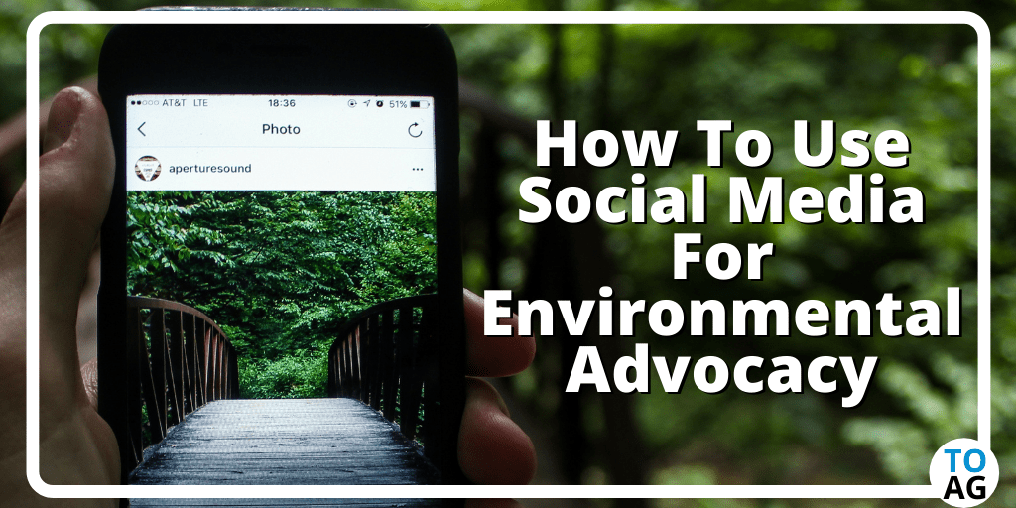
[Accessed from: https://theonlineadvertisingguide.com. Accessed: 09 May 2022]

Write paragraphs on the use of social media to save the environment.

Use the following as a guideline.

- Define the term ‘social media platforms’ and provide THREE ways in which the youth could responsibly make use of social media platforms when promoting safe and healthy living. (1+3) (4)
(Lower Order - DHR)

- Analyse TWO ways in which impact studies could be used to determine the effectiveness of an effort by the youth to use social media in order to save the earth. (2x4) (8)
(Middle Order - SER)
- Critically discuss how the consequences of an unhealthy environment could make it difficult for the youth to achieve academic success. (2x4) (8)
(Higher Order - DSS) (20)

[TOTAL SECTION C: 40 MARKS]
TOTAL = 20 + 40 + 40 = 100

