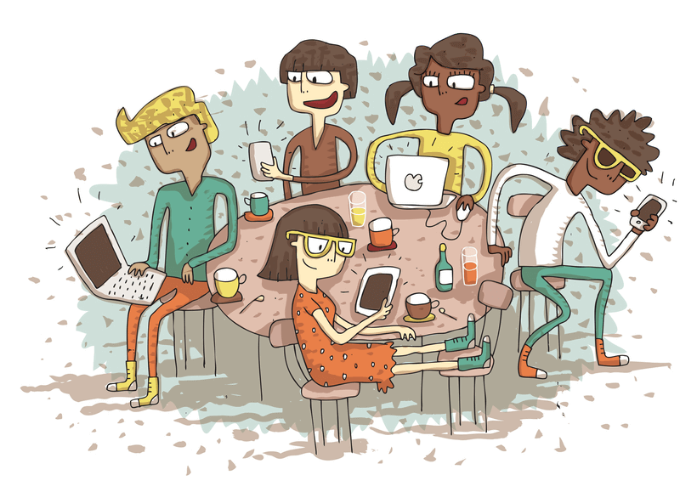
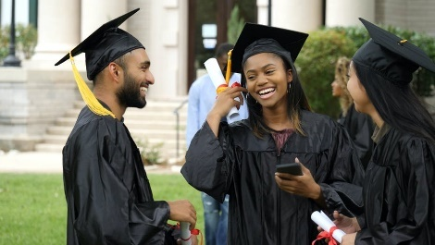
Adapting to Change
Development of the self in society
&
Careers and career choices
Grade 12- Term 1

Recommended Duration: 3 Weeks Total Marks: 90
MEMORANDUM

Summary of Assessment Rubric:
Activity | Description | Possible Mark | Mark Obtained | Moderated Mark
Section A | Question 1 | 30
 | Question 2 | 30
Section B | Question 3 (essay) | 15
 | Question 4 (essay) | 15
TOTAL |  | 90

Educator Feedback
______________________________________________________________________________________________________________________________________________________________

Instructions:
- In this task you will be required to complete Section A and Section B. Complete all the activities in each section. You will need to submit each activity typed out and attached to the cover page of this handout.
- You may use all sources provided, your textbook and the knowledge you have gained in class to complete this task.
- The task should be well-structured by including the following aspects:
- A completed cover page with learner and task details (provided by the teacher).
- Correctly numbered answers to correspond with questions.
- Each section should be answered on a new page.
- The task must be bound / stapled.
- Your teacher will explain the assessment process in detail.
- This written task must be handed in on the date mentioned on the cover page.

Section A:
Question 1: (30)

Study the following cartoon and then answer the questions that follow.
1.1 | 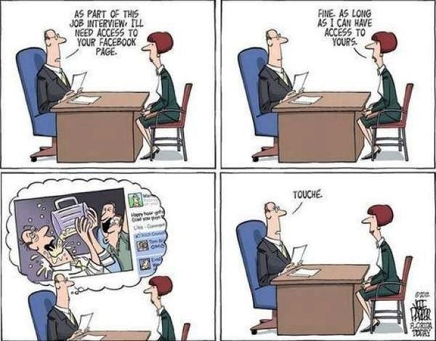 | 1
1.1.1  LO | List THREE ways of getting information on jobs available in your area.  - Newspaper  - Internet job sites like linked-in  - Local store noticeboards  - Adverts on company websites  Any THREE relevant suggestions | 3x1 (3)
1.1.2  LO | Name THREE criteria recommended in a cover letter for a job application.  - A summary of your abilities  - Summary of your qualifications  - List of your interests/ passions/ hobbies (relevant to the job you are applying for  - Emphasis why you are applying  - Emphasise why you are the best candidate for the job  Allow for alternative, well-reasoned answers. | 3x1 (3)
1.1.3  LO | Describe ONE way how social media can assist an individual in the job- hunting process.  - Allows you to connect to greater amount of people that has connections online  - Can connect to people that shows the same interests as you platform to find information  - Building a personal network to market yourself  - Companies use social media sites to source candidates for vacancies in their organisation  - Social network can help overcome the geographical barriers and provide equal access to job market information  - Social network provides an effective communication platform at low cost  Any ONE of the above or any other relevant answer for TWO marks () | 1x2 (2)
1.1.4  MO | Explain why a prospective employer would be so interested in accessing your social media profile?  - Your profile would give the employer an idea about your value and ethics and be able to determine if you would add value to their company.  - The employer would know your stand on issue of race/ gender/ religion and see how you respond to people who have different views to you.  - They would be able to see if you are involved in any unhealthy habits like alcohol binging and inappropriate parties.  - Identify if you have been involved in any illegal activity like distributing images of nudity.  - Your profile would elaborate on what you said about your previous employer . Its unlikely you would be employed if you openly slandered your employer or discussed situations or grievances related to work.  Any TWO of the above or any other relevant answer for TWO marks each () | 2x2 (4)
1.1.5  HO | Suggest TWO measures that you can do as a school leaver to ensure that you will be more employable in the world of work today.  - Make sure that your security settings are high so that no-one can have access into your settings.  - Be careful about what you say – never ever insult somebody or discuss conflict  - Do not complain about your job on any social media platform, this is then in public domain  - Be careful about the links you connect to your status – employers will try to work out the kind of person you are through your interests  - Be careful about the photos that you download or post this may also have negative impact on your job seeking goals.  Any TWO of the above or any other relevant response for TWO marks each. () | 2x2 (4)
1.2 | 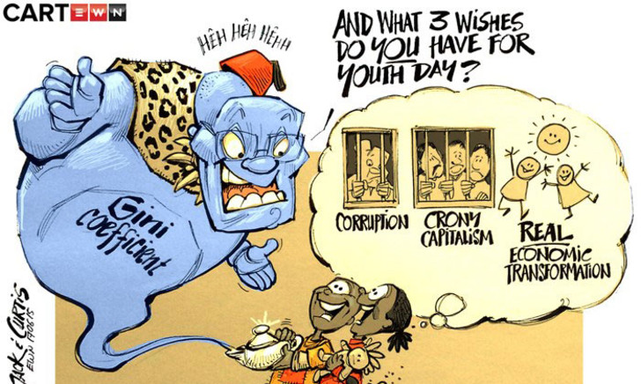
1.2.1  LO | Provide a definition for the term “corruption” and “cronyism”.  Corruption refers to dishonest misuse of public power and money for dishonest gain.  Cronyism refers to employing friends or family because of favouritism regardless of qualifications. | 2x2 (4)
1.2.2  LO | Name THREE examples of economic transformation for the youth of South Africa.  Providing more jobs opportunities for the youth working for the public sector after school.  Instituting a law that says all companies must employ a percentage of young people and train them.  Encourage youth to develop entrepreneurial opportunities by providing funding for small business ventures  Developing apprenticeship programs with established companies where youth can be trained and earn an income for a limited time.  Allow for alternative, well-reasoned answers. | 3x1 (3)
1.2.3  LO | State the meaning of the term SARS.  South African Revenue Services | 1x1 (1)
1.2.4  MO | Describe THREE ways of how corruption within the government has an impact on society.  - When people in the community see the news and hear stories of corruption, they lose faith in their government, which creates a negative image of the government and the South African society to the international public.  - The South African community will feel that corruption is acceptable and take actions to become corrupt themselves.  - The morals of the community could decrease as they feel let down by their leaders or feel they are not important enough.  - Those leaders in government who are honest and law abiding could also get a bad name leading to potential threats, defamation of character, loss of their jobs etc.  - The South African people could lose trust in their government to fulfill their promises and not follow instructions given like wearing a mask in COVID pandemic.  - Local communities may feel the need to take justice into their own hands which could lead to situations like gang violence and ultimately imprisonment.  Any THREE of the above or any other relevant answer for TWO marks each () | 3x2 (6)
 |  | [30]

Question 2: (30)
Read the following article and then answer the questions that follow.

Three South African vice-chancellors paint a post-COVID picture for universities
August 2, 2020 10.32am SAST
(adapted from https://theconversation.com/three-south-african-vice-chancellors-paint-a-post-covid-picture-for-universities-143490)
Across the world, the higher education sector is changing because of the COVID-19 pandemic. The vice-chancellors from three South African universities share their insights about what these changes could mean for the country’s higher education landscape.

What long-lasting changes to South Africa’s higher education sector has the pandemic brought? And how will these affect the way universities deliver teaching and research?

Mamokgethi Phakeng, University of Cape Town: University teaching will draw from various methods that range between fully face-to-face and fully online. COVID-19 fast-tracked this process as we launched emergency remote teaching.

Many of our academics say they will never again teach in the same way as before. The new way puts the needs of students with barriers to learning at the forefront. It helps us design good learning experiences and reconsider methods of assessment. Students can revisit online course material, ask questions and get personal support, in and out-of-normal teaching hours. It’s especially helpful to students who are second-language English speakers or who have a disability.

Adam Habib, University of the Witwatersrand: I believe we are going to see a stronger shift to a blended learning model. Anecdotal evidence is showing that our students are performing better in the online environment than face-to-face. The shift to online also means we are going to see the digital divide in our country grow sharper unless we are able to develop public-private partnerships to assist.

I do not believe we will have a human capacity issue. The real issue will remain how to finance higher education. There is going to be a significant financial challenge both as a result of subsidy cuts (given state finances) and the inability of students to pay fees (because of the economic crisis). In South Africa, we will also see a growing “missing middle” cohort as a result of job losses. Providing financial support to these students is going to be more important now than ever.

This means that we have much to teach the world on how to engage in blended learning in unequal contexts and how to assist poor people in this regard.
2.1  LO | Show ONE positive and ONE negative aspect to tertiary education going more online.  - P- Online learning means you can study from home without having to pay residence fees.  - N- For learners struggling with poverty, this will be increasing difficult.  Consider any other valid responses. | 1+1 (2)
2.2  LO | Provide THREE sources of financial aid for learners to study after school.  - Bursary  - Student loans from the bank  - Scholarship  - Learnership  Any THREE from above for ONE mark each | 3x1 (3)
2.3  LO | State the “type of pass” a matriculant would need for their NSC examinations to apply for university.  - A bachelors pass | 1
2.4  MO | Explain how you will adjust your lifestyle plan knowing that education at a tertiary level will be predominantly online.  - I would plan more time to exercise as there will be less walking to lectures across the campus and thus less opportunity to exercise.  - I would learn to manage my time in a day on a computer so that I do not spend too much time infront of a screen.  - I would also watch my eating habits so that I’m not constantly snacking and eat unhealthy while I work.  Any ONE of the above or any other relevant answer for TWO marks | 1x2 (2)
2.5  MO | Many learners found online learning very stressful over the last year. Discuss TWO stress management techniques to help relieve stress.  - Follow a balanced lifestyle. This means balancing time between online classes, exercise, friendships and sleep.  - Deal with your emotions and frustrations around using technology. Learn to use the programs used in online learning at the beginning of a year so that you’re not frustrated when you are trying to work.  - Be aware of your limitations request for help from a friend or speak to your teacher/ lecturer  - Work from a structured timetable so you don’t spend all day on the computer Make sure you are sleeping at a reasonable hour.  Any TWO of the above or any other relevant answer for TWO marks each | 2x2 (4)
2.6  MO | Explain the possible physical impact on learners who spend more time in online education.  - Eyesight can be impacted by spending so much time online with a computer. You might have to get an eyetest should you develop headaches while working.  - Muscles in your back could get stiff and painful from long periods of sitting and working. Choose a chair with support to protect the muscles in your back.  - Muscle cramping from lack of blood circulation. Get up ever hour and stretch or move your legs and arms in basic stretched while you are working. Drink lots of water.  - Any ONE well answered statement and explanation of physical impact on the body.  Any TWO of the above or any other relevant answer for TWO marks each | 2x2 (4)
2.7  MO | Discuss TWO social skills you can develop to remain healthy as an online learner.  - Make time to still meet face to face with fellow students so that you don’t loose social skills while online all the time.  - Manage your time spent on social media platforms. Time waisted spent on social media could impact your studies and cut into time spend with people.  - When spending time with friends and family be present in the moment not spending time distracted with digital devices Do not become so addicted to technology that it impacts your social skills.  Any TWO of the above or any other relevant answer for TWO marks each | 2x2 (4)
2.9.1  HO | “There is going to be a significant financial challenge both as a result of subsidy cuts (given state finances) and the inability of students to pay fees”  Evaluate how COVID and lockdown has impacted the financial aid application process in South Africa for students who wish to study after finishing matric.  - Less matric learners will have the available finances to study as family members who originally had a reliable income will no longer be able to pay for their children to study.  - Matriculants might have to get a job to help provide for their families as their families struggle to survive with too little income in the home.  - Due to a lack of access to digital resources, some learners wont know what bursary opportunities there are for learners with limited household incomes.  Any TWO of the above or any other relevant answer for TWO marks each | 2x2 (4)
2.9.2  HO | Suggest THREE strategies matriculants can use currently to cope with the transition from high school to student life at university.  - Plan your future in advance and know what you are going to study and where you intend studying. Research the requirements of the course you intend studying so you know what is required of you during your matric year.  - Develop a positive attitude towards change and take charge . This means embracing the opportunities that come along with change for personal growth.  - Think of previous periods in your life and how you handled the change. Use some of those skills to prepare you for the transition.  The THREE above or any other relevant answers for TWO marks each | 3x2 (6)
 |  | [30]
[TOTAL: SECTION A :60]

Section B: (30)
In this section you will be required to write TWO essays in response to the images.
Question 3:
Study the following caption and cartoon below and then complete the question in paragraphs:

To effectively communicate, we must realize that we are all different in the way we perceive the world and use this understanding as a guide to our communication with others.”
Quote by Tony Robbins
 | Write paragraphs on communication amongst teenagers.
 | - Define the term communication and identify TWO examples of ineffective communication between the group of friends in the cartoon.  - Definition:  - a process by which information is exchanged between individuals through a common system of symbols, signs, or behavior including verbal and non-verbal cues  Examples  - each person in the cartoon is communicating over their cellphones rather than talking face to face.  - The individuals are turned away from the others in the groups with no eye contact and spoken words.  The TWO above or any other relevant answers for ONE mark each | 1+2 (3)  LO
 | - In high school, you will come across people from many different cultural groups. Discuss THREE ways in which you accept and respect cultural/religious differences when building friendships.  - Maintain eye contact in conversation listening to their stories of themselves/ their beliefs Do not interrupt, allow them to communicate their own beliefs.  - When you express your feelings, be specific describe the feeling you can avoid misunderstandings when you communicate clearly.  - Do not impose your own beliefs/ cultural practices on someone else. Learn to share your beliefs with an attitude of communicating your beliefs rather than feeling you need to prove that your beliefs are right.  - Focus on finding the common ground eg. Hobbies/ likes etc when building friendships rather than seeing the cultural differences first.  Any THREE of the above or any other relevant answers for TWO marks each | 3x2 (6)  MO
 | - Recommend TWO ways that teenagers could improve their verbal communication skills amongst their peers. In your answers, indicate how EACH recommendation could lead to stronger relationships.  - Teenagers need to learn to communicate verbally their honest feelings and not just send a message. By being vulnerable, you will build a foundation of honesty that will take your relationships to a new level.  - Teenagers need to learn to sit opposite, facing their friends this way they will show an interest in the conversation and be able to listen attentively.  - They need to vary their conversations to not always involve their phones, this means describing events rather than just replaying the clip of the moment as it happened.  Any TWO of the above or any other relevant answers for THREE marks each | 2x3 (6)  HO
 |  | [15]
Question 4:

Study the following image and then complete the question in paragraphs:

 | 
 | Write paragraphs relating to the studying and writing of examinations
 | - List THREE study skills a matric learner could use to prepare for their NSC at the end of the year.  - Flashcards  - mnemonics  - Mind maps  - Summaries  - Tables  - Role play  Allow for alternative answers. | 3x1 (3)  LO
 | - Discuss THREE exam writing skills a matric learner could use when writing an examination to remain calm and focused.  - Sit upright in your chair, let your hands hang loosely by your sides and close your eyes for a moment. Block out all sound near you and focus on sounds far away. Then bring your focus back to the sounds in the room. This will help you calm down and focus again.  - Close your eyes and take deep breaths. Concentrate on your breathing in and out and focus on calming down. Do this for 1minute until you feel your heart rate slow down then continue writing.  - Close your eyes and rub your fingers in circles on the sides of your temples. Breathe deeply. This action will release tension and stress, relieving possible stress headaches.  Any THREE of the above or any other relevant answers for TWO marks each | 3x2 (6)  MO
 | - Recommend TWO study habits matric learners could put into practice to ensure that they are not cramming the night before their exam. In your answers, indicate how EACH recommendation could decrease the likelihood of cramming.  - Create a comprehensive study timetable which allocates specific times for each subject. This would help learners feel prepared the night before their exam, so they don’t need to study then.  - Learners could pay attention in class which will mean less study time at home. Learners will understand the work from the start, leading to less need to study the night before. /or/ less study time at home means it is easier to complete prior to the night before the exam.  - Practice self-discipline to avoid procrastination by sticking to any plan they have set. This will ensure learners have completed their work in advance.  - Study a smaller amount each day, as smaller chunks of work seem less daunting or demotivating. This will motivate the learner to start studying in advance.  - Have an accountability buddy who will contact the learner regularly to check their progress. The learner will start studying earlier so as they are constantly reminded /or/ they don’t want to disappoint their accountability buddy.  - Create a study group where learners teach each other the work. Learners will be forced to study to keep up with the group.  Any TWO of the above or any other relevant answers for THREE marks each | 2x3 (6)  HO
 |  | [15]
 | [TOTAL SECTION B: 30]
[GRAND TOTAL: 30 + 30+30 = 90]
LOWER ORDER: 16+6+6 =28 (31%)
MIDDLE ORDER: 10+ 14 +12= 36 (40%)
HIGHER ORDER: 4+10+12= 26 (29%)

