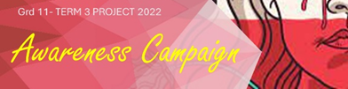
LEARNERS GUIDELINE for GENDER BASED AWARENESS PROJECT
These notes will form a summary of the content covered in the PowerPoint preparing you for the project.
- Remember the different forms of violence?
- domestic
- sexual
- rape
- physical
- emotional mental
- femicide
- sexual harassment

2) How do you go about challenging human rights violations?
- Know the basic human rights which can be found in the Bill of Rights.
Things like: All people have the right to be treated equally, to have dignity and self-respect, to express your ideas.
- Get involved in campaigns, events and projects. Remember and event is a planned once off activity e.g. roadshow and a project is a planned activity that runs over time.
- A campaign is a series of actions taken to impact a problem in society or that affects our environment.

3) The stages of a campaign include:
- Recognise the problem in a community eg. Rape of small children in Cape Town
- Work as a team to brainstorm ideas on how to make the public aware of the problem and to think of possible solutions.
- Then to promote these solutions using media like newspapers/ radio/ television/ social media/ games etc.
- Evaluate the effectiveness of the campaign and consider possible changes.

Over the next 4 weeks you and TWO / THREE friends will plan and execute an awareness campaign against GENDER BASED VIOLENCE in South Africa.
Your project will include all the stages of a campaign.

You will work in your group to:
- Design, develop, implement and evaluate a campaign aimed to build public awareness on Gender Based Violence (GBV).
- Develop promotional material which could include posters/ pamphlets/ adverts/ fact sheets and any other material you may deem suitable.
- Implement and evaluate the campaign- either on social media OR let members of your school community evaluate it.
- Reflect on the impact this campaign has had on you as an individual.
- Compile evidence by recording all resources in a bibliography.

PRACTICAL TIPS
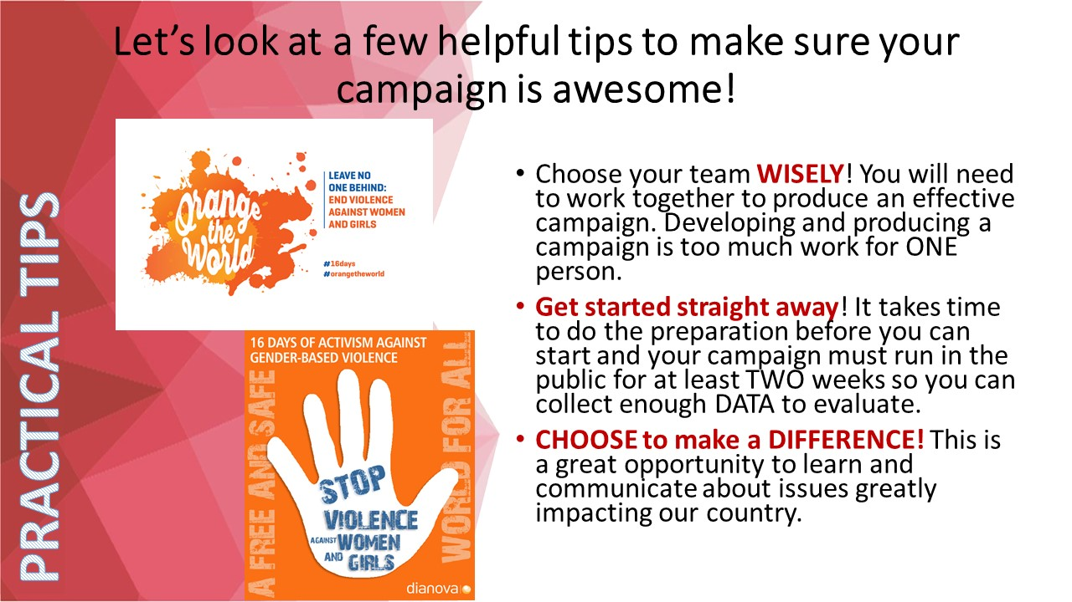:
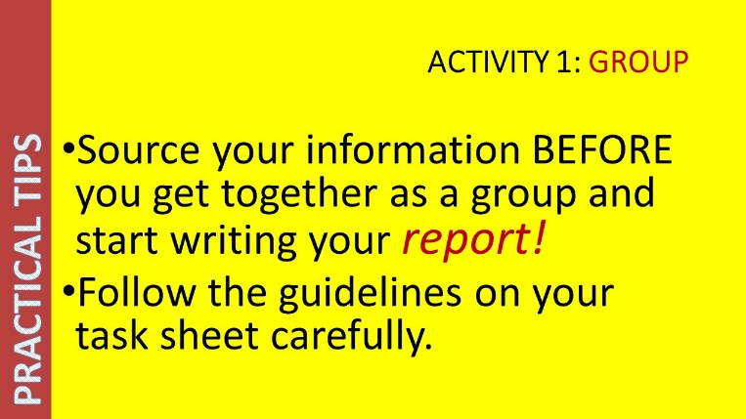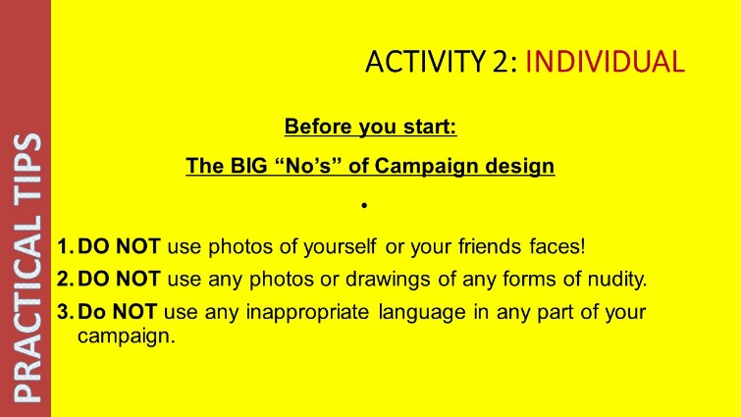
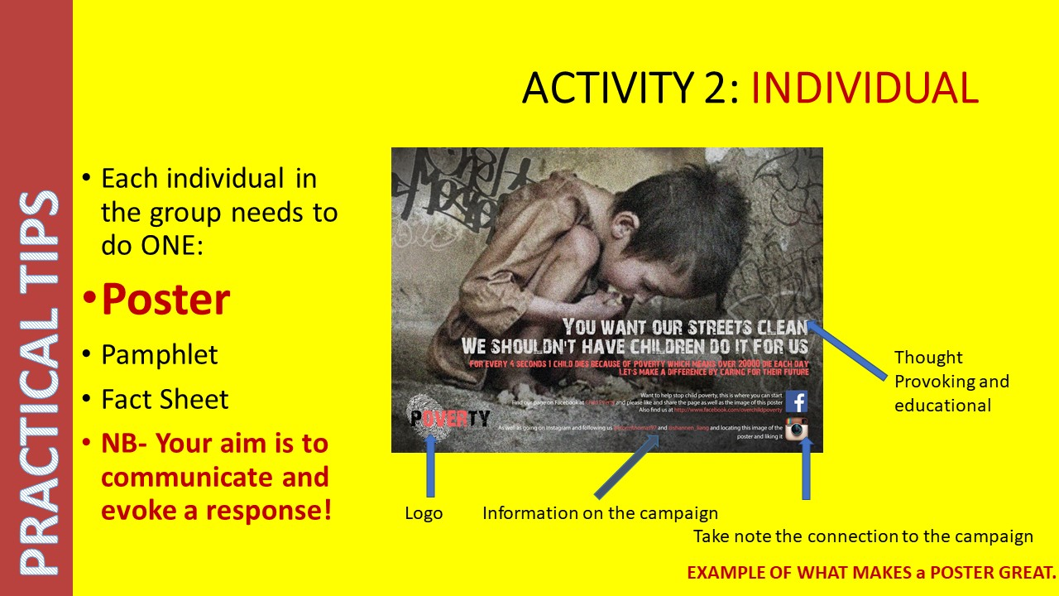
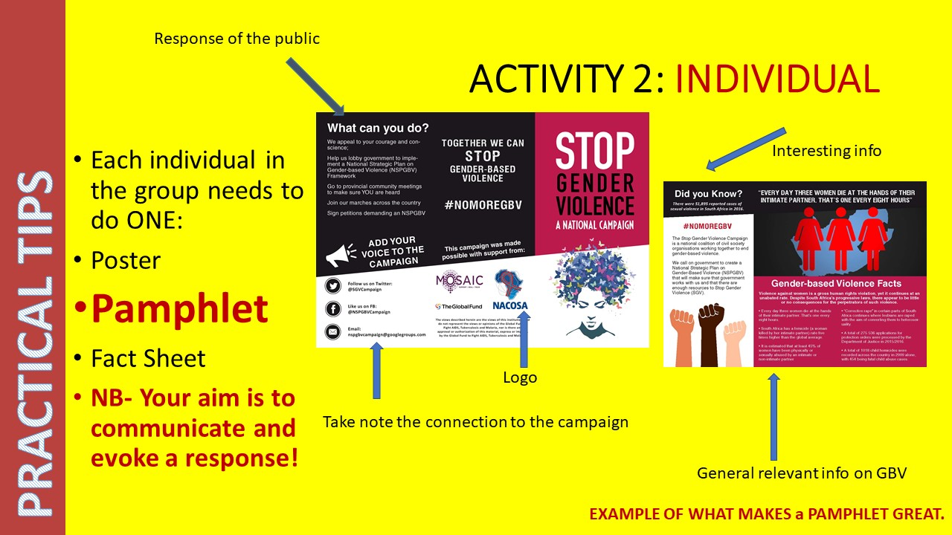
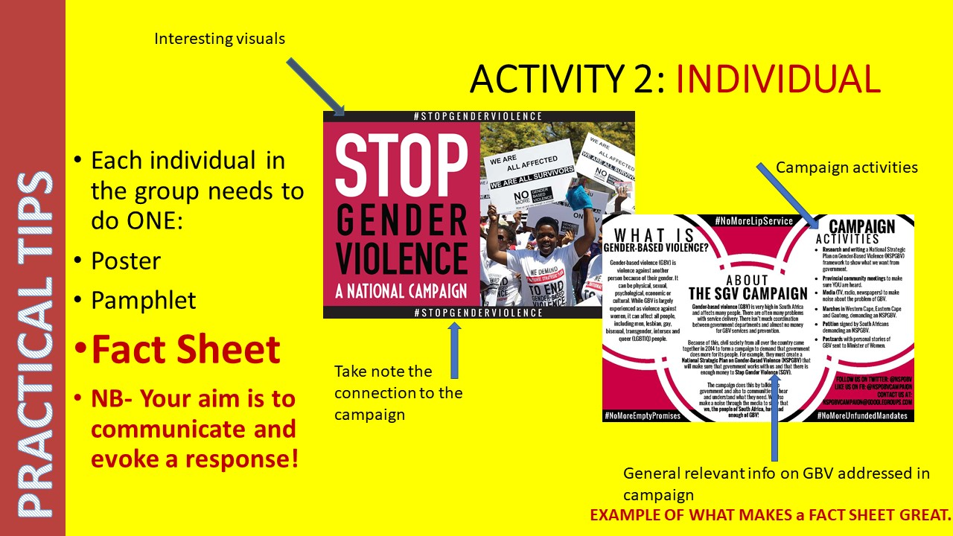
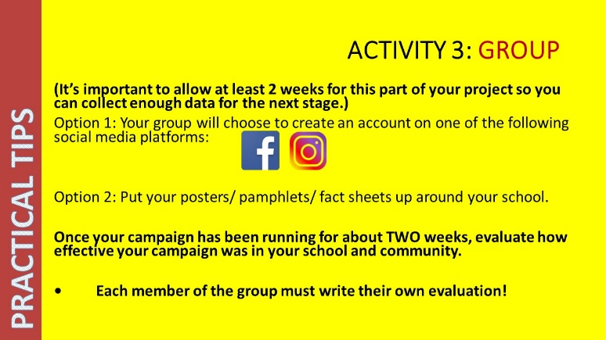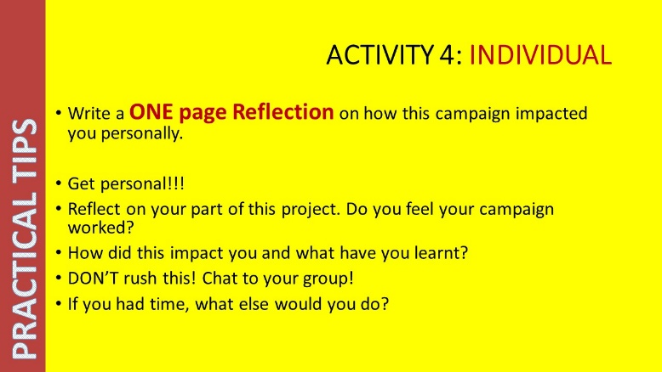
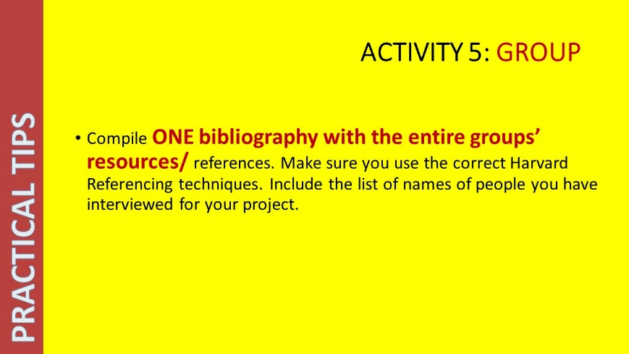

So…..Go for it! Be creative! We look forward to following your amazing campaign.

